
CAPSTONE PROJECT

MERA'S GENERAL MERCHANDISE STORE
MANAGEMENT SYSTEM WITH POS AND
CHAT SUPPORT

A Capstone Project
Presented to the Faculty of
College of Computer Studies

In Partial Fulfillment
of the Requirements for the Subject
Capstone Project 1

Presented by:

John Francis D. Quijano
Agie B. Verallo

May 2026
CHAPTER I
INTRODUCTION

Background of the Study
Technology plays an important role in improving the way businesses operate today. Many stores are now using computerized systems to make transactions faster, organize records efficiently, and provide better services to customers. These systems help businesses become more productive, accurate, and competitive in the modern market.
General merchandise stores handle different kinds of products and daily transactions, making proper management essential for smooth operations. A Point of Sale (POS) system is one of the most useful tools that can help store owners manage sales, monitor inventory, and generate reports more effectively. In addition, customer communication has also become an important part of business operations, and chat support features allow stores to interact with customers more conveniently and efficiently.
This study focuses on the development of "Mera's General Merchandise Store Management System with POS and Chat Support." The system is desig1ned to combine sales processing, inventory monitoring, and customer communication into one platform. It aims to provide a more organized and efficient way of managing store operations while improving the overall experience of both staff and customers.
Through this study, the researchers aim to create a user-friendly and reliable system that can support the daily activities of the store and contribute to better business management.

Objectives of the Study

General Objectives
This study aims to develop Mera's General Merchandise Store Management System with POS and Chat Support to improve sales transactions, inventory management, sales reporting, and customer communication.
Specifically, it aims to:
1. Option for the admin to which shows:
Manage Sales – Create new sales records and process customer transactions.
Monitor Communication – Read customer inquiries and messages received through the system.
Control Inventory – Update product information, stock quantities, and prices to maintain accurate inventory records.
Manage Records – Delete incorrect sales entries, discontinued products, inactive user accounts, spam messages, unnecessary report files, and outdated system configurations.
2. Display a dashboard which shows the following:
Total Daily Sales
Total Weekly Sales
Total Monthly Sales
Total Revenue
Total Number of Low-Stock Products
Total Number of Products
7-Day Sales Trend
Top-Selling Products
Stock Distribution by Category
Recent Sales Transactions
Quick Action Shortcuts (POS Checkout, Inventory, Support Chat, and Sales Reports)
Low-Stock Alerts
3. Develop a Reports Module that provides:
Daily Sales Report – Generates a report of all sales transactions completed each day.
Weekly Sales Report – Generates a summary of weekly sales transactions and total revenue.
Monthly Sales Report – Generates a report of monthly sales performance and total revenue.
Yearly Sales Report – Generates a report of annual sales performance, total transactions, and total revenue.
Top-Selling Products Report – Displays and generates a report of the best-selling products based on units sold and revenue.
Recent Transactions Report – Displays and generates a report of the latest sales transactions, including cashier, date and time, and transaction total.
Export Report – Allows administrators to export sales reports in CSV format for record-keeping and further analysis.
Print Report – Allows administrators to print generated sales reports for documentation and business records.
4. Implement Account Security and Recovery Features:
Provides email verification for newly registered accounts and enables secure password recovery through email and SMS notifications using password reset links or One-Time Passwords (OTP) to ensure authorized access and improve system security.
5. Develop a Mobile Application for Merchants and Customers:
The Android mobile application provides a convenient platform for both merchants and customers to access the system anytime using their Android smartphones.
6. Integrate a Secure Online Payment Gateway (GCash)
The system integrates a secure GCash payment gateway that enables customers to pay for their purchases electronically. It records payment transactions, confirms successful payments, generates digital receipts, and ensures that payment information is securely processed to provide a safe and convenient cashless transaction experience.
7.Determine the quality of the developed system based on ISO/IEC 25010:2011 Systems and Software Quality Model.
8.Determine the usability of the developed system based on the following criteria: Usefulness; Satisfaction; Ease of Use and Learning.

Significance of the Study
This study entitled “Mera’s General Merchandise Store Management System with POS and Chat Support” is significant because it provides benefits to the following:

Store Owner
The proposed system will help the store owner manage sales transactions, monitor inventory, and generate accurate reports efficiently. It will also improve decision-making, reduce manual work, and enhance the overall operations of the store.

Store Employees
The system will make daily tasks easier and faster by simplifying sales processing and inventory monitoring. It can also help minimize errors in recording transactions and improve work productivity.

Customers
Customers will benefit from faster and more convenient transactions. The chat support feature will also improve communication between the store and customers, leading to better customer service and satisfaction.

Future Researchers
This study will help the researchers enhance their knowledge and skills in system development, programming, database management, and problem-solving. It will also provide practical experience in developing a computerized business system.

Scope
The scope of this study focuses on the development of Mera's General Merchandise Store Management System with POS and Chat Support, designed to streamline the daily operations of Mera's General Merchandise Store. The system integrates multiple functions into one computerized platform, including a Point of Sale (POS) feature for processing purchases, calculating totals, generating receipts, and automatically recording transactions. It also includes an inventory management module for real-time monitoring of product stocks, pricing, product categories, and availability, as well as a sales reporting module that generates daily, weekly, monthly, and inventory reports to support business monitoring and decision-making. The system provides an admin portal that enables administrators to manage users, products, inventory, sales transactions, reports, customer inquiries, and system settings. It also includes a password recovery feature that allows administrators to securely reset their password through their registered email address. The study also includes a mobile application for both merchants and customers. Merchants can manage products, monitor inventory, receive customer orders, view sales summaries, respond to customer inquiries, and receive low-stock notifications. Customers can register and log in, browse products, search for items, add products to their cart, place orders or reservations, monitor order status, communicate with the store through chat support, and view their purchase history using their mobile devices. To improve account security, the system implements email verification during user registration and provides email for account verification and password recovery. These features help verify user identities and allow users to securely regain access to their accounts whenever they forget their passwords. In addition, the system integrates a secure GCash payment gateway that enables customers to make cashless payments for their purchases. The system records payment transactions, confirms successful payments, and generates digital receipts to ensure secure and convenient online transactions. The study also evaluates the developed system based on the ISO/IEC 25010 software quality characteristics, specifically functionality, usability, reliability, efficiency, security, and maintainability, to determine its effectiveness in improving the operations of Mera's General Merchandise Store.

Limitations
The study is limited to the development and implementation of Mera's General Merchandise Store Management System with POS and Chat Support for the internal operations of Mera's General Merchandise Store. The system focuses on sales transactions, inventory management, sales reporting, customer communication, account management, and secure digital payment processing.
Although the system includes a mobile application for merchants and customers, it is limited to essential store management and purchasing functions. The application does not support delivery tracking, GPS location services, or integration with third-party courier services. It is designed to operate with an active internet connection and compatible mobile devices. The password recovery feature is limited to registered email addresses, while email verification depends on the availability of external email. Delays or failures caused by internet connectivity, mobile network issues, or third-party service providers are beyond the control of the system. The online payment feature is limited to GCash as the supported digital payment method. Other payment gateways, online banking services, and international payment methods are not included in the current version of the system. The chat support feature is intended for basic customer inquiries and communication only. It does not include advanced artificial intelligence, natural language processing, or automated learning capabilities.
Furthermore, the system is intended for a single-store environment and does not support multi-branch management, warehouse management, supplier management, accounting, payroll, or advanced business analytics. Future enhancements may include additional payment gateways, delivery management, multi-branch support, and more advanced customer service and reporting features.

Definition of Terms

Administrator (Admin)
Conceptually, an administrator is an authorized individual who is responsible for managing, controlling, and maintaining the operations and resources of a computerized system. Operationally, in this study, the administrator refers to the authorized user who manages the system's sales, inventory, products, reports, user accounts, customer inquiries, system settings, and other administrative functions. The administrator can also recover their account through the registered email address.

Chat Support
Conceptually, chat support is a digital communication service that allows customers to communicate with a business to ask questions, request assistance, or obtain information. Operationally, in this study, chat support refers to the communication feature that allows customers to send inquiries to Mera's General Merchandise Store and enables authorized store personnel to view and respond to customer messages through the system.

Customer
Conceptually, a customer is an individual who purchases goods or services from a business for personal or other intended use. Operationally, in this study, a customer refers to a registered user who can browse products, place orders or reservations, make payments, communicate with the store through chat support, monitor order status, and view purchase history using the system.

Database
Conceptually, a database is an organized collection of electronic information that allows data to be stored, accessed, managed, updated, and retrieved efficiently. Operationally, in this study, the database refers to the MySQL database used by the proposed system to store and manage user accounts, product information, inventory records, sales transactions, customer information, and other system-related data.

Dashboard
Conceptually, a dashboard is a graphical user interface that presents important information, statistics, and data summaries in an organized and easily understandable format. Operationally, in this study, the dashboard refers to the system interface that displays information such as daily, weekly, and monthly sales, total revenue, total products, and low-stock items to help the administrator monitor the performance and status of the store.

Email Verification
Conceptually, email verification is a security process used to confirm that an email address provided by a user is valid and accessible to that user. Operationally, in this study, email verification refers to the process of confirming a newly registered user's email address before the account is fully activated and allowed to access the system.

Forgot Password
Conceptually, forgot password is an account recovery feature that allows users to regain access to their accounts when they cannot remember their passwords. Operationally, in this study, the forgot password feature allows authorized users to recover their accounts by receiving a password reset link, verification code, or One-Time Password (OTP) through their registered email address or supported notification service.

GCash Payment
Conceptually, GCash payment is a digital payment method that enables users to electronically pay for goods or services through the GCash platform. Operationally, in this study, GCash payment refers to the integrated digital payment option that allows customers to make cashless payments for their purchases. The system records the payment transaction, confirms successful payments, and generates digital receipts.

Inventory Management
Conceptually, inventory management is the process of monitoring, organizing, and controlling a business's products and stock to maintain appropriate quantities and availability. Operationally, in this study, inventory management refers to the system function that allows authorized users to add products, monitor stock quantities, update prices and quantities, identify low-stock items, and remove discontinued products.

Merchant
Conceptually, a merchant is an individual or business involved in selling goods or products to customers. Operationally, in this study, a merchant refers to authorized store personnel who can use the system or mobile application to manage products, monitor inventory, receive customer orders, view sales information, respond to customer inquiries, and receive low-stock notifications.

Mobile Application
Conceptually, a mobile application is a software application designed to operate on mobile devices, such as smartphones, and provide users with access to specific services and functions. Operationally, in this study, the mobile application refers to the mobile platform provided for merchants and customers. Merchants can manage products, inventory, orders, sales information, and customer inquiries, while customers can browse products, place orders, monitor order status, communicate with the store, and view their purchase history.

Mera's General Merchandise Store
Conceptually, a general merchandise store is a retail business establishment that sells a variety of consumer products to meet the different needs of its customers. Operationally, in this study, Mera's General Merchandise Store refers to the specific business establishment where the proposed Mera's General Merchandise Store Management System with POS and Chat Support is intended to be implemented and evaluated.

Point of Sale (POS)
Conceptually, a Point of Sale (POS) is a computerized system used by businesses to process and record sales transactions between the business and its customers. Operationally, in this study, the POS refers to the system module used to process customer purchases, calculate transaction totals, record payments, generate receipts, and automatically update inventory and sales records.

Sales Transaction
Conceptually, a sales transaction is the exchange of goods or services between a seller and a customer in return for payment. Operationally, in this study, a sales transaction refers to every customer purchase processed and recorded through the POS system, including the products purchased, quantities, payment details, transaction amount, and other related transaction information.

Sales Report
Conceptually, a sales report is an organized summary of sales information used to monitor and evaluate the sales performance of a business over a specific period. Operationally, in this study, a sales report refers to the computerized reports generated by the system, including daily, weekly, and monthly sales reports, product sales reports, inventory reports, and overall sales summaries used to monitor revenue and support business decision-making.

System
Conceptually, a system is a collection of interconnected components that work together to perform specific functions and achieve a common purpose. Operationally, in this study, the system refers to the Mera's General Merchandise Store Management System with POS and Chat Support, which integrates sales processing, inventory management, sales reporting, customer communication, account security, mobile access, and digital payment processing into one computerized platform.

User
Conceptually, a user is an individual who interacts with a computer system, application, or software to access its available functions and services. Operationally, in this study, a user refers to any authorized individual who accesses and interacts with the proposed system, including administrators, merchants, cashiers, and customers, according to their assigned roles and access permissions.

Conceptual Framework
The conceptual framework of the study presents the overall structure and flow of the proposed Mera's General Merchandise Store Management System with POS and Chat Support. It illustrates the relationship among the inputs, processes, outputs, and outcomes involved in the development and implementation of the system using the Input–Process–Output–Outcome (IPOO) Model.
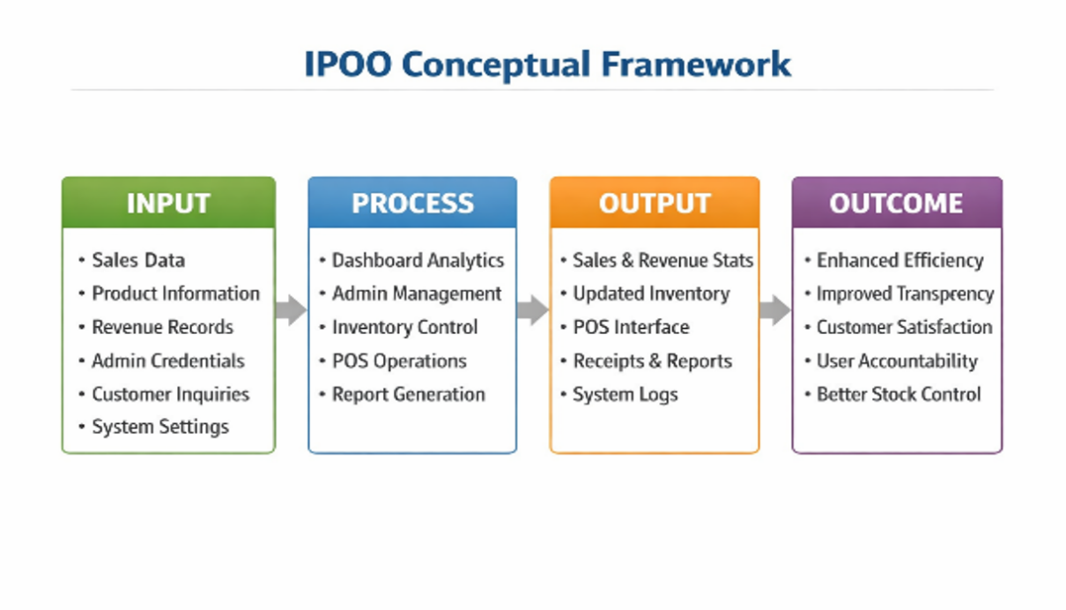
Figure 1. Conceptual Framework
illustrates the conceptual framework of the proposed Mera's General Merchandise Store Management System with POS and Chat Support using the Input–Process–Output–Outcome (IPOO) Model. The system starts with essential inputs such as product and inventory data, sales transactions, user accounts, customer inquiries, payment details, and system settings. These inputs are processed through features like POS transactions, inventory management, report generation, chat support, account management, email verification, password recovery, GCash payment integration, and mobile application services. As a result, the system produces updated records, sales reports, payment confirmations, verified accounts, chat responses, and dashboard analytics. Overall, the framework shows how the system improves store operations by making them more efficient, secure, organized, and convenient while supporting better customer service and business decision-making.
CHAPTER II
RELATED LITERATURE AND PRIOR ARTS SEARCH
This chapter presents the review of related literature, related studies, concepts and principles, and prior arts that are relevant to the development of the proposed Mera’s General Merchandise Store Management System with POS and Chat Support. The reviewed materials provide information and support regarding Point of Sale (POS) systems, inventory management, sales reporting, database management, and customer communication systems.
Technology plays a vital role in improving business operations, particularly in retail and merchandise stores. Many businesses now adopt computerized systems to make transactions faster, manage inventory more accurately, and enhance customer service. Studies consistently show that management systems reduce manual work, increase productivity, and organize records efficiently.
According to Santos and Cruz (2023) explained that POS systems help businesses process transactions quickly and accurately while automatically recording sales data. Their study emphasized that computerized sales systems reduce human errors in calculations and improve transaction efficiency. POS systems also allow store owners to monitor daily sales and generate organized reports for better decision-making.
Reyes et al. (2022) reported that highlighted that manual inventory checking often leads to inaccurate stock records, missing products, and overstocking. Their findings showed that computerized inventory systems provide real-time monitoring of product availability and stock movement, improving product tracking and reducing time spent on manual checking. Proper inventory management also prevents financial losses caused by shortages and expired products.
According to Dela Cruz (2024) stated that explained that chat support systems allow customers to ask questions and receive assistance conveniently. Faster communication improves customer satisfaction and strengthens trust in businesses. Chat support also reduces the need for customers to visit stores personally for simple inquiries.
According to Castañeda Unac et al. (2024) found that business intelligence and automated reporting systems enable businesses to monitor sales performance more efficiently by providing organized reports and data visualization that support faster and more accurate decision-making. These systems improve business operations by transforming sales data into meaningful information that assists managers in planning and evaluating business performance.
Torres (2023) emphasized that databases improve data retrieval, record management, and system reliability. Secure databases protect important business information from unauthorized access and data loss.
Ramos and Villanueva (2022) noted that user-friendly systems help employees perform tasks faster and with fewer mistakes. Their study highlighted that simple interfaces are easier to understand and operate, especially for small business owners and employees with limited technical knowledge.
Overall, the reviewed literature demonstrates that computerized management systems provide significant benefits in sales transactions, inventory monitoring, customer communication, and reporting. These findings support the development of the proposed Mera’s General Merchandise Store Management System with POS and Chat Support, showing how technology can improve efficiency, accuracy, and customer service in retail businesses.

Related Concepts and Principles
Several studies related to store management systems, POS systems, inventory systems, and customer communication platforms support the development of this study. These works emphasize the importance of automation in improving business operations and customer satisfaction.
Lopez and Martinez (2023) found that computerized POS systems in small retail businesses significantly improved transaction speed and accuracy. Automated calculations reduced cashier errors and helped store owners monitor sales more effectively, making POS systems essential for productivity and efficiency.
Lim et al. (2025) reported that manual inventory methods often lead to inaccurate stock records and inefficient inventory monitoring. Their study demonstrated that a computerized inventory management system provides real-time stock visibility and automates inventory processes, improving data accuracy, reducing manual work, and helping small businesses manage inventory more efficiently.
Cai et al. (2024) found that effective chatbot communication improves customer satisfaction, trust, and engagement by providing timely and responsive assistance. Their study showed that well-designed chat support enhances customer interactions and encourages continued patronage by delivering a more positive service experience.
Steen (2024) explained that sales analysis and automated reporting allow businesses to identify trends, evaluate sales performance, and make data-driven decisions. By automating the collection and analysis of sales data, businesses can improve inventory planning, pricing strategies, and overall operational efficiency.
Divina et al. (2025) developed a data-driven Point of Sale (POS) and inventory management system that integrates sales processing, inventory monitoring, and reporting features into a single platform. Their findings showed that the integrated system improved operational efficiency, enhanced inventory accuracy, streamlined business processes, and provided real-time analytics to support better decision-making.
Ferrara et al. (2024) emphasized that strong authentication policies and secure user account management are essential for protecting information systems from unauthorized access and identity-related security threats. Their study highlighted that well-designed authentication mechanisms improve system security, protect sensitive information, and enhance the reliability of digital systems.
Overall, these studies demonstrate that automation and integration in store management systems enhance efficiency, accuracy, and customer service. They provide strong conceptual support for the development of the proposed Mera’s General Merchandise Store Management System with POS and Chat Support.

Prior Arts and Reference System
Here are the nearest prior arts of our system Mera’s General Merchandise Store Management with POS and Chatsupport.
Youtube
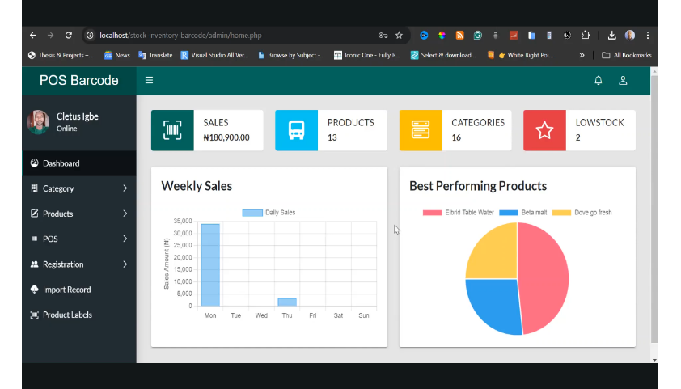
ImageSource: https://www.youtube.com/watch?v=VO23kyhXurA&t=2s
The web-based dashboard is a POS system that manages sales, inventory, and products in real time. It provides a centralized view of business operations and performance.
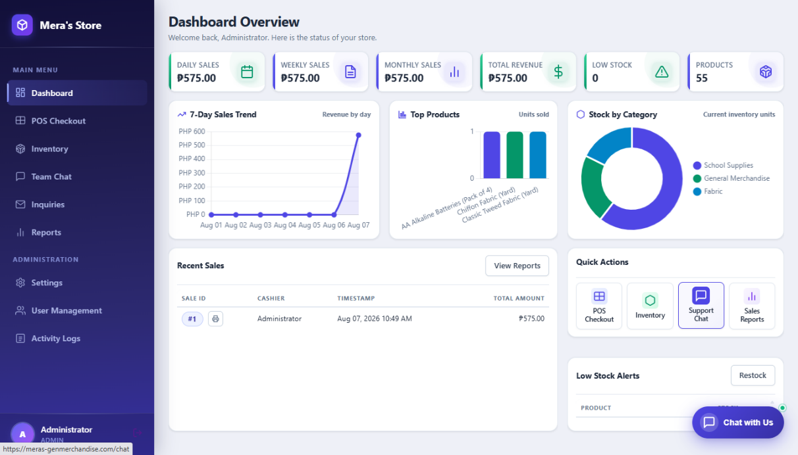
Figure 2.Youtube.as the nearest prior arts of Mera’s General Merchandise Store Management System with POS and Chatsupport.
LinkedIn
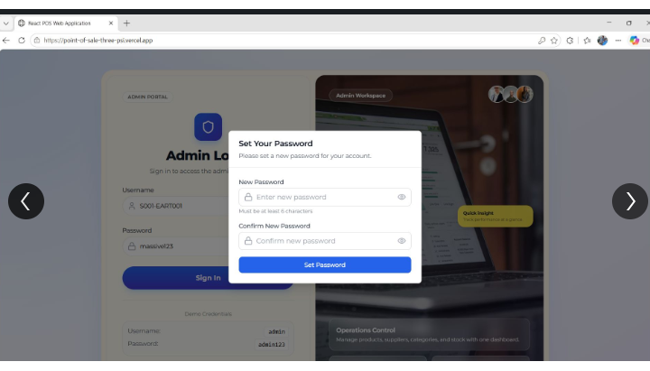
ImageSource: https://www.linkedin.com/posts/edward-mintah-1bb747322_possystem-businesssoftware-webdevelopment-activity-7460403501920231425taNt?utm_source=social_share_send&utm_medium=member_desktop_web&rcm=ACoAAGkWq58BP1eEmaK3SlC4LJAwlCrY6HkehG8
This POS web interface enhances security by requiring administrators to change their default password before accessing the dashboard.
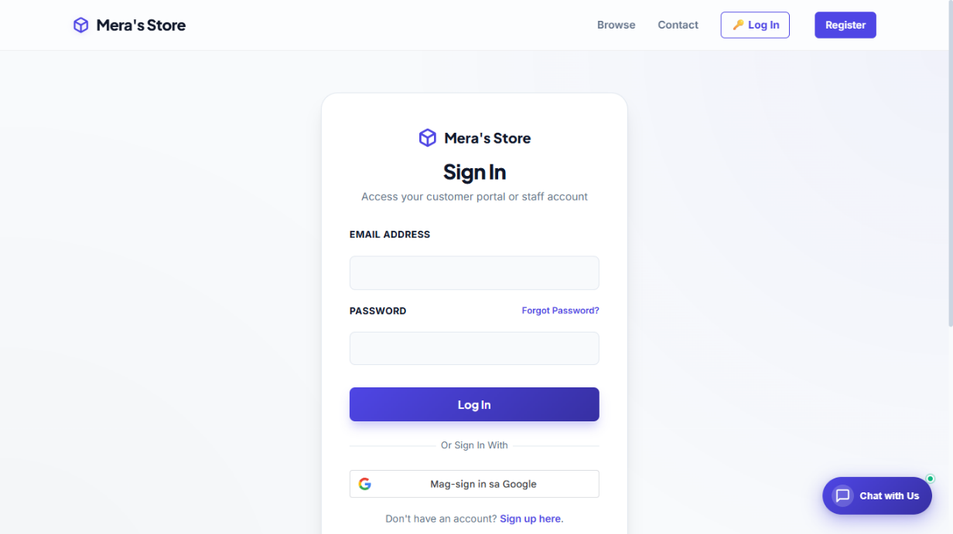
Figure 3. LinkedIn. as the nearest prior arts of Mera’s General Merchandise Store Management System with POS and Chatsupport.
LinkedId
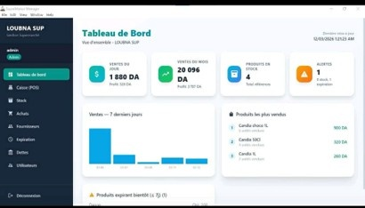
ImageSource: https://www.linkedin.com/posts/mohammed-rahmani-041a602a0_retailtech-supermarketsoftware-inventorymanagement-activity-7437746788960378880-Wf2h?utm_source=social_share_video_v2&utm_medium=android_app&rcm=ACoAAGkWq58BP1eEmaK3SlC4LJAwlCrY6HkehG8&utm_campaign=copy_link
This dashboard provides a quick overview of sales, profits, inventory, and alerts, with charts and lists for monitoring store performance and stock status. It also includes access to POS, purchases, suppliers, debts, and user management.
Figure 4. LinkedIn. as the nearest prior arts of Mera’s General Merchandise Store Management System with POS and Chatsupport.
LinkedIn
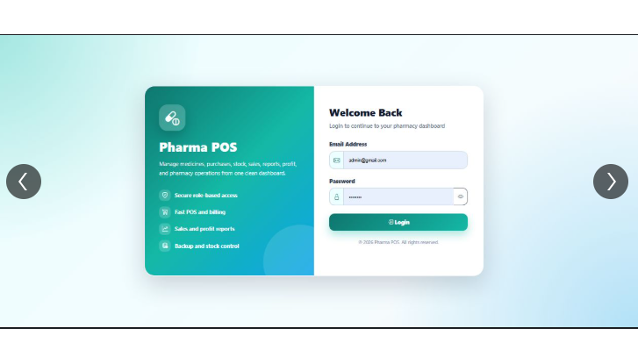
ImageSource:https://www.linkedin.com/posts/umer-shakeel-7040a7180_webdevelopment-php-mysql-activity7457381188580769795s2wp?utm_source=social_share_send&utm_medium=member_desktop_web&rcm=ACoAAGkWq58BP1eEmaK3SlC4LJAwlCrY6HkehG8
This figure shows the Items module of the POS system, powered by OSPOS, where businesses can view and manage their inventory database. It provides a structured table of products with key details for tracking and sales operations.
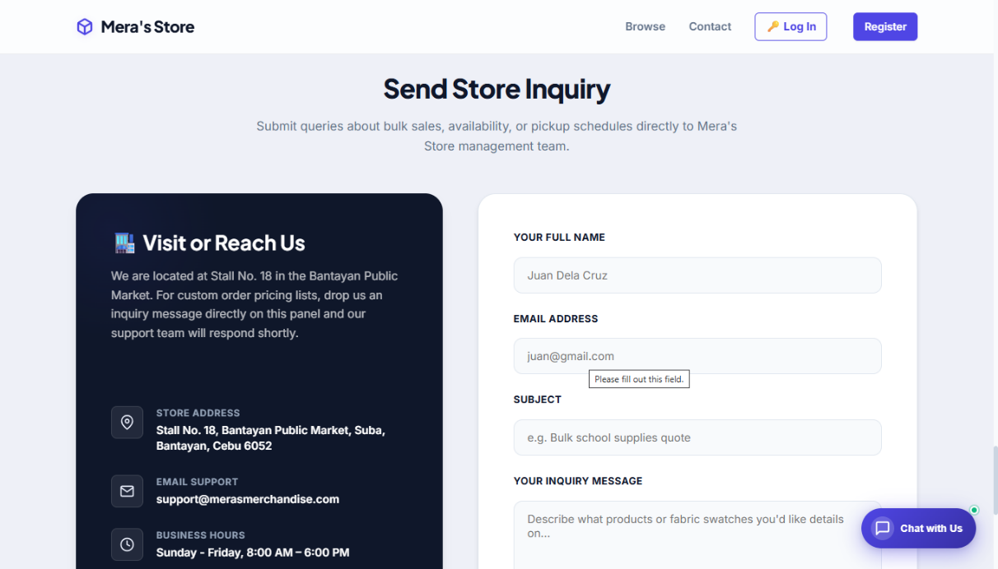
Figure 5. LinkedIn. as the nearest prior arts of Mera’s General Merchandise Store Management System with POS and Chatsupport.
Stokivo
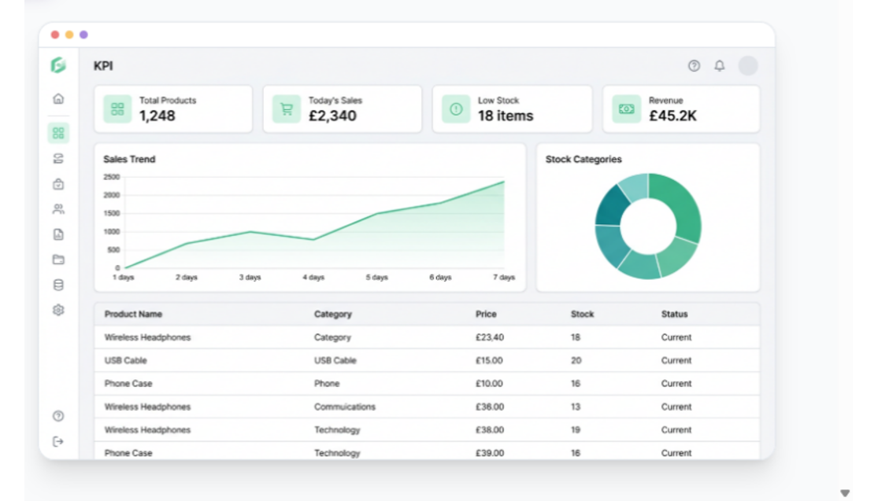
Image Source: https://www.stokivo.com/#
This figure shows the Stokivo Smart Inventory Dashboard, a web-based interface designed to give businesses a bird’s-eye view of inventory and sales performance. It consolidates key performance indicators (KPIs), stock data, and alerts into one streamlined platform.
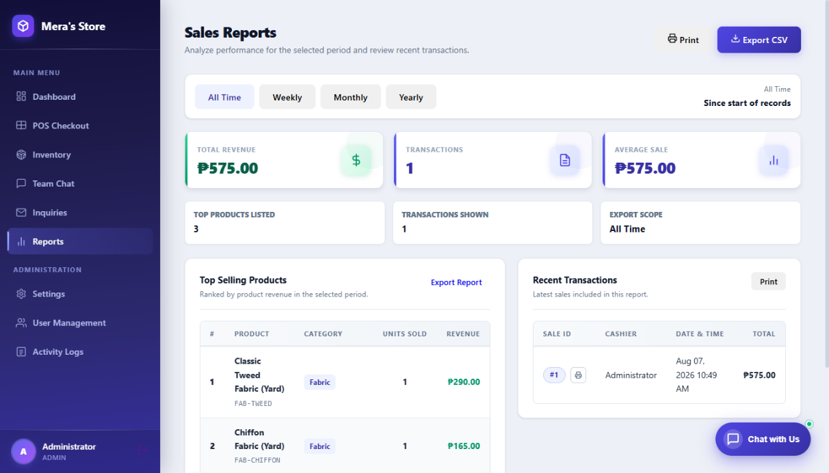
Figure 6. Stokivo as the nearest prior arts of Mera’s General Merchandise Store Management System with POS and Chatsupport.
LinkedId
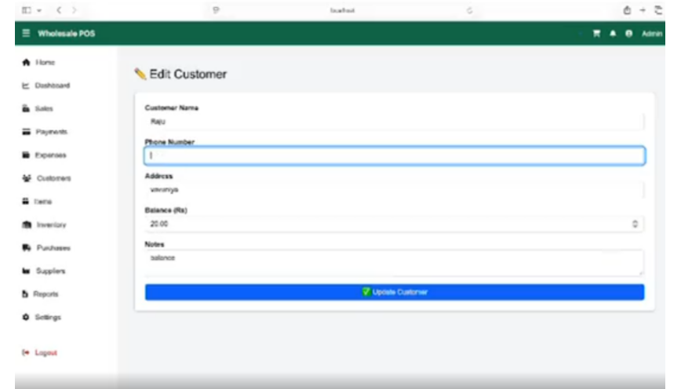
ImageSource: https://www.linkedin.com/posts/thulasi-suthakaran-3329b6381_aspnet-csharp-mysql-activity-7460233150674382848-EoqM?utm_source=social_share_send&utm_medium=member_desktop_web&rcm=ACoAAGkWq58BP1eEmaK3SlC4LJAwlCrY6HkehG8
This Wholesale POS Management System is a business management solution aimed at wholesale and retail operations. Its purpose is to provide a centralized, digital platform for handling transactions, inventory, and financial tracking.
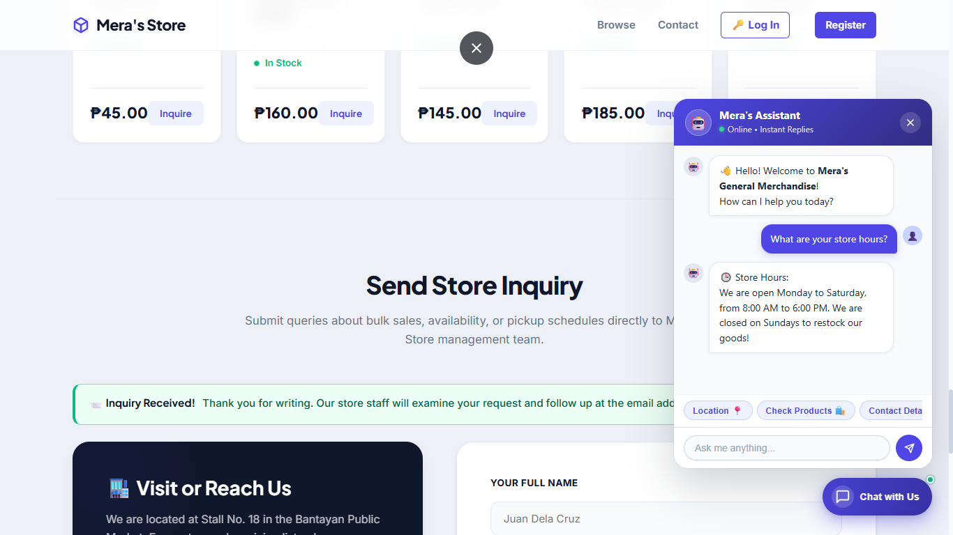
Figure 7.LinkedIn. as the nearest prior arts of Mera’s General Merchandise Store Management System with POS and Chatsupport.
LinkedId
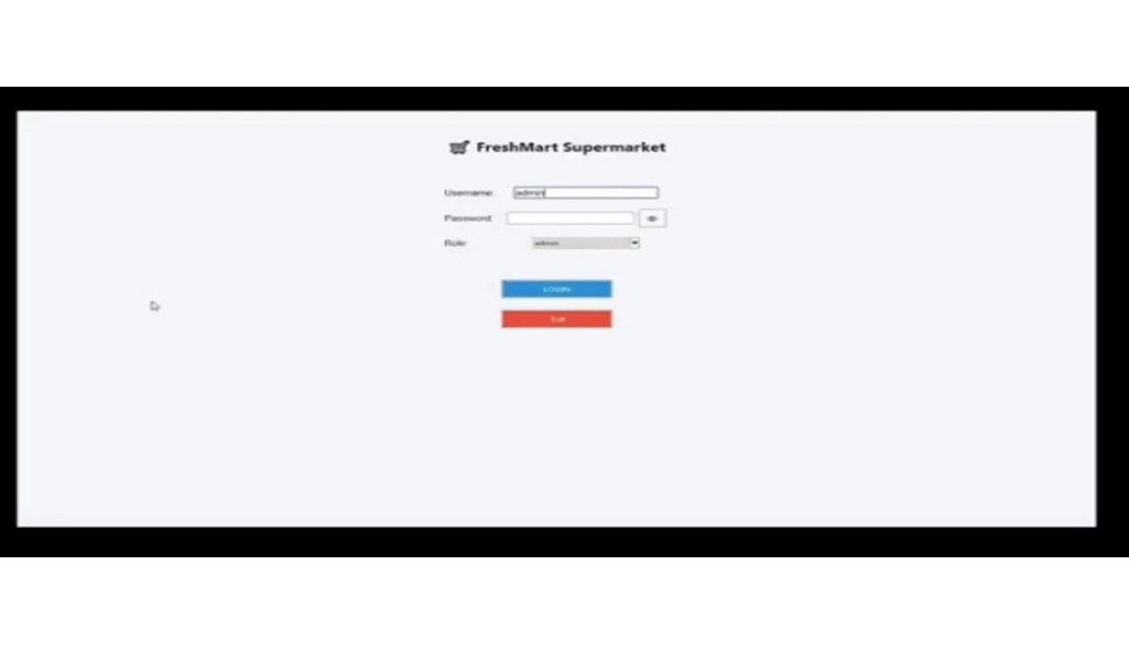
ImageSource:https://www.linkedin.com/posts/muhammadahmed856_python-sqlserver-tkinter-activity-7460206910248771584fIAz?utm_medium=ios_app&rcm=ACoAAGjsVC4BFilCxfd6GsUzM9gGGVWO8EfhQWk&utm_source=social_share_send&utm_campaign=copy_link
The LinkedIn post demonstrating a retail shop management application built with Python, SQL Server, and Tkinter is covered by prior art, since the integration of Python GUIs (Tkinter) with relational databases like SQL Server for point-of-sale and inventory systems has been widely documented in open-source projects, academic tutorials, and commercial POS frameworks well before this disclosure; therefore, the work represents an application of existing, publicly available technologies rather than a novel invention.
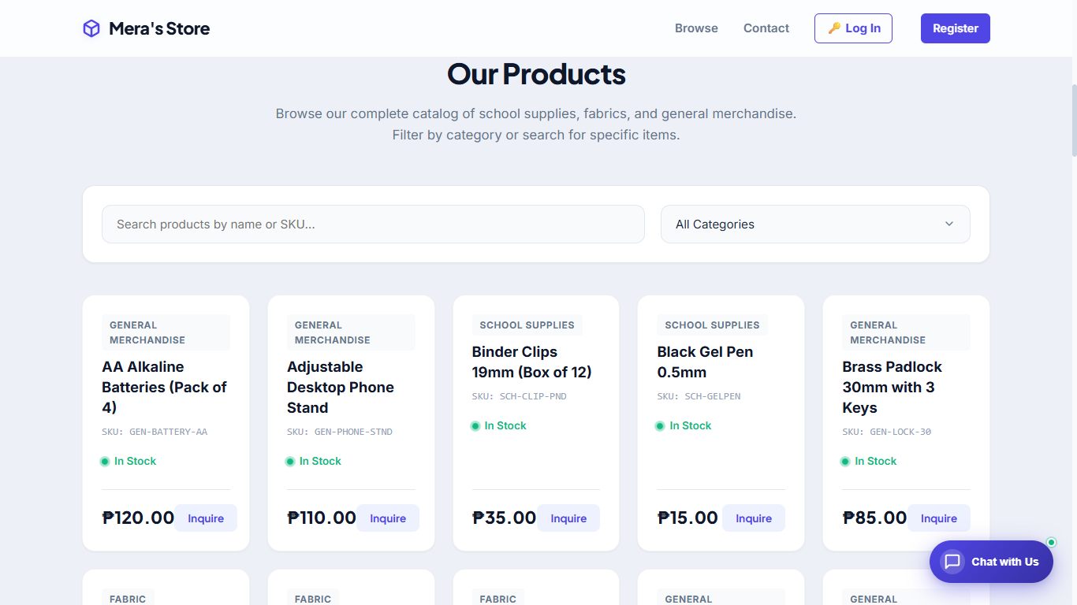
Figure 8.LinkedIn. as the nearest prior arts of Mera’s General Merchandise Store Management System with POS and Chatsupport.
LinkedId
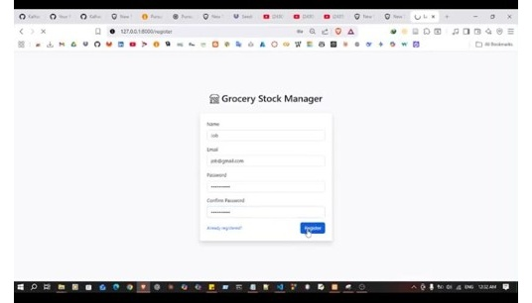
ImageSource: https://www.linkedin.com/posts/pasan-kalhara_webdevelopment-php-mysql-activity-7460759529073324033-3-gu
The LinkedIn post showcasing a web development project using PHP and MySQL for store or retail management is covered by prior art, since the combination of PHP for server-side scripting and MySQL for database management has been extensively documented and implemented in countless open-source projects, tutorials, academic coursework, and commercial retail systems for more than two decades; therefore, this disclosure represents a routine application of well-established technologies rather than a novel invention.
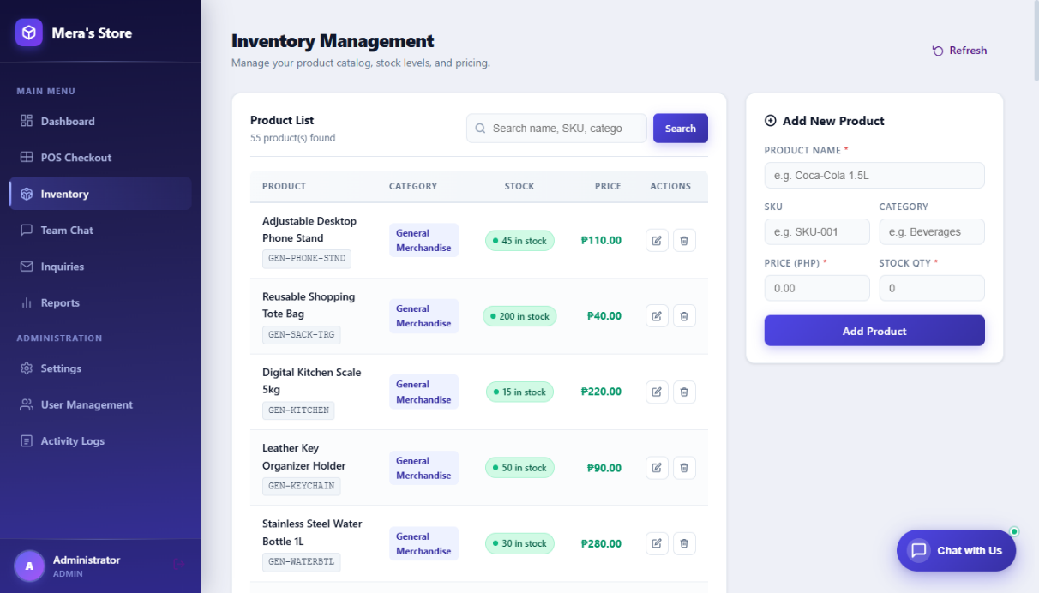
Figure 9. LinkedIn. as the nearest prior arts of Mera’s General Merchandise Store Management System with POS and Chatsupport.
LinkedId
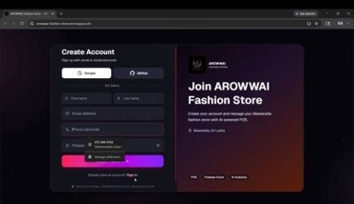
Source: https://www.linkedin.com/posts/mohommadhu-afnan-27b958291_fullstackdevelopment-nextjs-react-activity-7463434614586396673-dHwT
The LinkedIn post presenting a full-stack development project using Next.js and React is covered by prior art, since the use of Next.js as a React framework for building web applications has been extensively documented and implemented in open-source repositories, tutorials, academic coursework, and commercial platforms for years; therefore, this disclosure represents a standard application of well-established technologies rather than a novel invention.
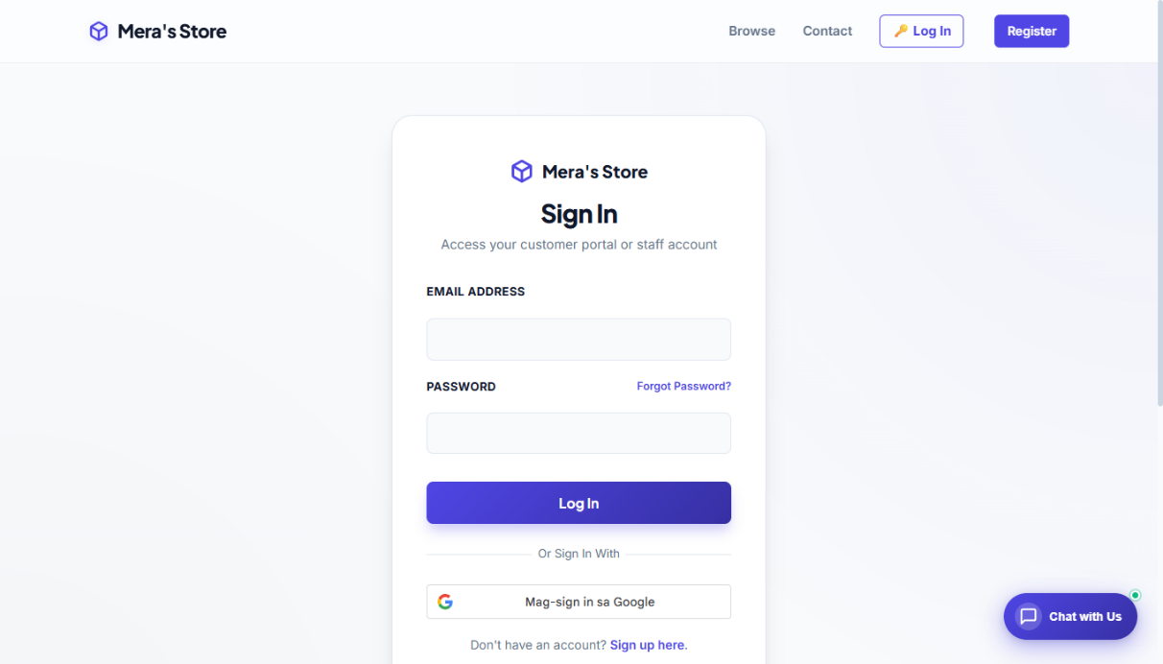
Figure 10. LinkedIn. as the nearest prior arts of Mera’s General Merchandise Store Management System with POS and Chatsupport.
LinkedId
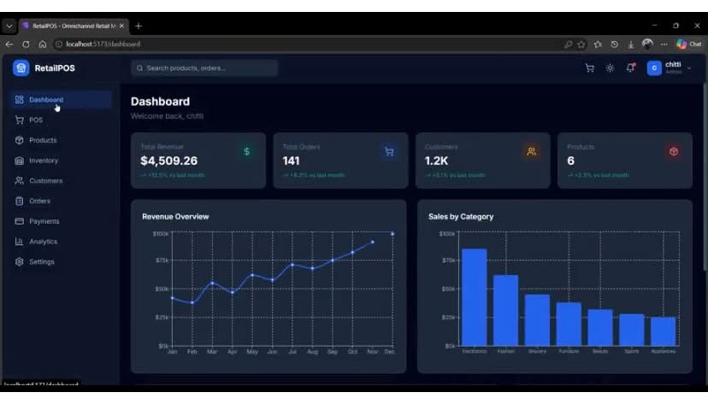
ImageSource:https://www.linkedin.com/posts/borigishreeka_fullstackdevelopment-webdevelopment-javascript-activity-7465295679544819713-pdFp?utm_medium=ios_app&rcm=ACoAAGjsVC4BFilCxfd6GsUzM9gGGVWO8EfhQWk&utm_source=social_share_send&utm_campaign=copy_link
The direct prior art for Borigi Shreeka’s Omnichannel Retail POS project is Amazon’s retail platform, Flipkart’s e-commerce system, and POS solutions like Square POS and Lightspeed POS. These systems had already implemented secure login, inventory management, customer handling, checkout, payments, analytics, and multi-store support before this project, making them clear precedents.
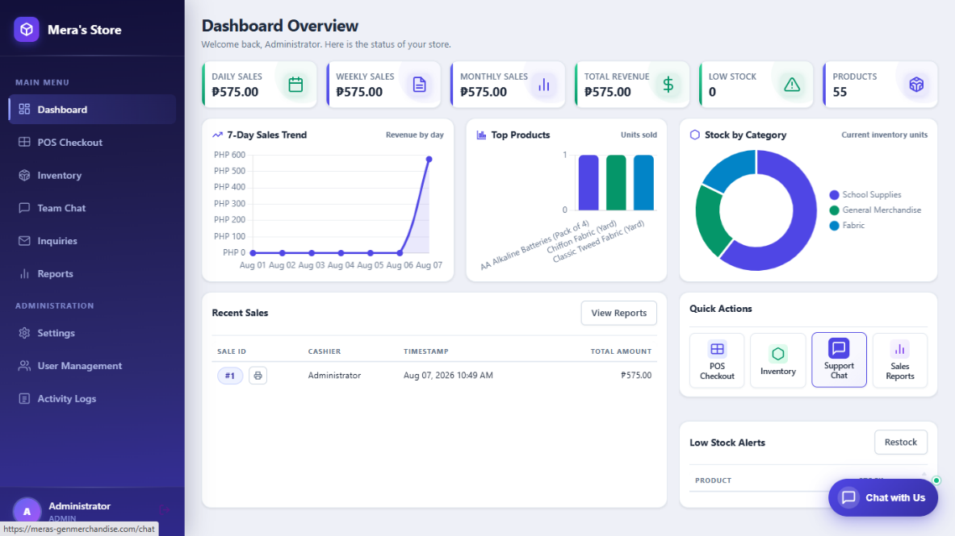
Figure 11. LinkedIn. as the nearest prior arts of Mera’s General Merchandise Store Management System with POS and Chatsupport.
LinkedIn
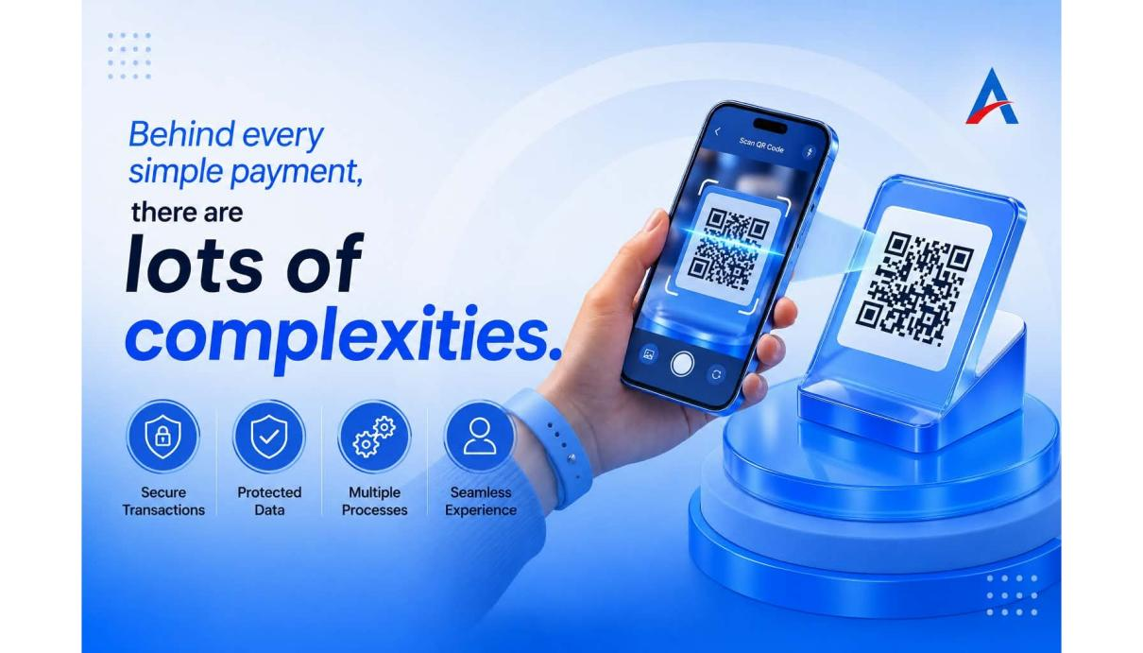
ImageSource: https://www.linkedin.com/posts/ascertaintechnologies_behind-every-simple-payment-activity-7498210228945960960-Xez7
This figure shows the Android mobile application for Mera’s General Merchandise Store. It allows merchants to manage products, inventory, orders, sales, and customer inquiries, while customers can browse products, place orders, track orders, use chat support, and view purchase history through their Android smartphones.
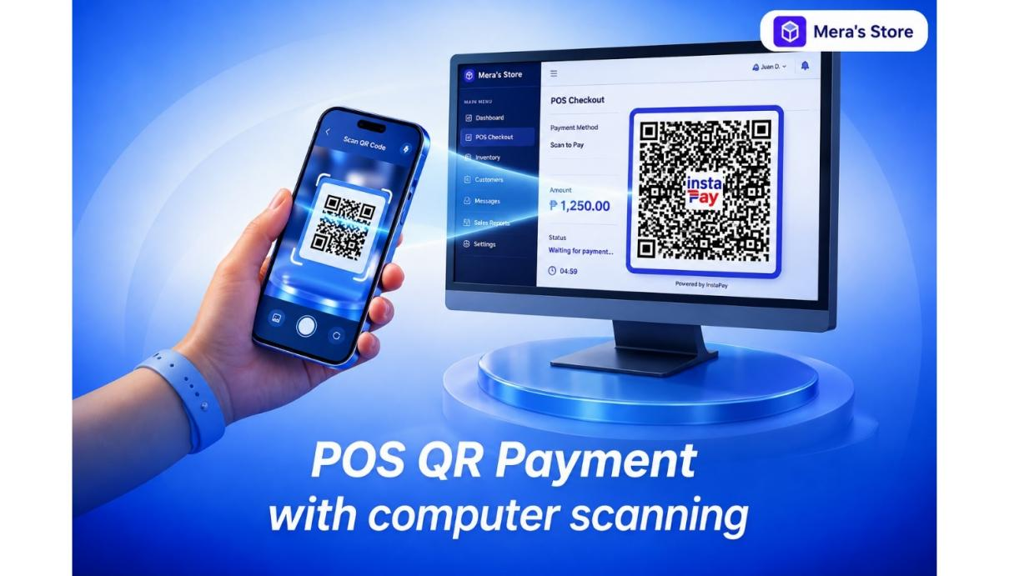
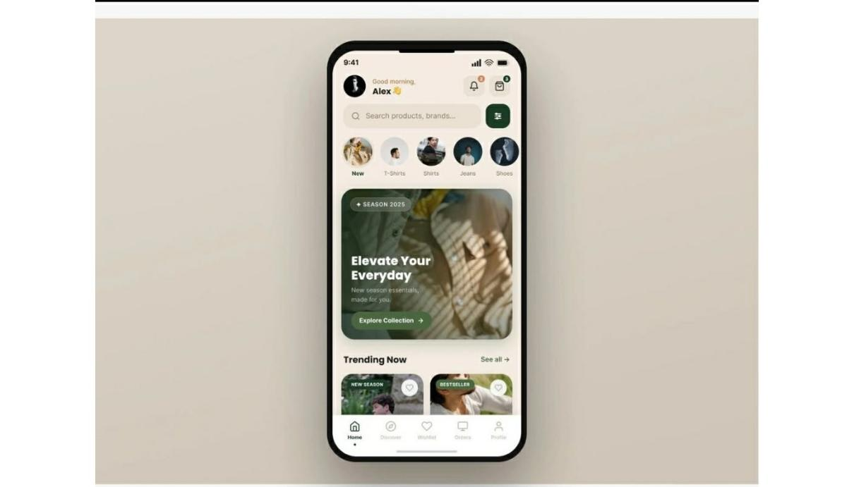
Figure 12. LinkedIn. as the nearest prior arts of Mera’s General Merchandise Store Management System with POS and Chatsuport.

LinkedIn
Imagesource: https://lnkd.in/p/gZqkuFTx
This figure is considered a nearest prior art because it shows a mobile shopping application with product browsing, categories, search, and customer navigation similar to Mera’s Android mobile application. However, Mera’s application includes additional features such as ordering, chat support, order tracking, purchase history, and GCash payment.
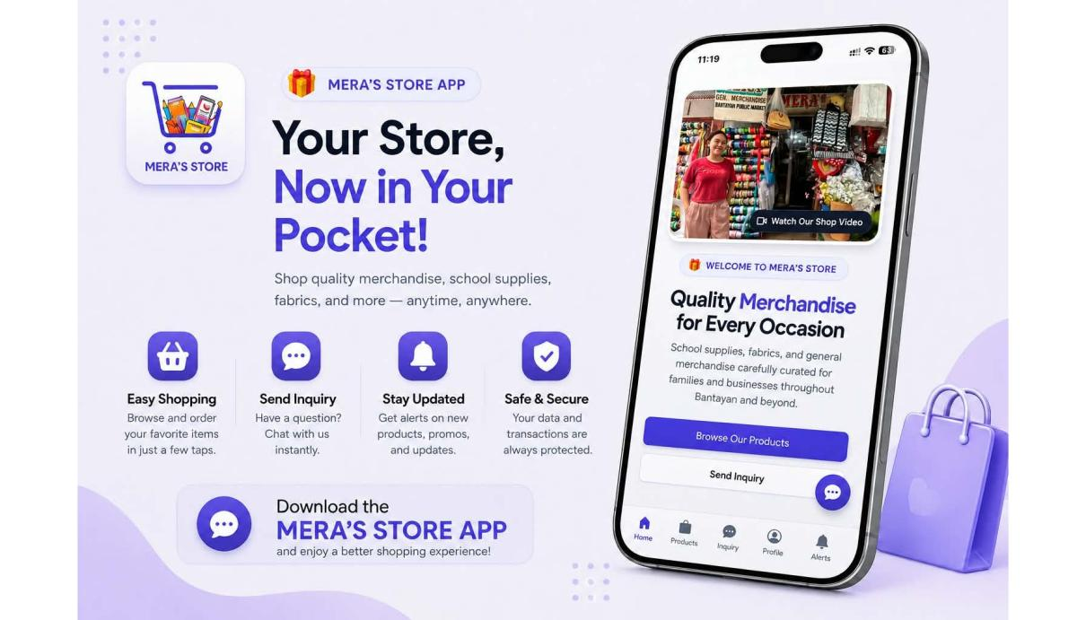
Figure 13 LinkedIn. as the nearest prior arts of Mera’s General Merchandise Store Management System with POS and Chatsuport.

Synthesis
The Mera’s General Merchandise Store Management System with POS and Chat Support addresses the inefficiencies of manual store operations by integrating three core elements: speed, accuracy, and communication. Its POS feature ensures fast, error-free transactions, the inventory module provides real-time stock monitoring to prevent shortages or overstocking, and the chat support enhances customer interaction and trust. What makes the system unique is its ability to synthesize strengths from prior industry systems, borrowing order flow from restaurants, expiry tracking from pharmacies, and financial reporting from wholesale platforms—into one comprehensive tool. Guided by the IPO framework, input like customer and product data are processed through POS, inventory, and chat functions to produce output such as faster service, accurate reports, and improved customer satisfaction. Overall, the system embodies literature’s call for solutions that are functional, user-friendly, reliable, and secure.
CHAPTER III
METHODOLOGY
This chapter walks through the methodology behind the development of Mera’s General Merchandise Store Management System with POS and Chat Support. It covers every stage of the process, from gathering requirements and designing the system down to coding, testing, and handing the system over to the store for actual use, and it explains how the system was evaluated.

Research Design
This study used the developmental research design supported by descriptive evaluation. Developmental research was a good fit because the researchers set out to design, build, and refine a working software product that answers a real business need: the manual handling of sales, inventory, reports, and customer communication at Mera’s General Merchandise Store. The descriptive part of the design was used to gather and describe how respondents rated the quality and usability of the finished system.
The team followed the Agile development model, specifically an iterative, Scrum-based approach. Agile made sense for this project because the system is made up of several connected modules, such as the POS, inventory, reports, mobile application, chat support, and GCash payment, which could be built, tested, and improved in short cycles. Since the system serves four types of users (the Administrator, Merchant, Cashier, and Customer), each with different needs, it was important to put working parts in front of the store owner and employees early instead of planning everything in isolation.
Sprint cycles, a prioritized product backlog, and regular reviews gave the researchers a way to break the work into manageable pieces and stay responsive whenever requirements changed. It also let them show progress at regular intervals, which helped catch problems before they became expensive to fix.

Development Methodology: System Development Life Cycle (SDLC)
The development followed six phases based on the Agile life cycle. Figure 14 below shows the overall flow and how each phase feeds into the next.
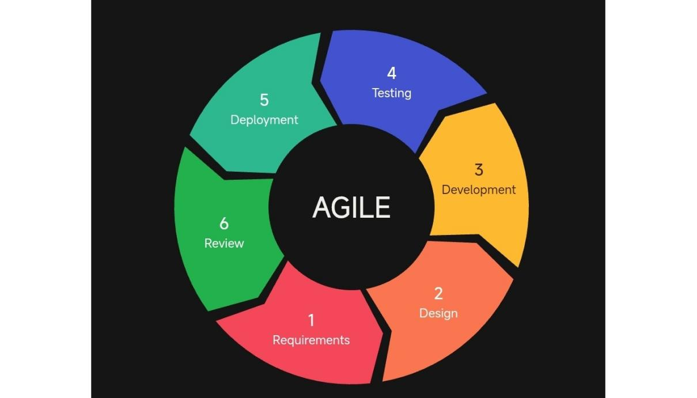
Figure 14. Agile Development Model Applied in the Study

Phase 1: Planning and Requirements Gathering
The first thing the researchers needed to do was understand the actual problem. How are sales recorded? How is stock checked? How are reports prepared, and how do customers send their inquiries? To answer these questions, the researchers spent time with the people directly involved in running the store.
During this phase, the researchers:
- Interview. Interviewed the store owner and employees to find out how sales are recorded, how stock is monitored, how reports are prepared, how customer inquiries are received, and what difficulties they experience in these activities.
- Observation. Observed the daily operations of the store, particularly the handling of sales transactions, the checking of stock, and the receiving of customer inquiries.
- Document analysis. Examined existing records such as sales records, receipts, and stock lists to determine the data that the system had to store and produce.
- Review of related systems. Studied the related literature and prior arts presented in Chapter II to identify features that would be useful for the system.
- Planning. Defined the objectives and scope of the system, identified the four user roles, and prepared a product backlog, a prioritized list of every feature and task that guided the rest of the development.
The information gathered was organized into functional and non-functional requirements. The functional requirements for each type of user were as follows:
- Administrator. Create sales records and process transactions; read customer inquiries; update product information, stock quantities, and prices; delete incorrect sales entries, discontinued products, inactive accounts, spam messages, unnecessary report files, and outdated configurations; view the dashboard; generate, export (CSV), and print sales reports; manage user accounts and system settings; and recover the account through the registered email address.
- Merchant. Manage products and inventory; receive and process customer orders; view sales summaries; respond to customer inquiries; and receive low-stock notifications through the mobile application.
- Cashier. Log in to the system; process POS transactions; accept cash and GCash payments; and generate receipts.
- Customer. Register and verify the email address; log in and recover the account through a password reset link; browse and search products; add items to the cart; place orders or reservations; pay through GCash; monitor order status; communicate with the store through chat support; and view purchase history.
The non-functional requirements were based on the quality characteristics of ISO/IEC 25010:
- Functionality. All modules must perform the functions specified in the objectives and produce correct results, such as accurate totals, stock deductions, and report figures.
- Usability. The interfaces must be simple, consistent, and easy to learn, even for users with limited technical knowledge.
- Reliability. Transactions must be saved completely and consistently, and stored records must remain available to authorized users.
- Efficiency. Common actions such as searching a product, checking out, and loading the dashboard must respond within a reasonable time under normal store use.
- Security. Passwords must be stored in hashed form; access must be based on user roles; email verification and password reset links or OTPs must expire; data transmitted between the applications and the server must be protected; and GCash payment details must be processed through the payment gateway and not stored by the system.
- Maintainability. The system must be built in separate modules with organized and documented code so that errors can be corrected and features can be updated easily.
By the end of this phase, the researchers had a clear understanding of what the system needed to accomplish and a roadmap for building it.

Phase 2: System Design
Once the requirements were clear, the researchers moved into designing the system, both how it would look and how it would work behind the scenes. Instead of trying to get the design perfect on the first attempt, the layouts were prepared, shown to the store owner and employees, and revised based on their comments.
Here is what the researchers worked on:
- Prepared the system architecture showing how the web admin portal and the Android application communicate with the application server, the MySQL database, and the external email and GCash services.
- Drew the use case diagram and the context diagram to show how the Administrator, Merchant, Cashier, and Customer interact with the system and what data flow between the system and its external entities.
- Designed the entity relationship diagram and database schema, mapping out the tables for users, categories, products, sales, sale items, orders, payments, chat messages, and account tokens.
- Prepared flowcharts and user interface layouts for the web portal and the mobile application.
The goal throughout this phase was to let the people who would actually use the system shape its design, so the final product would feel natural to them rather than something they had to figure out on their own.

Phase 3: Development
This is where most of the actual coding took place. The researchers organized the work into six Scrum sprints. Each sprint delivered a working set of modules that were coded, integrated, and reviewed before the next sprint began. The sprints were structured as follows:
- Sprint 1 – Account Management and Security: Built user registration, login, role-based access, email verification, and password recovery through an email reset link.
- Sprint 2 – Product and Inventory Management: Developed the product and category records, stock quantity and price updates, and low-stock detection.
- Sprint 3 – POS and Payment: Built the cart and checkout, receipt generation, cash and GCash payment, and automatic stock deduction.
- Sprint 4 – Dashboard and Reports: Developed the dashboard indicators and charts; the daily, weekly, monthly, and yearly sales reports; top-selling products; recent transactions; and CSV export and printing.
- Sprint 5 – Mobile Application and Chat Support: Built the Android application for merchants and customers, including ordering, purchase history, and chat support.
- Sprint 6 – Integration and Refinement: Conducted system-wide testing, corrected remaining errors, refined the interface based on user feedback, and prepared the system for evaluation.
After each sprint, the store owner and employees reviewed the delivered features and pointed out anything that needed adjusting. This kept the development aligned with what users actually needed rather than what the researchers assumed they needed.

Phase 4: Testing
Testing was not a one-time event at the end. Each time a sprint was finished, its output was tested for correctness, security, and usability so that errors could be caught while they were still small and easy to fix. The system was tested at four levels:
- Unit Testing – Individual functions and modules, such as login, product entry, and total computation, were tested one at a time.
- Integration Testing – Connected modules were tested together to confirm that data moved correctly between them, for example that a completed sale updates the inventory and appears in the reports.
- System Testing – The complete system was tested as a whole, including the web portal, the mobile application, and the connection to the email, SMS, and GCash services.
- User Acceptance Testing (UAT) – The store owner, employees, and sample customers tried the system to confirm that it met their needs.
Errors found at each level were documented and corrected, and the affected features were tested again. Examples of the test cases used include the following:
- Registration. Registering a customer with a valid email address creates the account and sends a verification email; login is allowed only after verification.
- Login. A wrong password is rejected and an error message is displayed.
- Password reset. A reset link or OTP is sent to a registered email and expires after use or after the allowed time.
- POS sale. A sale with items in stock computes the correct total, generates a receipt, and deducts the stock.
- Stock limit. A quantity greater than the available stock is rejected and the user is informed.
- Low stock. Reducing a product to its reorder level shows a low-stock alert on the dashboard and in the merchant application.
- GCash payment. A successful payment is recorded with a digital receipt, while a failed payment does not mark the order as paid.
- Reports. A daily sales report matches the recorded sales and can be exported to CSV.
- Chat. A message sent by a customer appears to the administrator or merchant, and the reply appears to the customer.

Phase 5: Deployment
Once the system was built and tested, the tested system was installed and made available to the store for actual use. The web admin portal and POS were made available on the store computer, and the Android application was provided to merchants and customers so that they could use the system from their phones.

Phase 6: Review and Feedback
The final phase focused on making sure the transition from the old manual process to the new system went smoothly. The store owner, employees, and sample customers used the system and gave their comments, which were used for refinements, and the final version was evaluated using the instruments described in the Evaluation Method below.

Summary of Agile Practices Integrated into the Development
Throughout the six phases, the researchers relied on several Agile practices to stay organized and keep the store in the loop. The table below outlines each practice and how it was applied.
Table 1. Agile Practices Used in the Development
Agile Practice | How It Was Used
Product Backlog | A running list of all features ranked by priority. It was updated as the researchers learned more about what the store needed.
Sprint Cycles | Development was split into six short sprints, each delivering a working piece of the system that could be reviewed and tested.
Sprint Reviews | At the end of each sprint, the researchers presented what they had built to the store owner and employees and collected feedback.
Iterative Refinement | Feedback was not just noted. It was incorporated into the next sprint, so the system kept improving with each cycle.
Incremental Delivery | The system was delivered in working increments, from account management up to mobile ordering and chat support, instead of all at once.

Tools and Technologies
The following tools and technologies were used in building the system. They were selected based on what the researchers were comfortable with, what was freely available, and what fit the project’s requirements for a web-based platform with a database backend, a mobile application, and integrated features such as chat support and GCash payment.
- Web Front-End – HTML5, CSS3, JavaScript
- Server-Side – PHP
- Database – MySQL
- Mobile Application – Android Studio
- Local Server – XAMPP (Apache, MySQL)
- Code Editor – Visual Studio Code
- Version Control – Git and GitHub
- Deployemnt - Hostinger(720 pesos)
- Design Tools – draw.io, Figma
- Email and SMS – SMTP email service, SMS gateway
- Online Payment – GCash payment gateway
- Testing – Web browsers, Android emulator and device, Postman
The hardware used in the development and testing of the system is listed below.
- Development Computer – Laptop or desktop computer with at least an Intel Core i5 (or equivalent) processor, 8 GB RAM, and 256 GB storage
- Android Device – Smartphone running Android 8.0 or higher
- Store Computer (POS) – Desktop or laptop computer with a modern web browser
- Receipt Printer – Thermal or standard printer for receipts and reports
- Network – Stable internet connection for the web portal, mobile application, email and SMS, and GCash payment

Evaluation Method
To measure whether the system achieved what it set out to do, the researchers prepared structured questionnaires and distributed them to 42 respondents selected through purposive sampling, since only those with knowledge of, or direct experience with, the store operations or information systems could properly evaluate the system. The respondents were the store owner and merchants (2), the store employees (5), the customers (30), and IT experts (5). The IT experts evaluated the software quality of the system using the ISO/IEC 25010:2011 Systems and Software Quality Model, while the store owner, employees, and customers evaluated its usability using a questionnaire patterned after the USE Questionnaire of Lund (2001). The evaluation looked at the system from the following angles:
- Functionality – Are the features (POS, inventory, reports, chat, orders, GCash payment) complete, and do they work correctly?
- Usability – Is the system easy to understand, learn, and operate?
- Reliability – Does the system operate consistently and keep records correctly?
- Efficiency – Does the system respond quickly and use resources appropriately?
- Security – Are accounts, data, and payment processing protected from unauthorized access?
- Maintainability – Can the system be corrected and updated easily?
- Usefulness – Does the system help users complete store tasks and save time and effort?
- Satisfaction – Are users pleased with using the system?
- Ease of Use and Learning – Is the system simple to operate and quick to learn?
Each item used a five-point Likert scale, where 5 means Strongly Agree and 1 means Strongly Disagree. The weighted mean of each criterion was interpreted using the following scale:
- 5 (4.21 – 5.00) – Strongly Functional
- 4 (3.41 – 4.20) – Agree (Very Good)
- 3 (2.61 – 3.40) – Neutral (Good)
- 2 (1.81 – 2.60) – Disagree (Fair)
- 1 (1.00 – 1.80) – Strongly Disagree (Poor)
After the system had been developed and tested, the researchers secured permission from the store owner and the concerned faculty, oriented the respondents on the purpose of the study and on how to use the system, and let them use the web portal or the mobile application according to their roles. The questionnaires were then answered, collected, checked for completeness, and tallied. The weighted mean was used to determine the level of quality and usability of the system, computed as:
WM = Σ(f × x) / N
where WM is the weighted mean, f is the frequency of responses for each rating, x is the value of the rating, and N is the total number of responses. The frequency and percentage will be used to describe the distribution of the respondents, computed as:
The frequency and percentage were used to describe the distribution of the respondents, computed as:
P = (f / N) × 100
where P is the percentage, f is the frequency, and N is the total number of respondents. The computed weighted means will be interpreted using the scale presented earlier in this chapter.

Ethical Considerations
The researchers will follow ethical standards throughout the study. Participation of the respondents will be voluntary, and each respondent will be informed of the purpose of the study and of their right to decline or withdraw at any time. Personal information and responses will be kept confidential, used only for academic purposes, and handled in accordance with the Data Privacy Act of 2012 (Republic Act No. 10173). The permission of the store owner will be secured before the system is tested with actual store data. Within the system itself, user passwords will be stored in hashed form, access will be limited by user role, and payment details will be processed only through the GCash payment gateway and will not be stored by the system. The researchers will also acknowledge all sources used in the study and report the results honestly.

Schedule Feasibility

Gantt Chart
A Gantt chart is a bar chart that presents a project schedule. It lists the project tasks on the vertical axis and the time intervals on the horizontal axis. The length of each bar shows how long an activity takes, along with its start and finish dates.
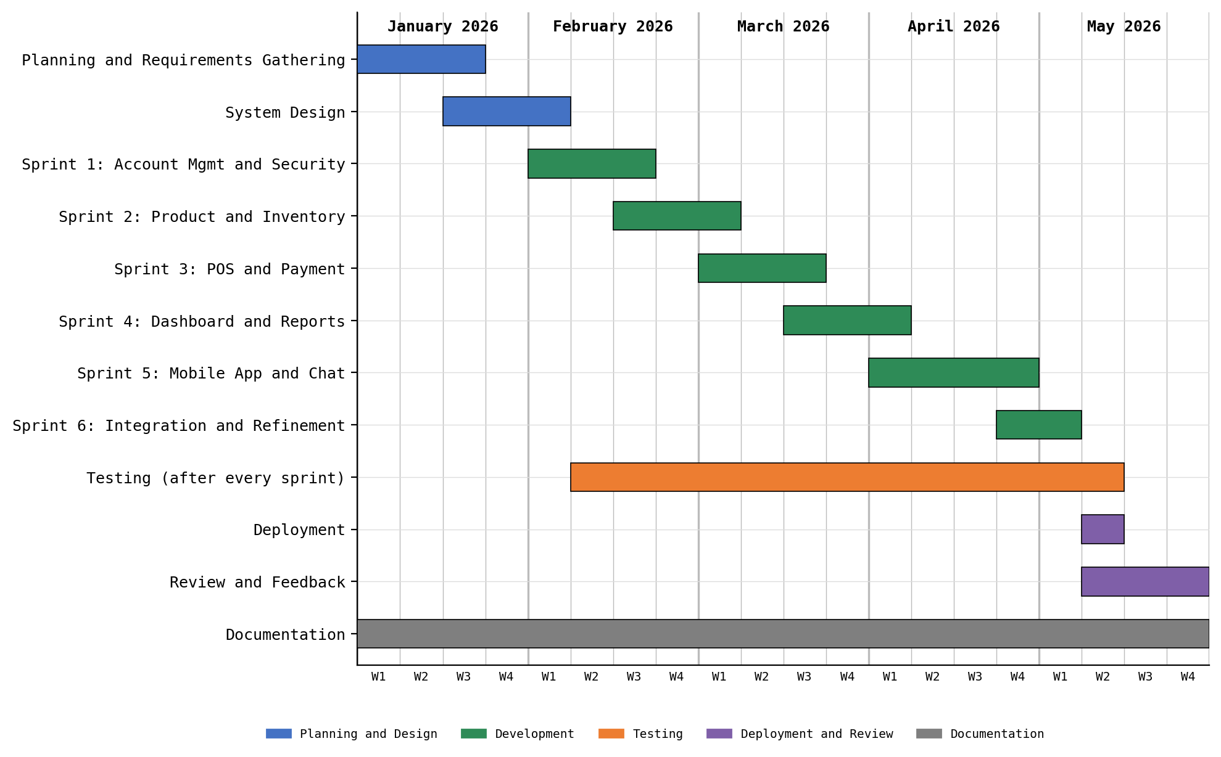
Figure 15. Gantt Chart
Figure 15 shows the timetable of the project, from planning up until the system was fully developed into a working product. It also shows how much time each task needed before its deliverable was finished.

Requirements Modelling

Context Flow Diagram
A context flow diagram, also called a level 0 data flow diagram, shows the whole system as a single process and defines its limits. It stays at a high level and does not go into the detailed inner workings of the system.
Figure 16 presents the context diagram of the system. It shows the data that flow between the system and its external entities: the administrator, merchant, cashier, customer, GCash payment gateway, and email.
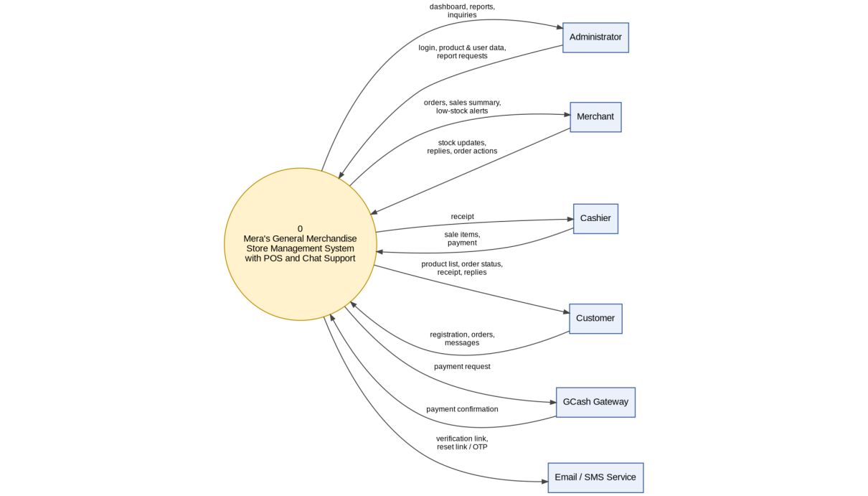
Figure 16. Context Diagram

Data Flow Diagram
A data flow diagram (DFD) shows visually how data move within a system. It illustrates the flow of information between processes, data stores, and external entities, which gives a clear overview of the system’s functions and data interactions. Figure 17 breaks the system down into its main processes.
[Insert the Data Flow Diagram here]
Figure 17. Data Flow Diagram

Use Case Diagram
Figure 18 shows the use case diagram of the system and how the four types of users interact with its main functions. The Administrator has full authority: processing POS transactions, managing inventory, viewing the dashboard, generating sales reports, managing user records and settings, replying to chat messages, and receiving GCash payments. The Merchant manages products and inventory, views the dashboard summary and sales reports, and replies to customer chat. The Cashier logs in to process POS transactions, accepts cash and GCash payments, and generates receipts. The Customer registers, browses products, places orders, pays through GCash, and sends chat messages to the store.
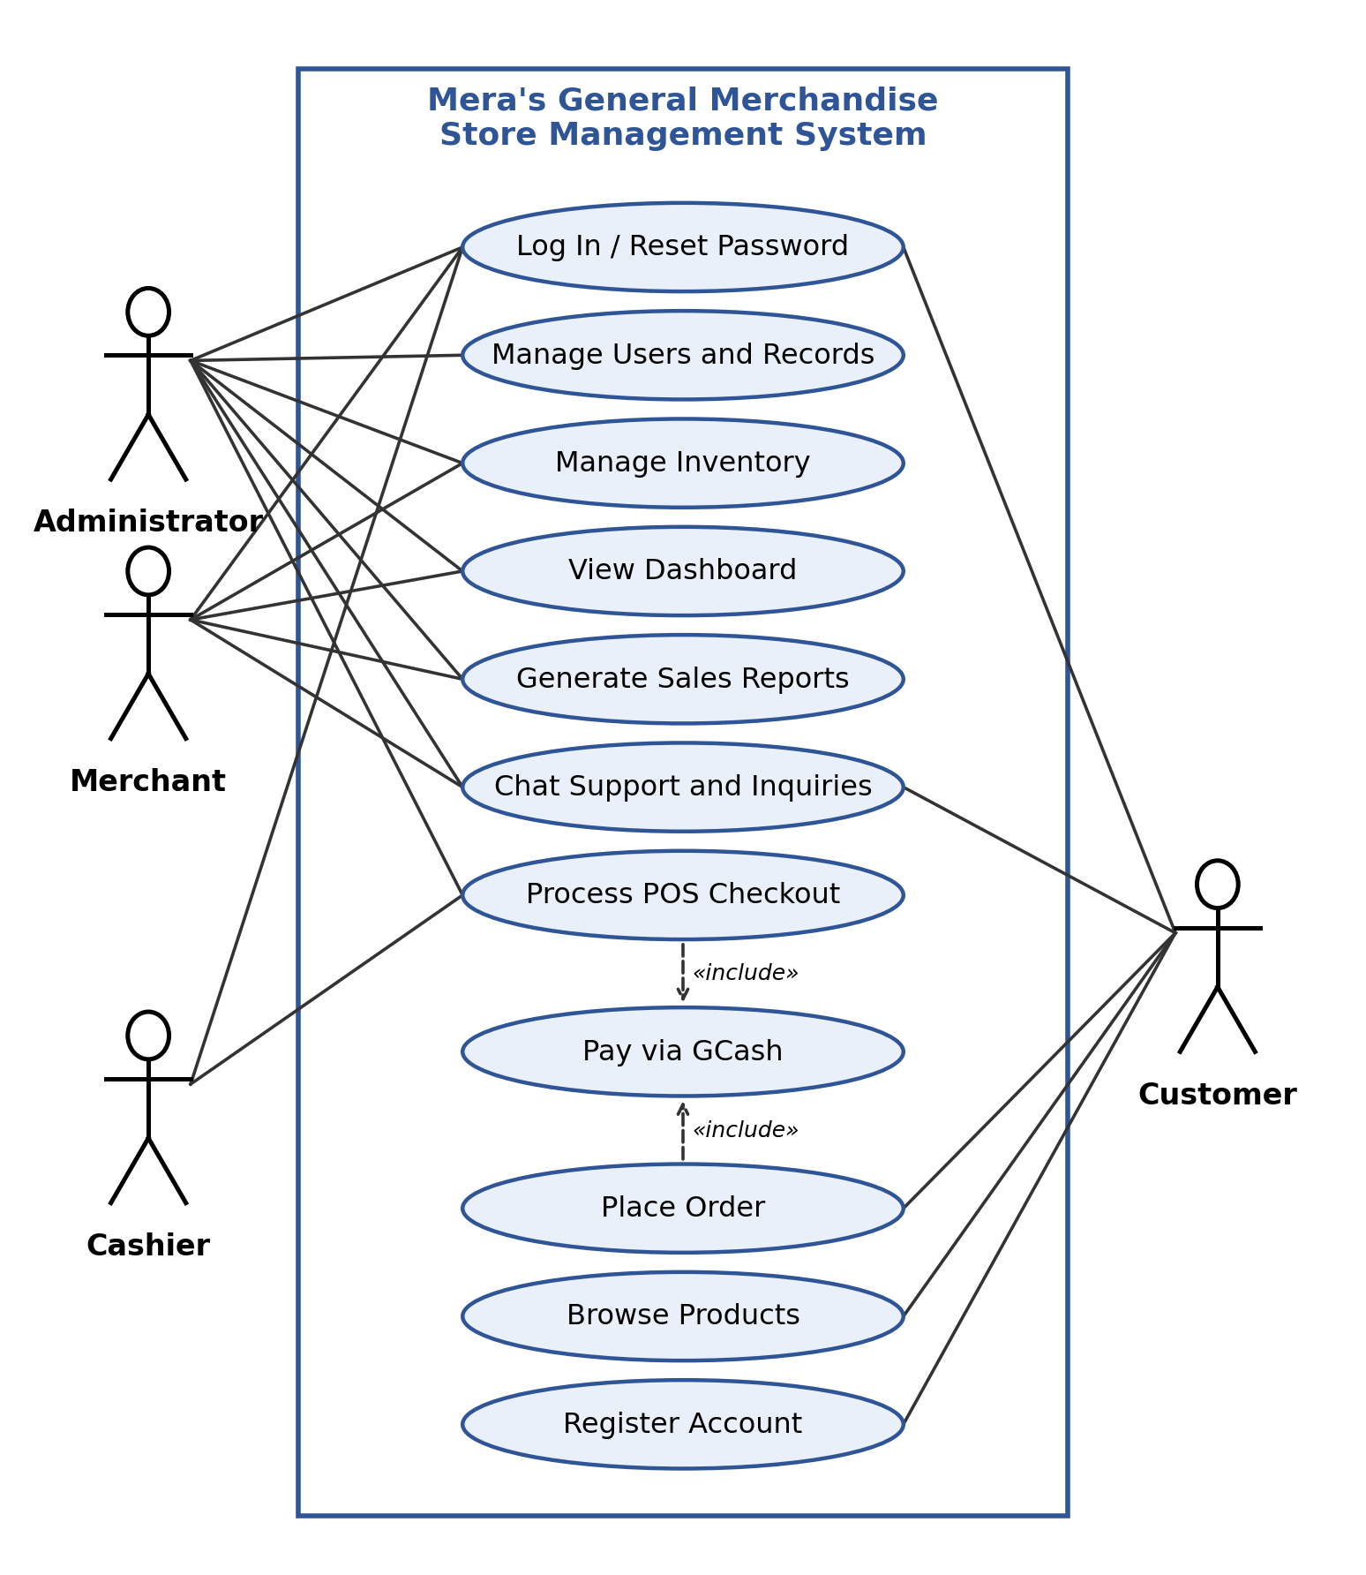
Figure 18. Use Case Diagram

System Architecture
Figure 19 shows the architecture of the system. The web admin portal and the Android mobile application communicate with the application server through secure requests. The application server processes the business logic, including authentication, POS transactions, inventory, orders, reports, and chat, and stores all data in the MySQL database. It also connects to external services for email and for GCash payment processing.
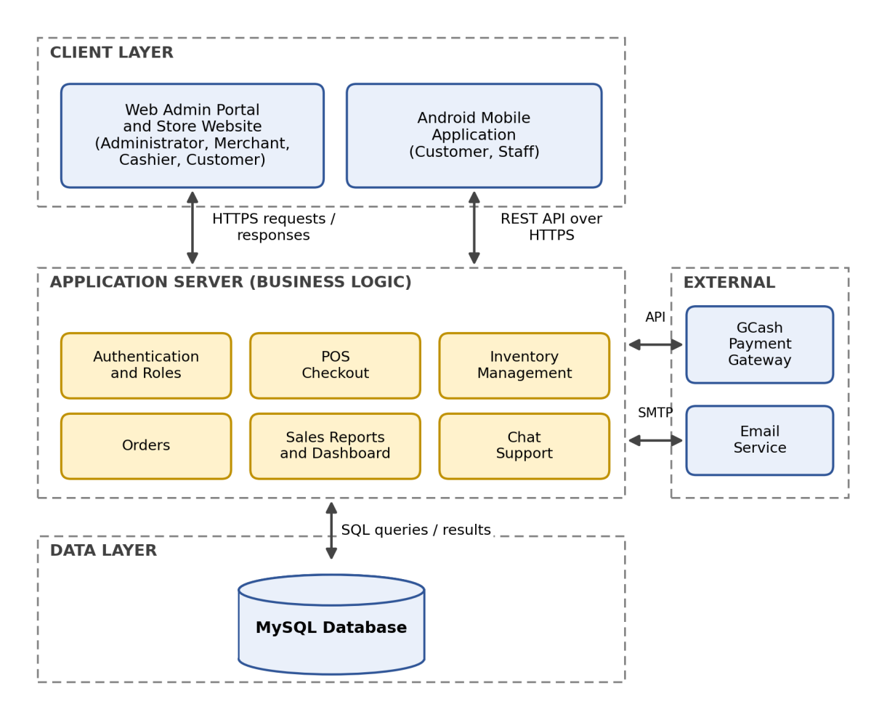
Figure 19. System Architecture

Entity Relationship Diagram
Figure 20 shows the entity relationship diagram of the MySQL database. The design links users, categories, products, sales, sale items, orders, payments, chat messages, and account tokens so that every transaction and communication can be traced and reported accurately. The users table stores the account information, roles, and verification status; the categories and products tables store the items and their stock levels; the sales and sale items tables store each completed transaction; the orders and payments tables store customer orders and payment details, including GCash confirmations; the chat messages table stores the conversations between customers and store personnel; and the account tokens table stores email verification links, password reset links, and OTPs together with their expiry and usage status.
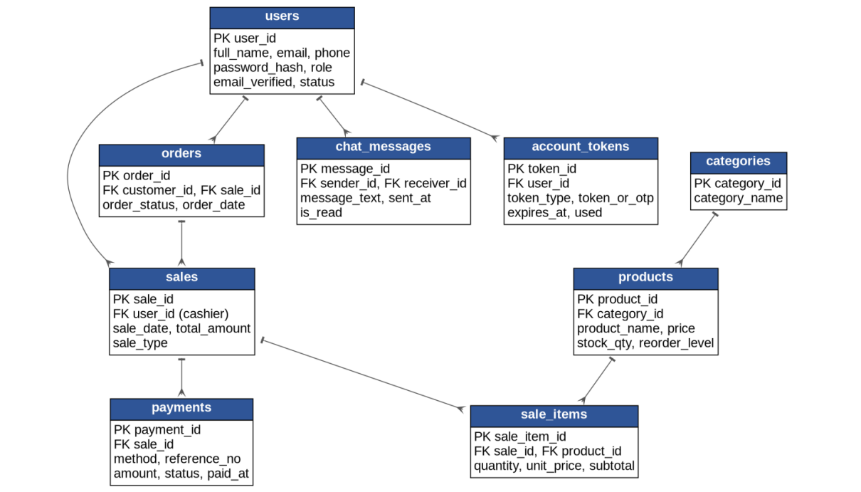
Figure 20. Entity Relationship Diagram

System Flowchart
The flowcharts below trace the MERAS web and mobile system from the moment the URL is entered. An oval marks the start or end, a parallelogram an input, a rectangle a page or process, a diamond a decision, a cylinder a database table, a circle an on-page connector, and a downward pentagon an off-page connector that continues on the chart bearing the same code.
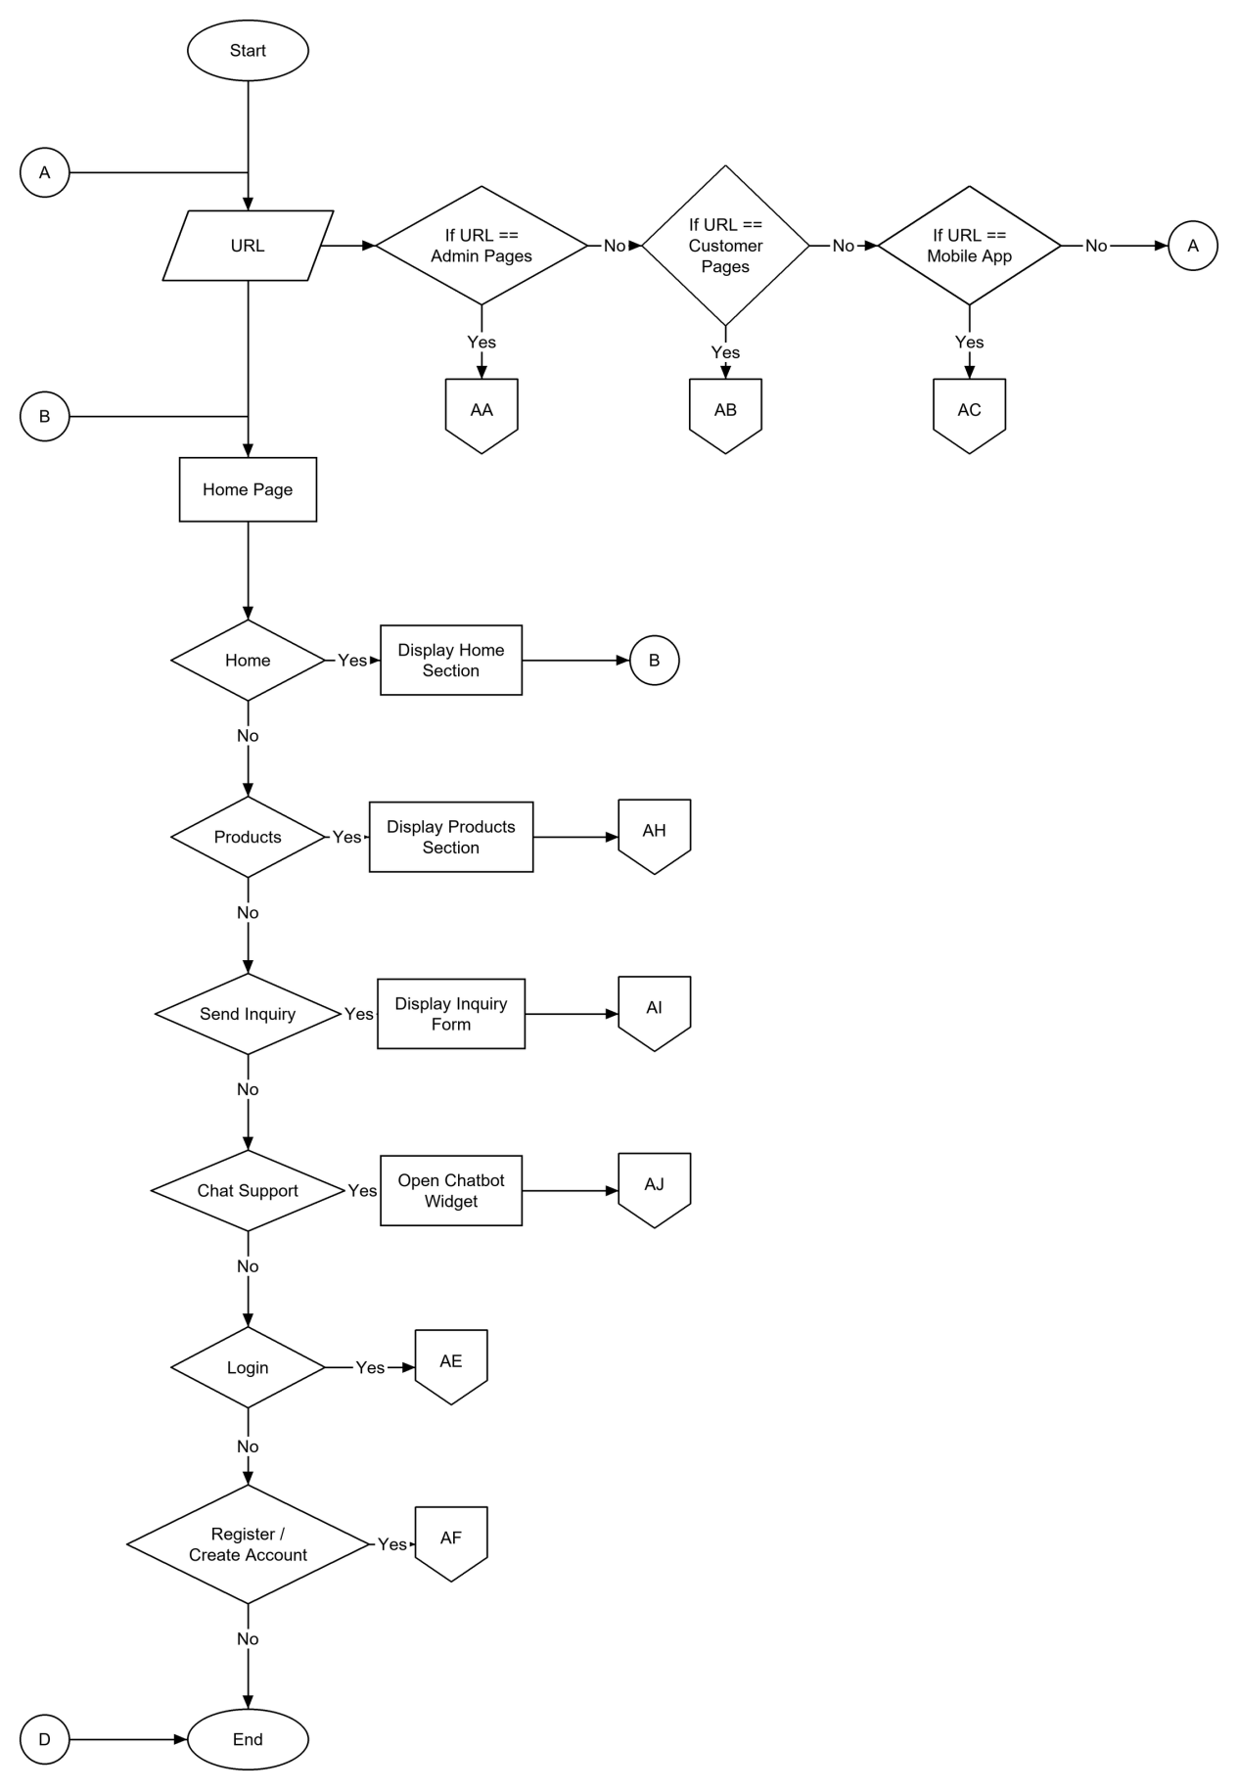
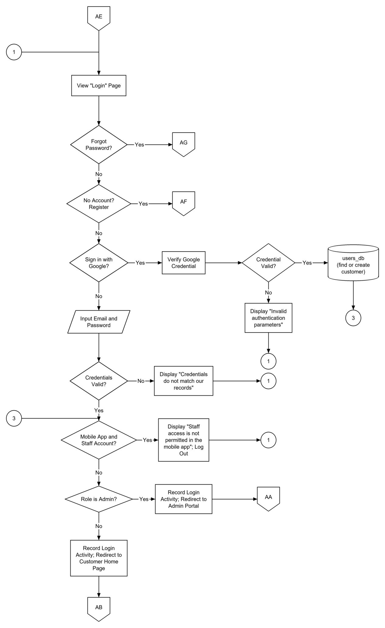
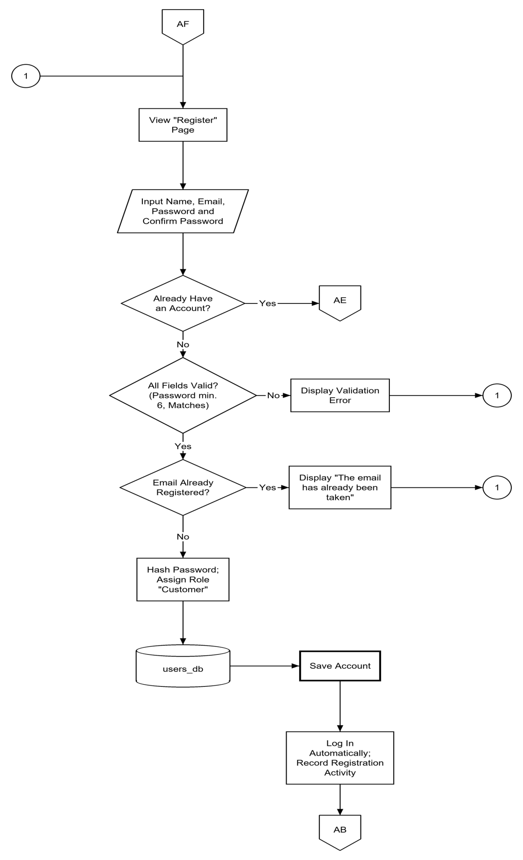
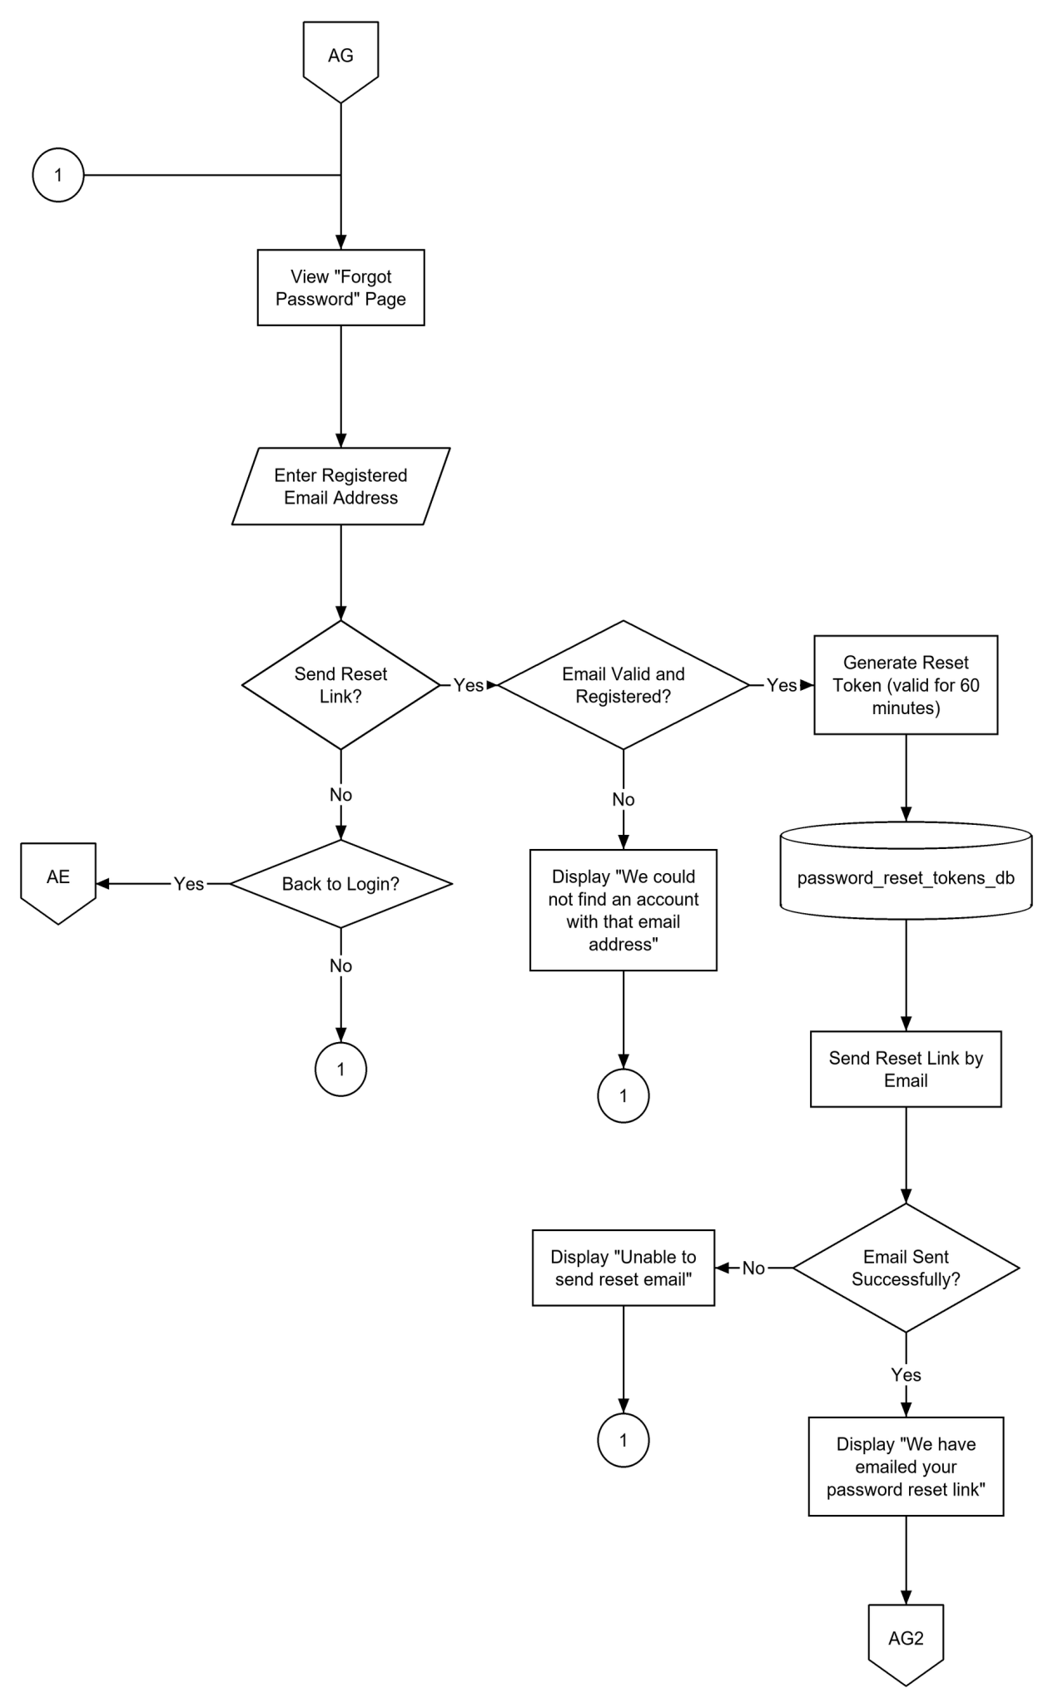
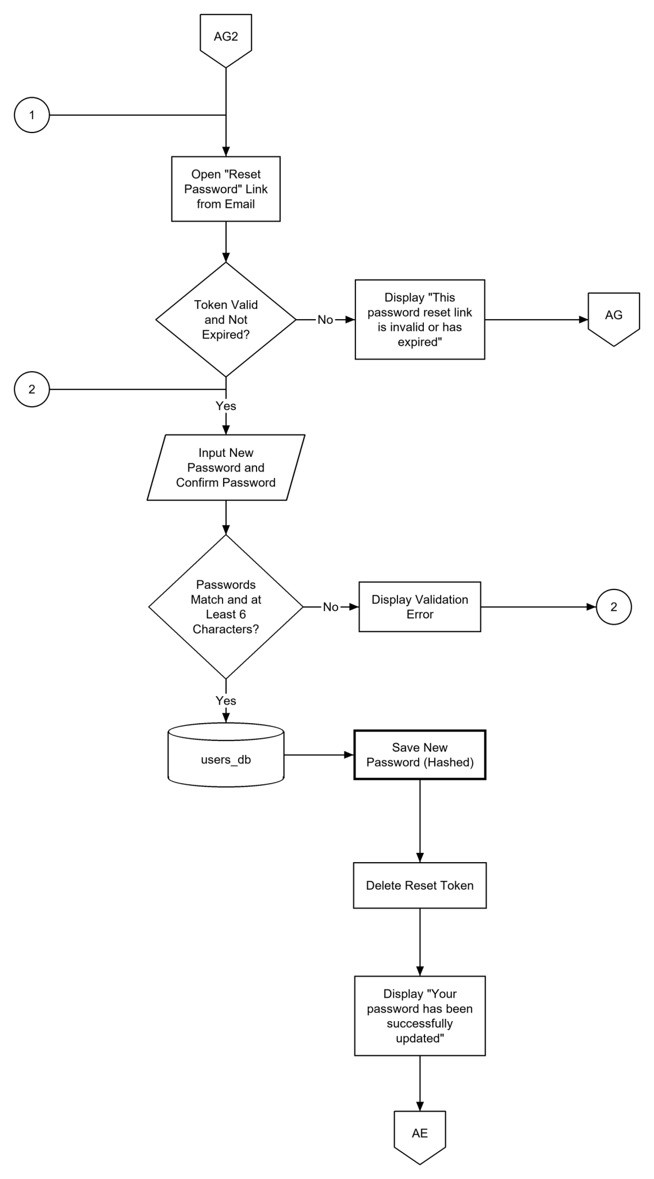
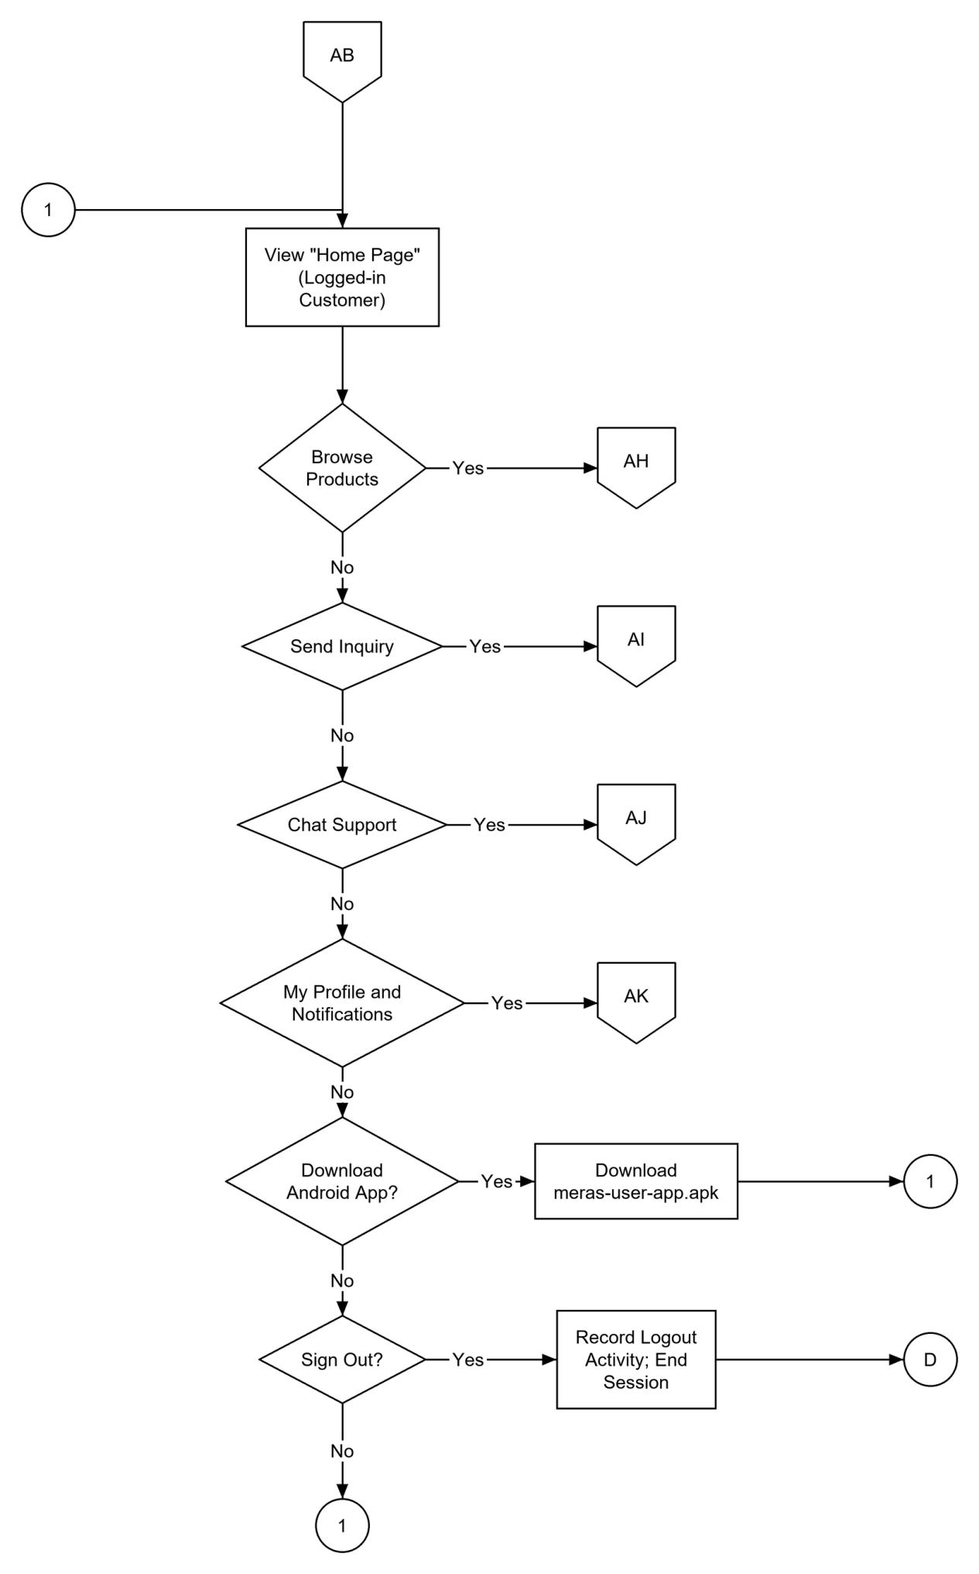
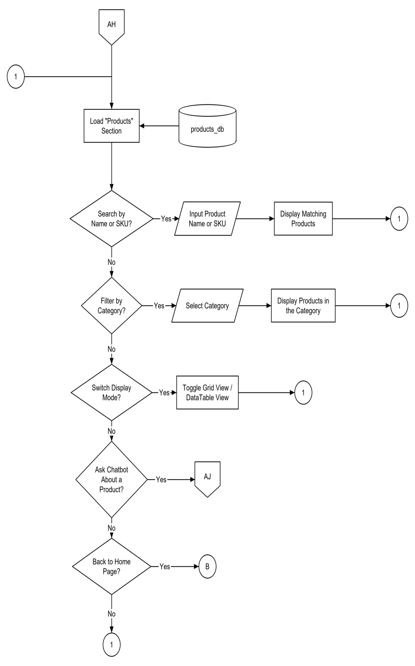
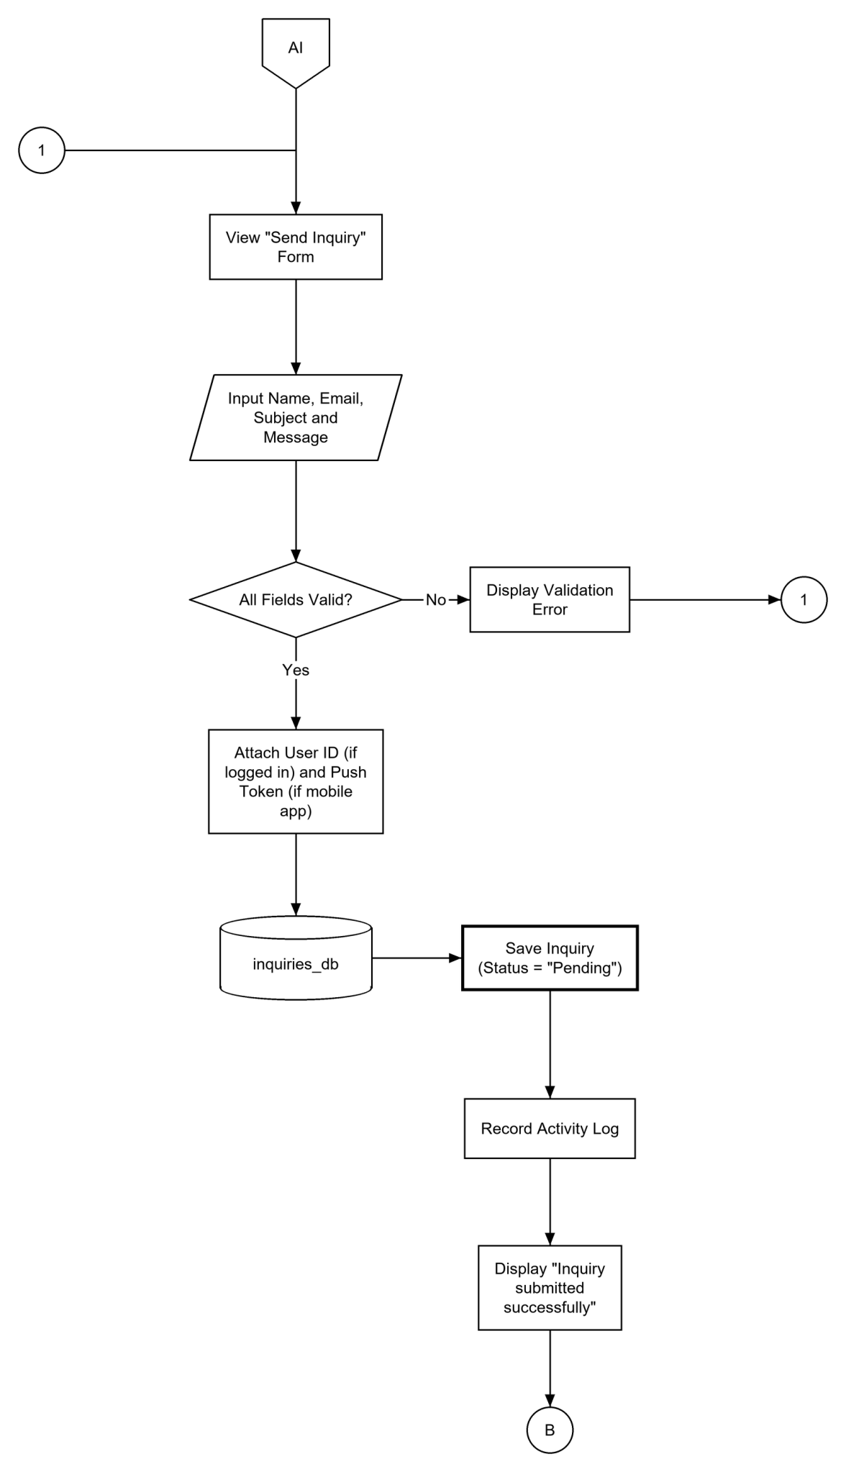
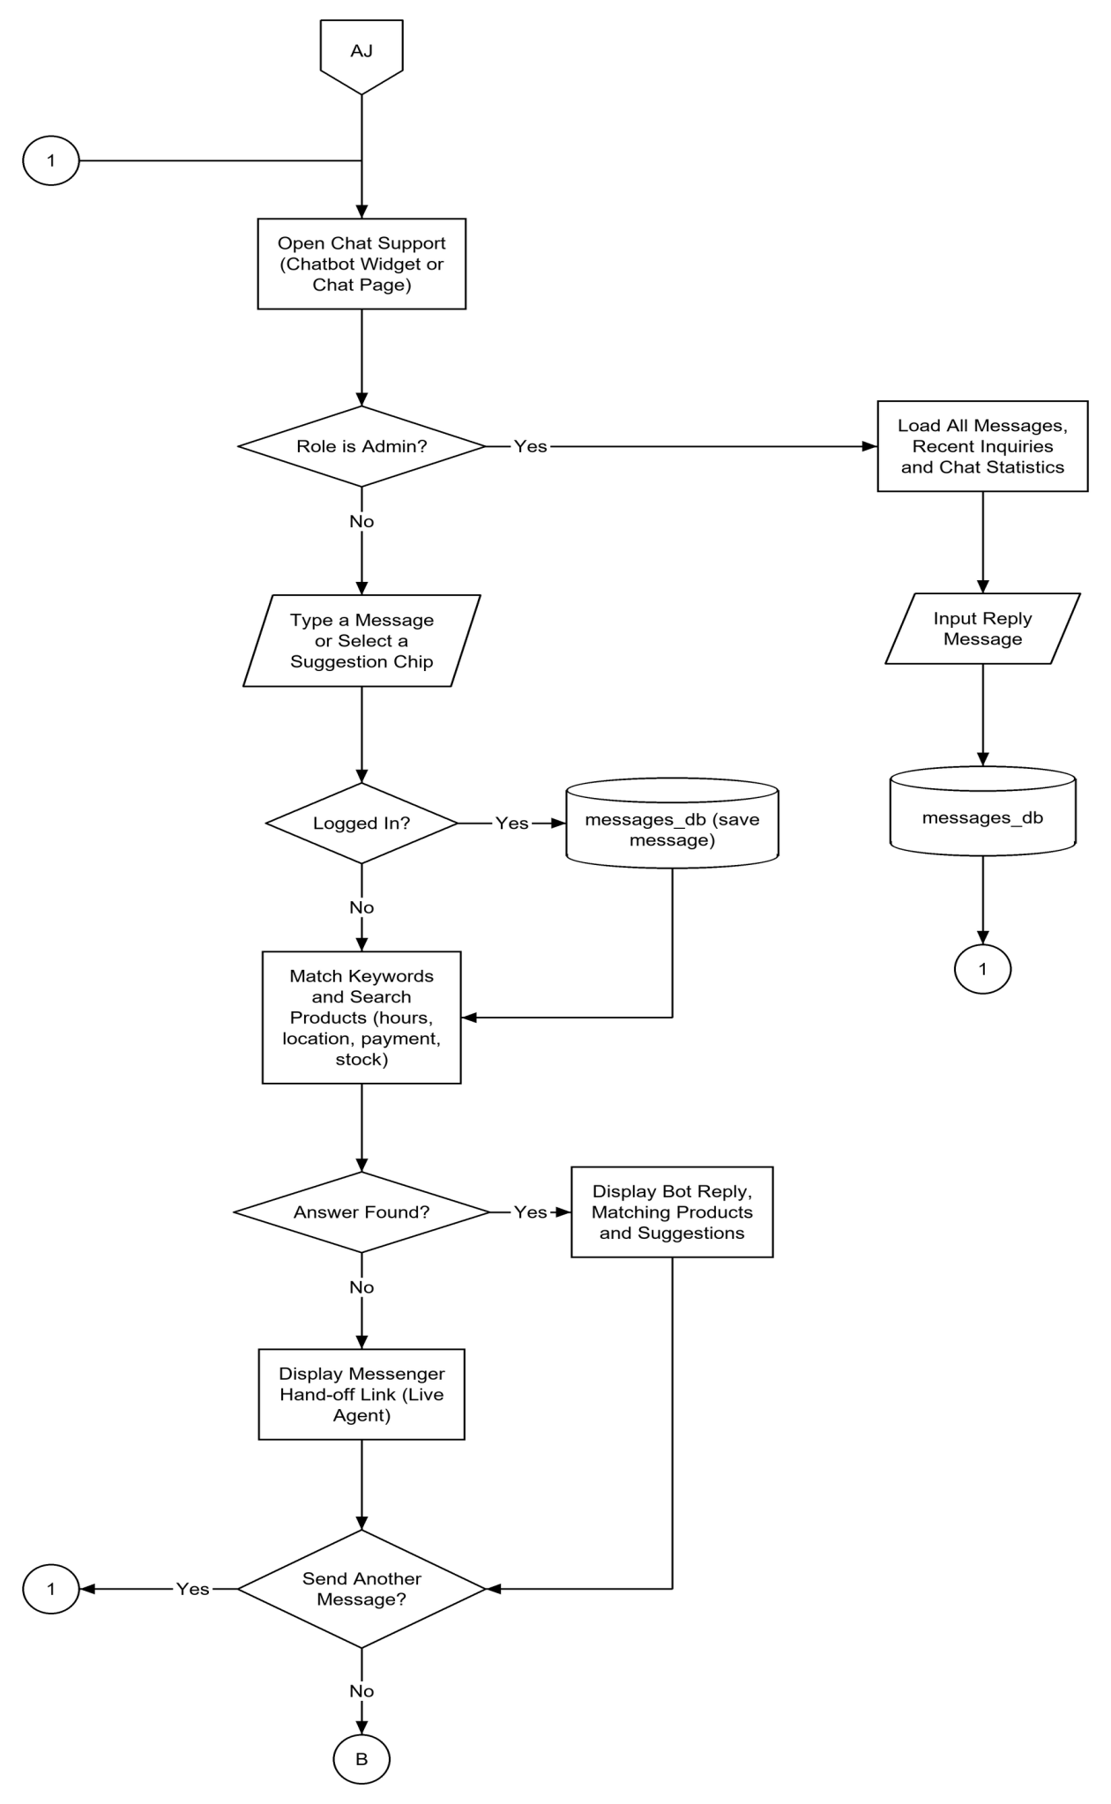
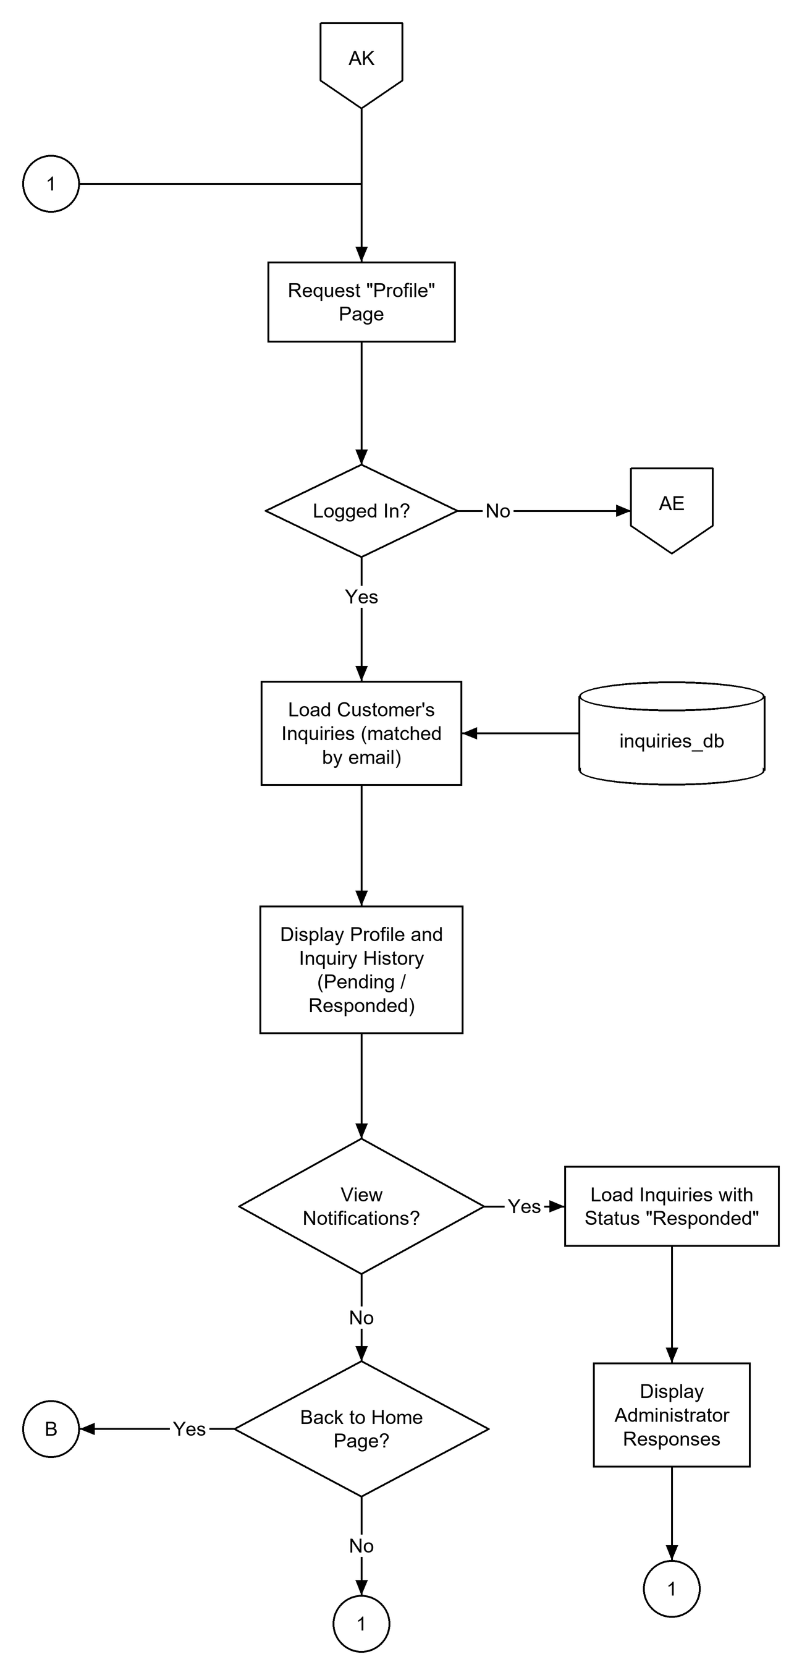
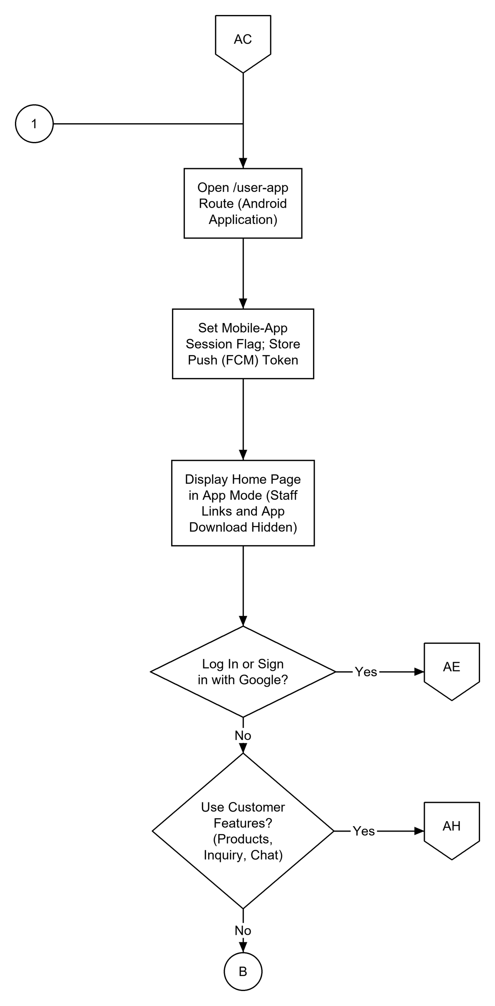
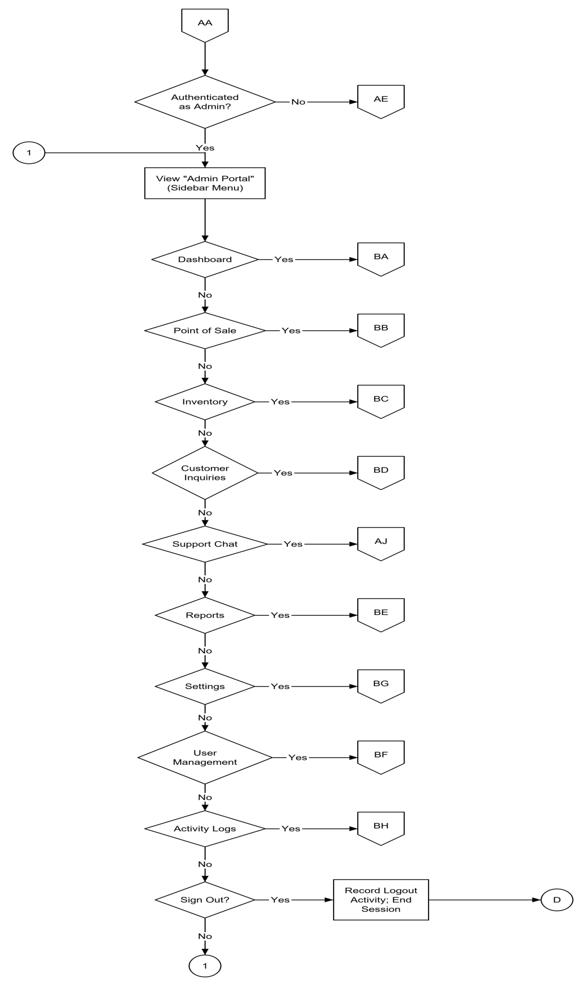
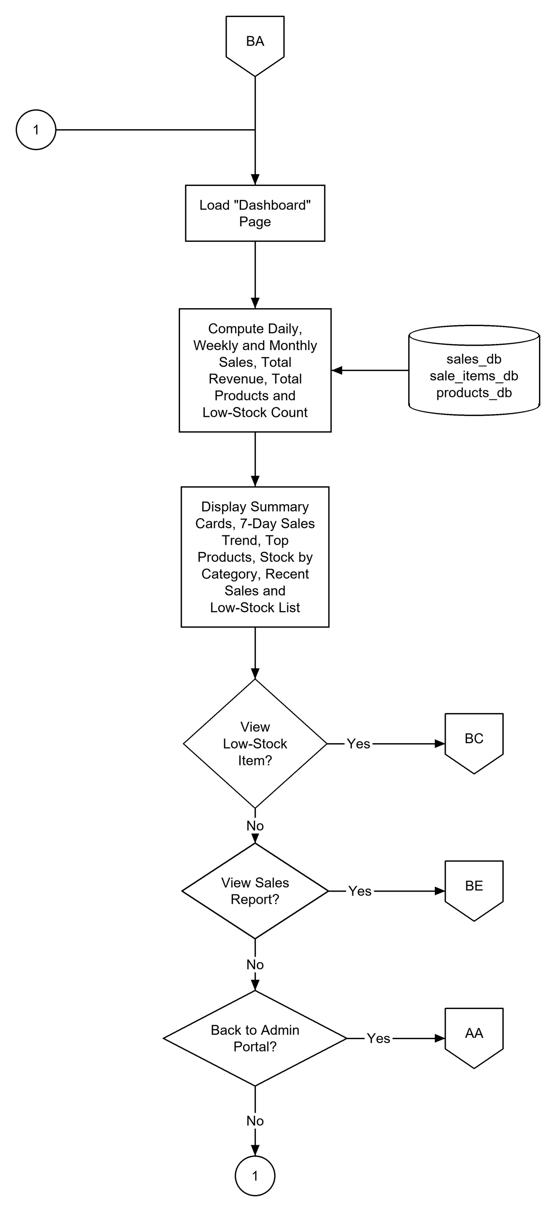
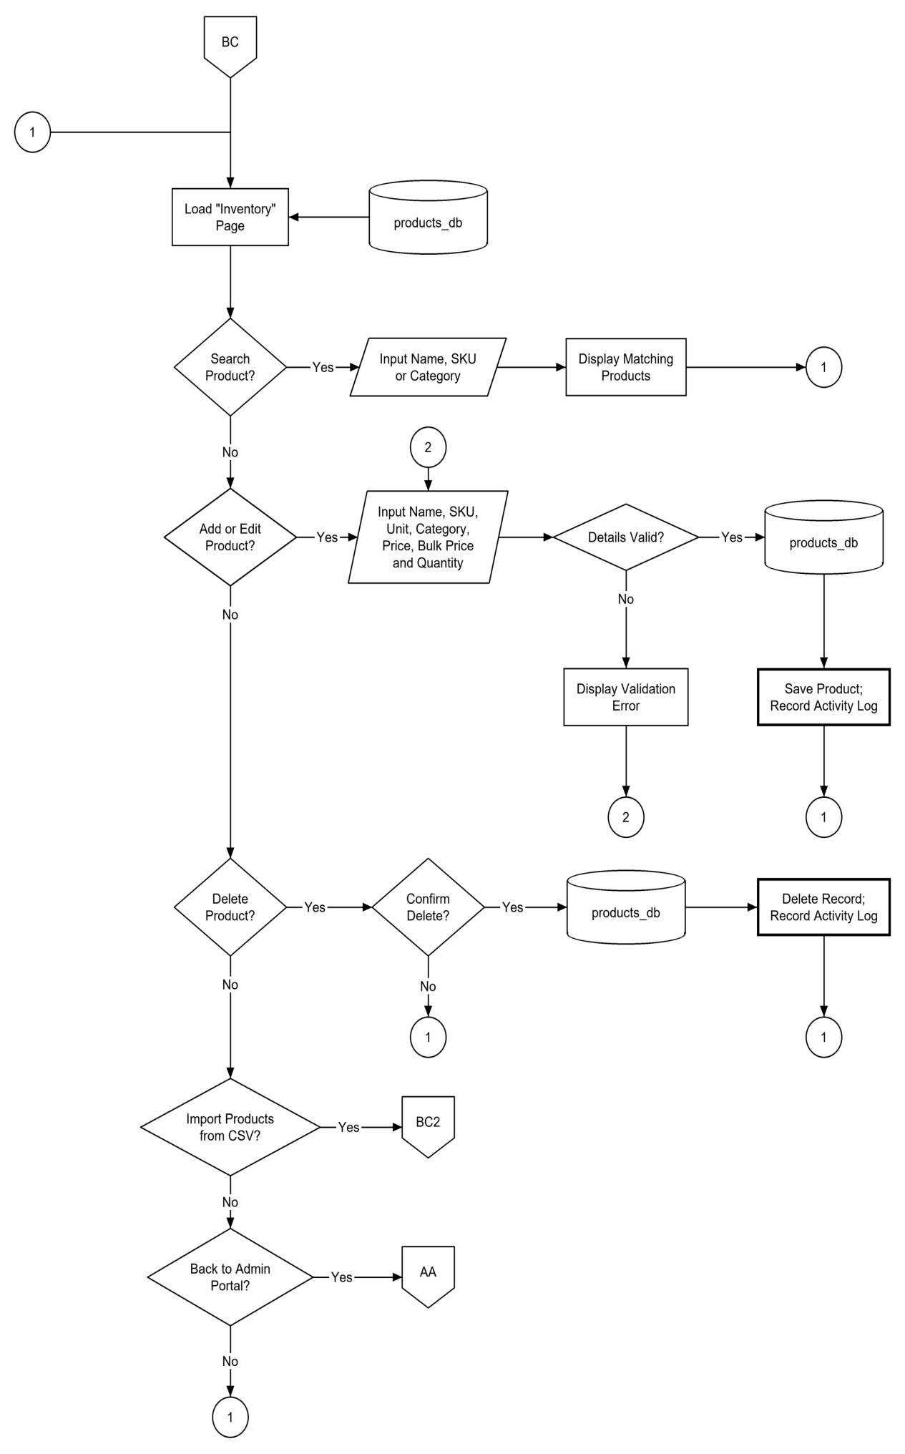
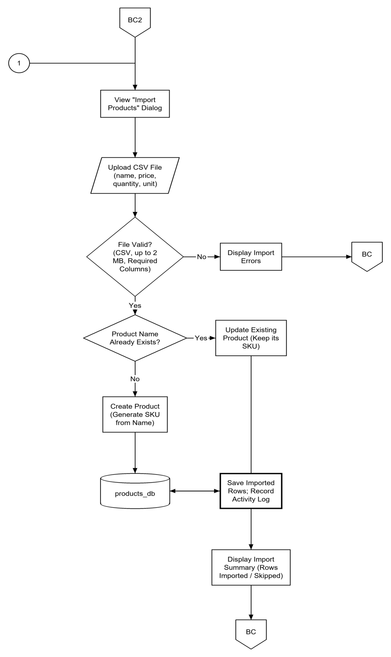
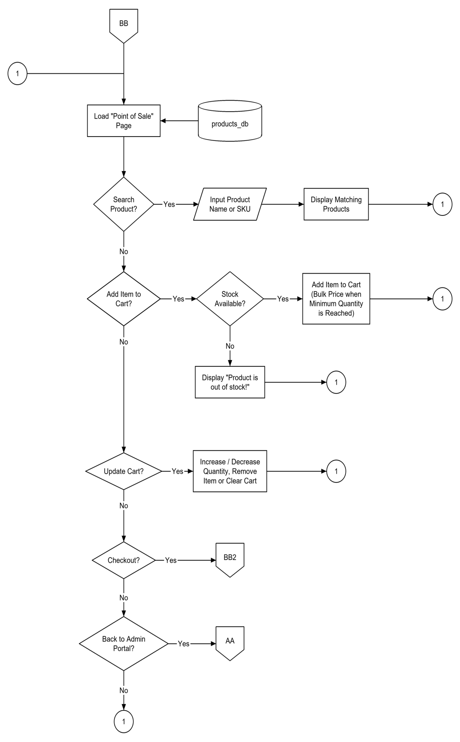
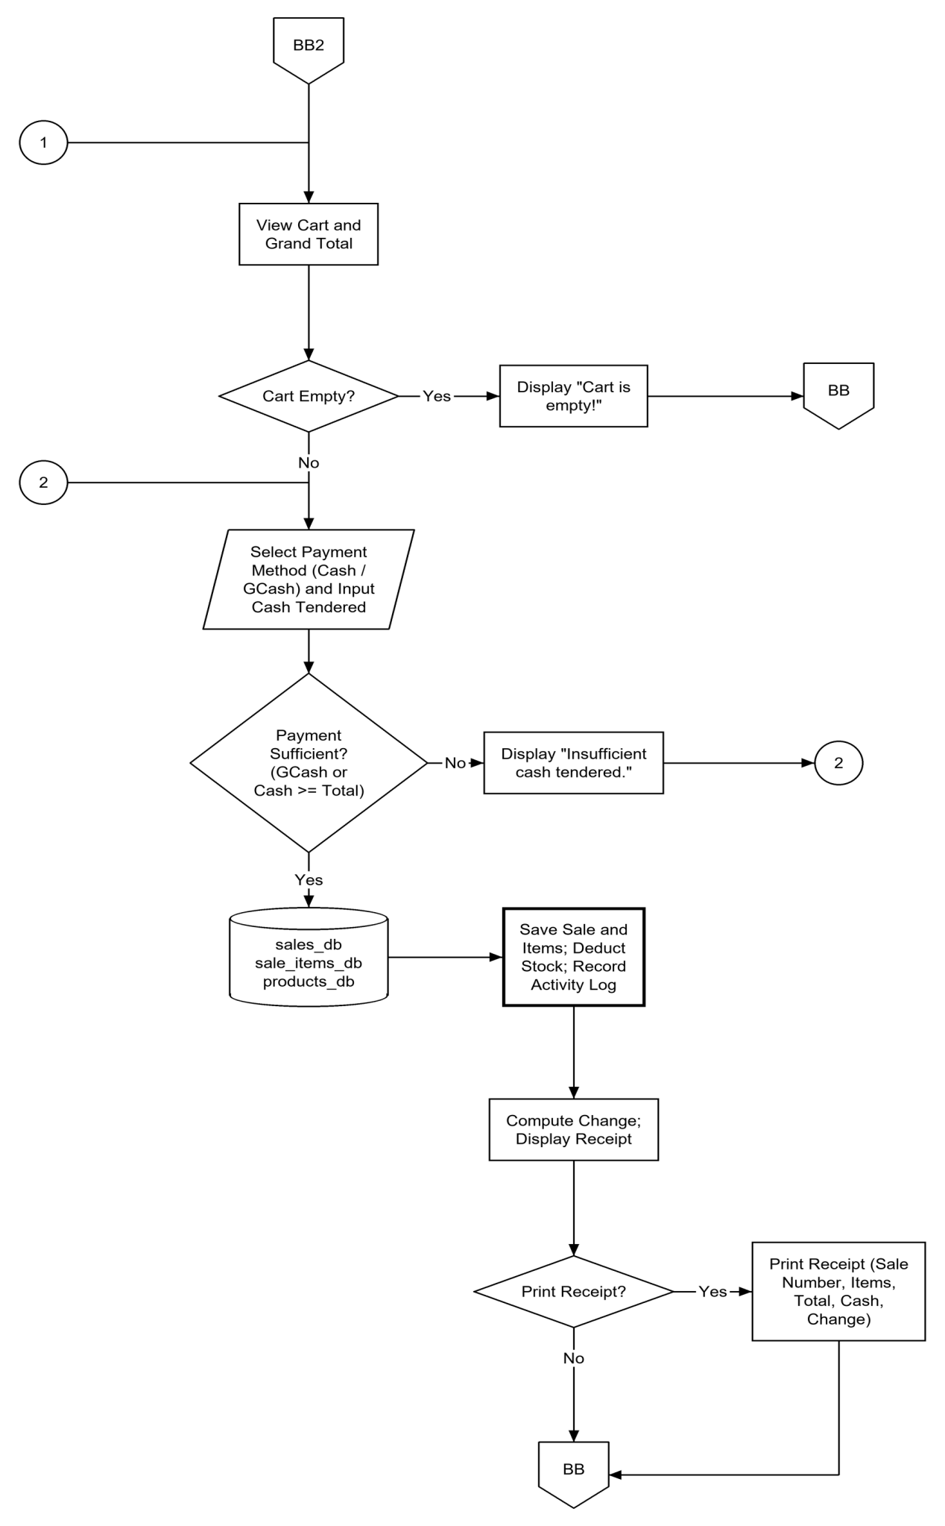
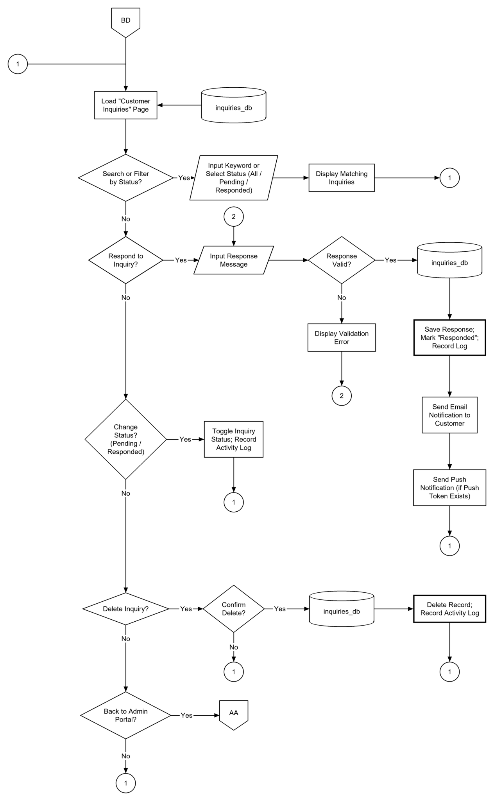
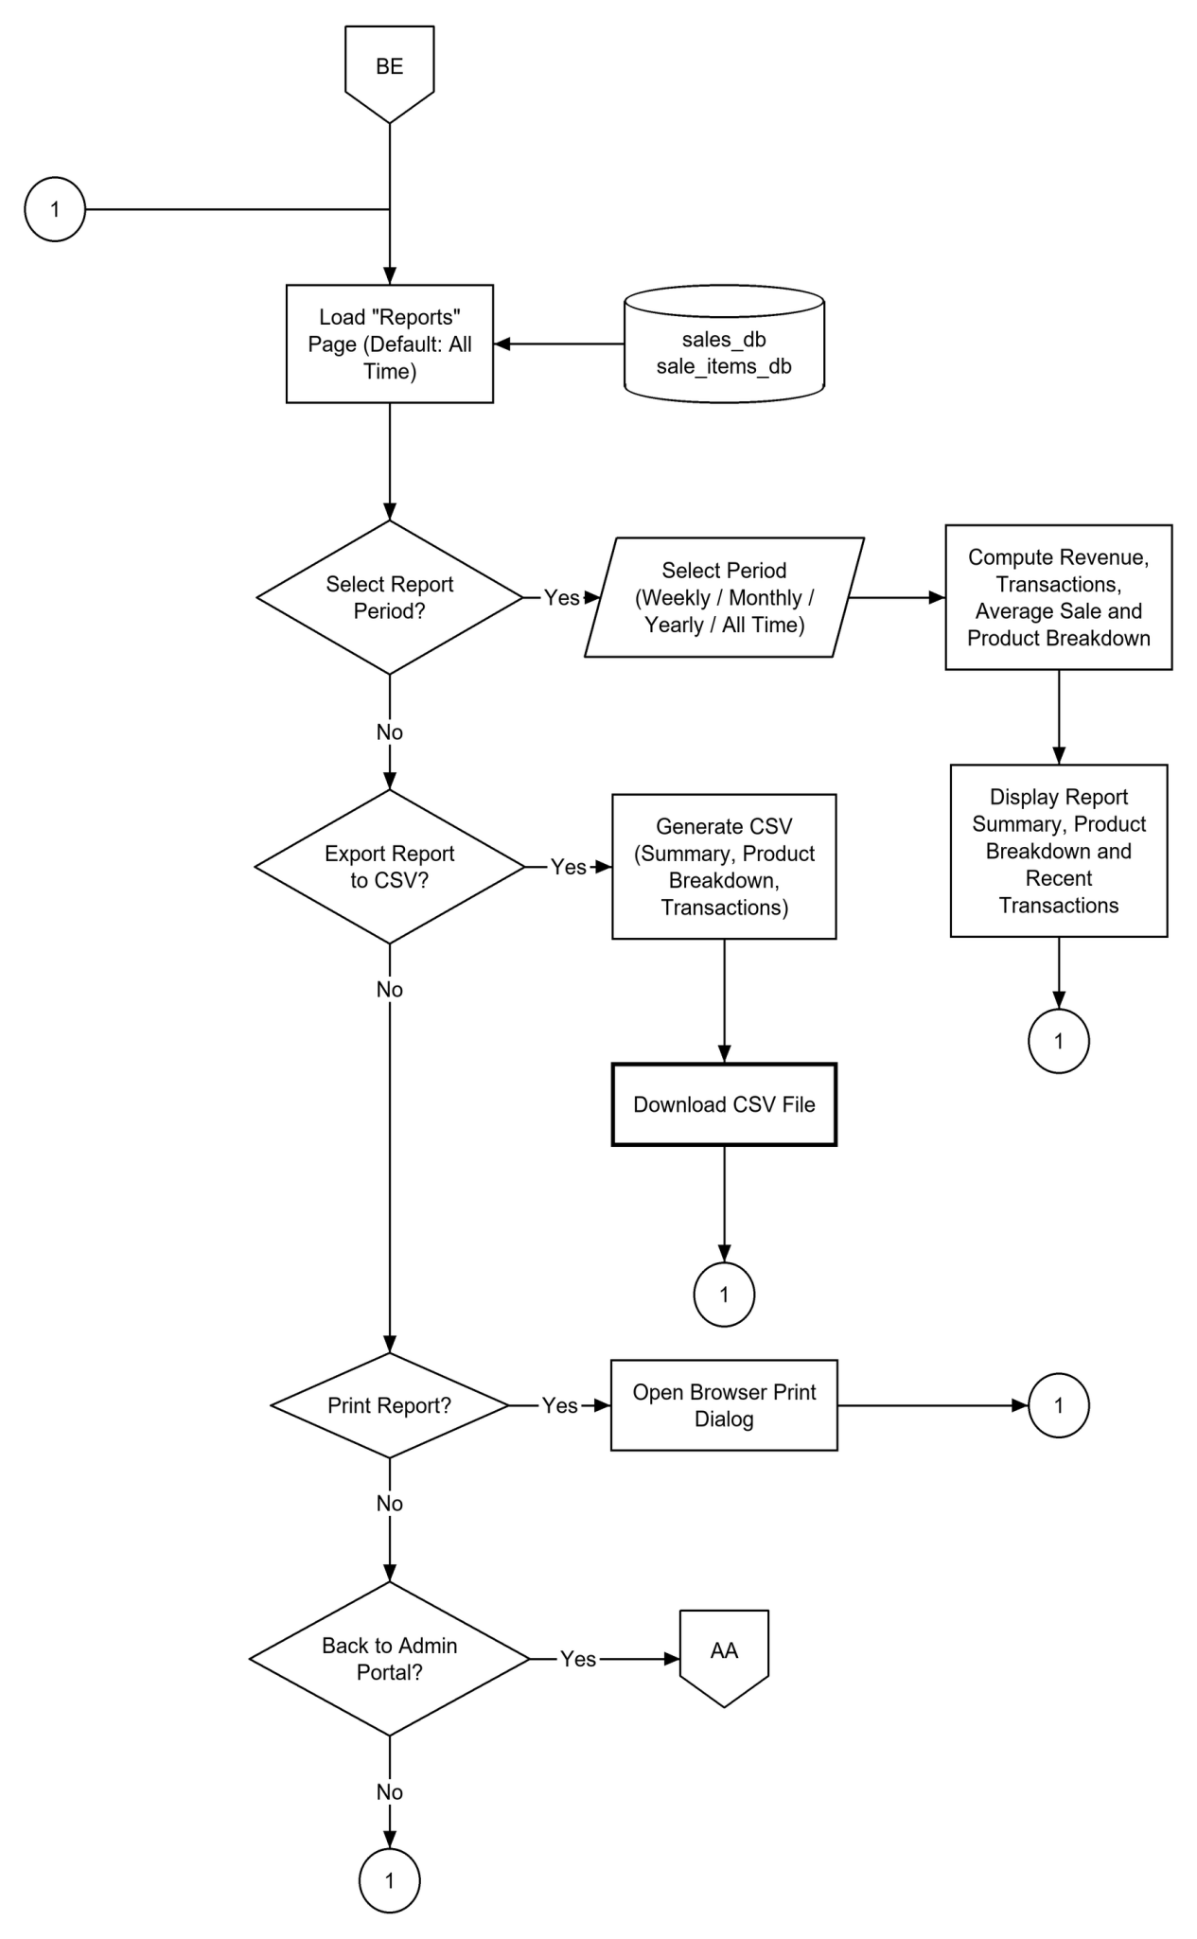
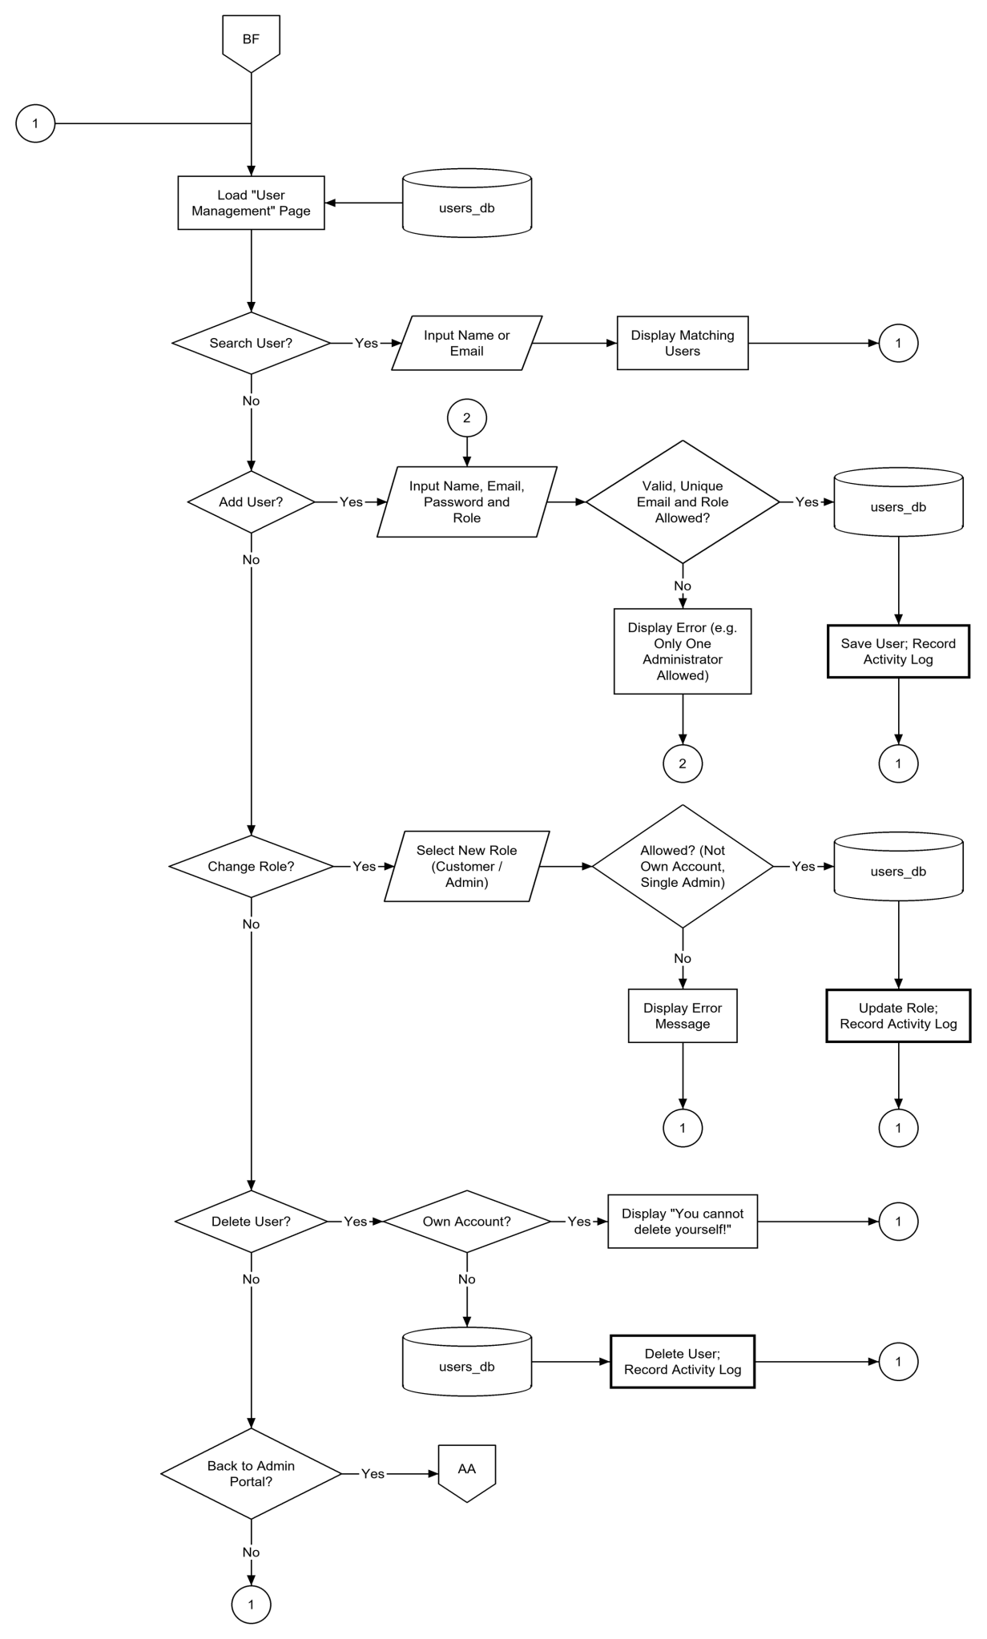
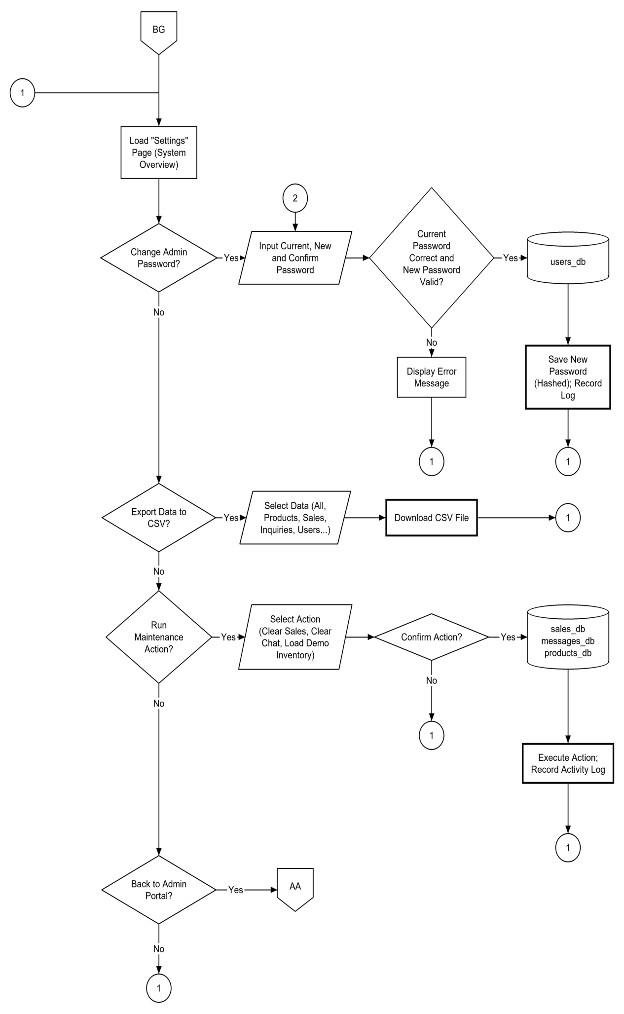
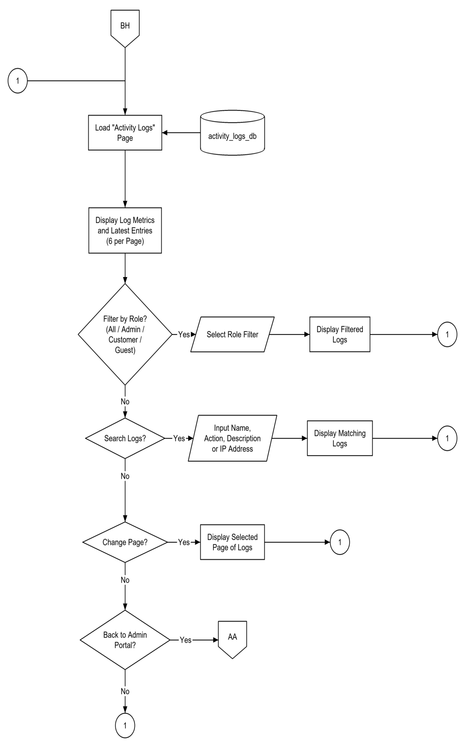
CHAPTER IV
PRESENTATION, ANALYSIS, AND INTERPRETATION OF RESULTS
After the thorough checking and evaluation of IT experts, the following are the results:
Rating Scale:  [5] Strongly functional  [4] Functional  [3] Moderately functional | [2] Slightly functional  [1] Not functional

Table 2 shows the distribution of the 42 respondents who evaluated the system.
Table 2. Profile of the Respondents
RESPONDENT GROUP | FREQUENCY | PERCENTAGE | BASIS OF EVALUATION
Store owner and merchants | 1 | 3.03% | Usability
Store employees (cashiers and staff) | 4 | 12.12% | Usability
Customers | 25 | 75.76% | Usability
IT experts | 3 | 9.10% | ISO/IEC 25010
TOTAL | 33 | 100.00%

Table 2 shows that the customers formed the largest group with 33 respondents (100.00%), followed by the store employees and the IT experts with 3 respondents each (9.10%), and the store owner and merchants with 1 respondent (3.03%). The large share of customers means that the system was evaluated mainly from the point of view of its intended end users, while the store owner, the store employees, and the IT experts provided the viewpoints of those who operate the system and who assess its technical quality.

Functionality of the System
The functionality of the system was evaluated according to the interface of each type of user. The administrator portal was evaluated by the 12 respondents who used the administrator portal (the store owner and merchants, the store employees, and the IT experts), while the customer website and the Android mobile application were evaluated by the 33 respondents who used the customer website and the mobile application (the customers and the IT experts).

Administrator Dashboard
Table 3 presents the functionality of the administrator dashboard as rated by the 12 respondents who used the administrator portal (the store owner and merchants, the store employees, and the IT experts).
Table 3. Functionality of the Administrator Dashboard
 | MEAN | VERBAL INTERPRETATION
How functional is our system in terms of displaying the Daily Sales? | 4.58 | Strongly Functional
How functional is our system in terms of displaying the Weekly Sales? | 4.50 | Strongly Functional
How functional is our system in terms of displaying the Monthly Sales? | 4.50 | Strongly Functional
How functional is our system in terms of displaying the Total Revenue? | 4.67 | Strongly Functional
How functional is our system in terms of displaying the Total Number of Products? | 4.58 | Strongly Functional
How functional is our system in terms of displaying the Low Stock Count? | 4.42 | Strongly Functional
How functional is our system in terms of displaying the Recent Sales? | 4.50 | Strongly Functional
How functional is our system in terms of displaying the Low Stock Alerts? | 4.75 | Strongly Functional
How functional is our system in terms of displaying the Seven-Day Sales Trend chart? | 4.33 | Strongly Functional
How functional is our system in terms of displaying the Top-Selling Products and Stock by Category charts? | 4.42 | Strongly Functional
TOTAL WEIGHTED MEAN | 4.53 | Strongly Functional

Table 3 shows that the system was rated Strongly Functional across all criteria by the respondents, with mean scores ranging from 4.33 to 4.75. Specifically, the system obtained 4.58 for displaying the Daily Sales, 4.50 for displaying the Weekly Sales, 4.50 for displaying the Monthly Sales, 4.67 for displaying the Total Revenue, 4.58 for displaying the Total Number of Products, 4.42 for displaying the Low Stock Count, 4.50 for displaying the Recent Sales, 4.75 for displaying the Low Stock Alerts, 4.33 for displaying the Seven-Day Sales Trend chart, and 4.42 for displaying the Top-Selling Products and Stock by Category charts. With a total weighted mean of 4.53, the overall interpretation is Strongly Functional, which indicates that the dashboard presents the sales, revenue, product, and low-stock information of the store clearly and accurately, giving the store owner a quick view of the daily operation of the business.
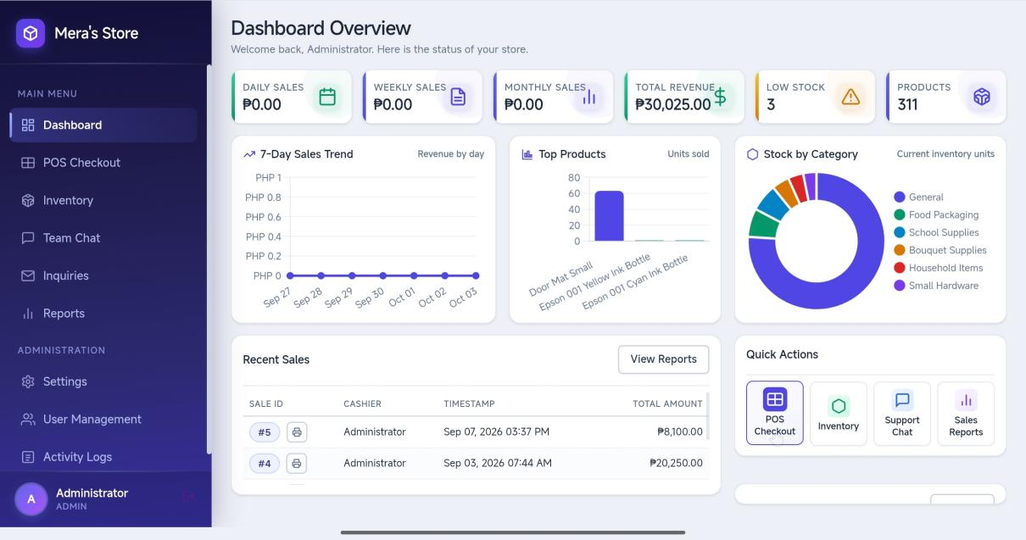
Figure 21. In terms of displaying the Daily Sales.
Figure 21 shows the dashboard of the administrator portal. It displays the Daily Sales, Weekly Sales, Monthly Sales, Total Revenue, the number of Products, and the Low Stock count, together with charts for the seven-day sales trend, the top-selling products, and the stock by category. The Recent Sales table lists the sale ID, cashier, timestamp, and total amount, the Low Stock Alerts list shows the products that need to be restocked, and the Quick Actions give shortcuts to POS Checkout, Inventory, Support Chat, and Sales Reports. This section helps the administrator monitor the sales and the stock of the store at a glance.

Administrator Management Functions
Table 4 presents the functionality of the management functions of the administrator portal as rated by the 12 respondents who used the administrator portal (the store owner and merchants, the store employees, and the IT experts).
Table 4. Functionality of the Administrator Management Functions
 | MEAN | VERBAL INTERPRETATION
How functional is our system in terms of managing product records and inventory? | 4.67 | Strongly Functional
How functional is our system in terms of importing products from a CSV file? | 4.33 | Strongly Functional
How functional is our system in terms of setting bulk prices and units of measure for products? | 4.42 | Strongly Functional
How functional is our system in terms of processing POS sales through the cart and checkout? | 4.75 | Strongly Functional
How functional is our system in terms of accepting cash and GCash payments and computing the change? | 4.58 | Strongly Functional
How functional is our system in terms of generating and printing receipts? | 4.67 | Strongly Functional
How functional is our system in terms of deducting sold quantities from the inventory automatically? | 4.75 | Strongly Functional
How functional is our system in terms of generating weekly, monthly, and yearly sales reports and exporting them to CSV? | 4.58 | Strongly Functional
How functional is our system in terms of viewing top-selling products and recent transactions? | 4.50 | Strongly Functional
How functional is our system in terms of managing customer inquiries and sending email responses? | 4.50 | Strongly Functional
How functional is our system in terms of replying to customers through the support chat? | 4.42 | Strongly Functional
How functional is our system in terms of managing user accounts and roles? | 4.50 | Strongly Functional
How functional is our system in terms of monitoring activity logs? | 4.42 | Strongly Functional
How functional is our system in terms of managing system settings and security? | 4.50 | Strongly Functional
TOTAL WEIGHTED MEAN | 4.54 | Strongly Functional

Table 4 shows that the system was rated Strongly Functional across all criteria by the respondents, with mean scores ranging from 4.33 to 4.75. Specifically, the system obtained 4.67 for managing product records and inventory, 4.33 for importing products from a CSV file, 4.42 for setting bulk prices and units of measure for products, 4.75 for processing POS sales through the cart and checkout, 4.58 for accepting cash and GCash payments and computing the change, 4.67 for generating and printing receipts, 4.75 for deducting sold quantities from the inventory automatically, 4.58 for generating weekly, monthly, and yearly sales reports and exporting them to CSV, 4.50 for viewing top-selling products and recent transactions, 4.50 for managing customer inquiries and sending email responses, 4.42 for replying to customers through the support chat, 4.50 for managing user accounts and roles, 4.42 for monitoring activity logs, and 4.50 for managing system settings and security. With a total weighted mean of 4.54, the overall interpretation is Strongly Functional, which indicates that the administrator portal effectively supports the whole workflow of the store, from the management of products and inventory and the processing of sales, to the generation of reports, the handling of customer inquiries, and the control of user accounts, activity logs, and system settings.
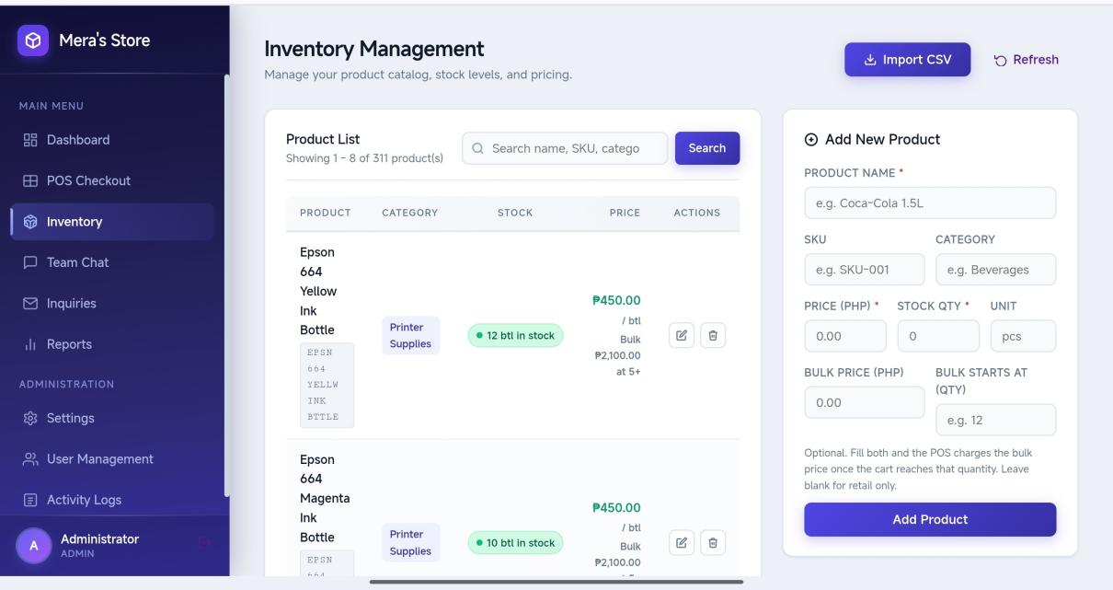
Figure 22. In terms of managing product records and inventory.
Figure 22 shows the part of the system where the administrator manages the Product List. Each product is displayed with its name, category, stock quantity, and price, together with the actions for editing or deleting the product, and a search box allows a product to be located quickly. This section helps the administrator keep the product records, prices, and stock quantities of the store accurate and up to date.
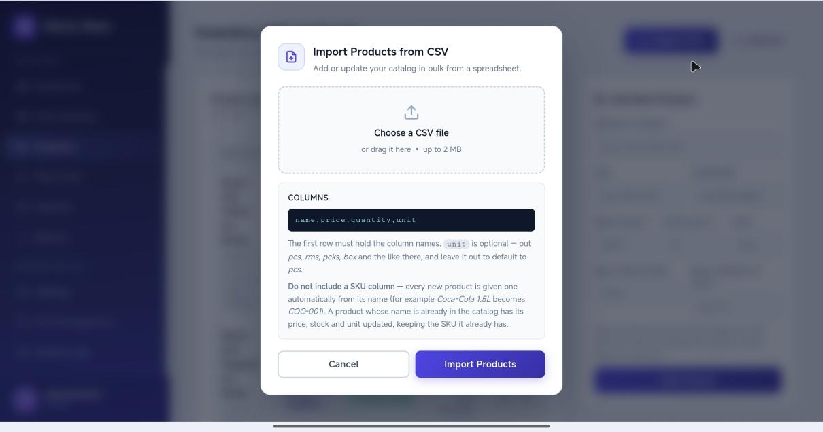
Figure 23. In terms of importing products from a CSV file.
Figure 23 shows the form used to add or edit a product, with fields for the Product Name, SKU, Price (PHP), Stock Qty, Unit (such as pieces, reams, packs, boxes, and kilograms), Bulk Price (PHP), and the quantity at which the bulk price starts. A separate window, Import Products from CSV, allows many products to be loaded at once. This section speeds up the encoding of the inventory and supports both retail and wholesale pricing.
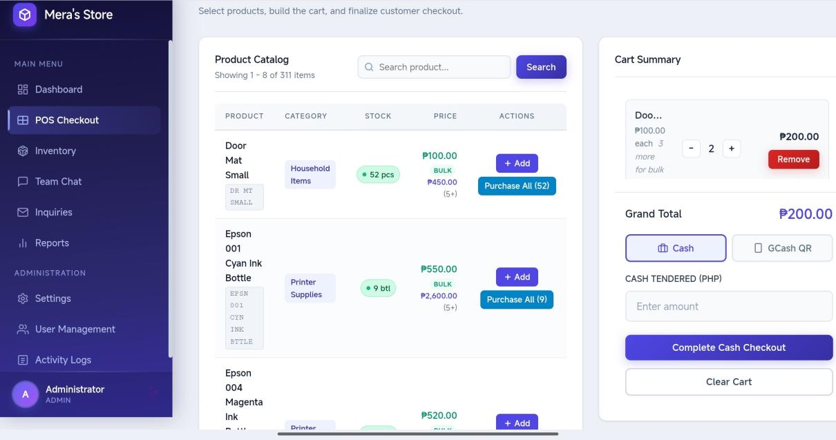
Figure 24. In terms of processing POS sales through the cart and checkout.
Figure 24 shows the Point of Sale screen. The Product Catalog lists the products with their category, stock, and price and can be searched, and a product is added to the Cart Summary with one action. In the cart, the cashier can increase or decrease quantities, remove an item, or clear the cart, while products without stock are marked Unavailable and the price changes to the bulk price once the bulk quantity is reached. This section helps the cashier prepare a sale quickly and with the correct total.
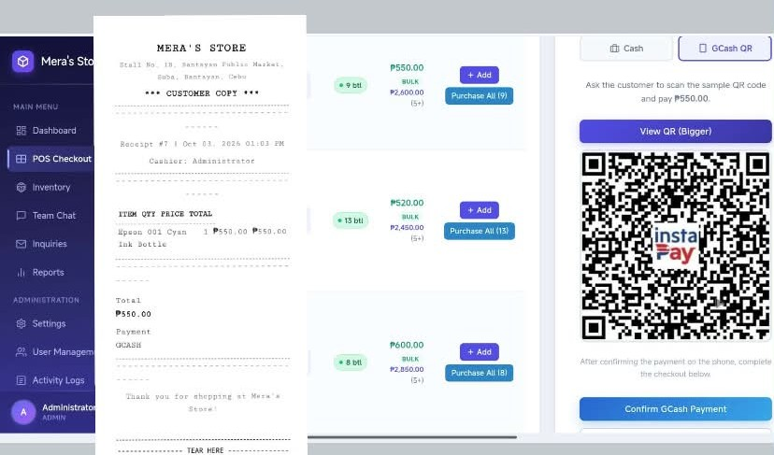
Figure 25. in terms of accepting cash and GCash payments and computing the change.
Figure 25 shows the payment part of the Point of Sale. For a cash payment, the cashier enters the Cash Tendered (PHP) and completes the checkout, and the system computes the change. For a GCash payment, the GCash QR Code is displayed and the cashier confirms the payment. After the checkout, the Receipt Ready window shows the items, quantities, and totals with the option to Print Receipt, and the sold quantities are deducted from the inventory automatically. This section ensures that every sale is recorded, receipted, and reflected in the stock.
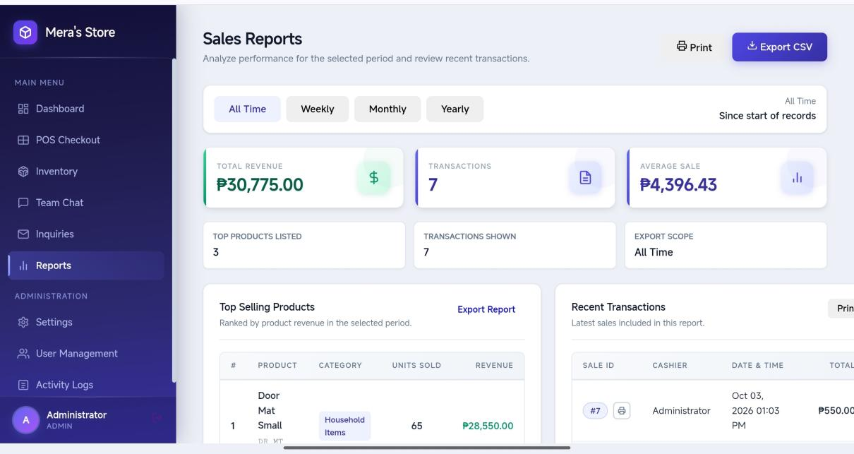
Figure 26. in terms of generating and printing receipts.
Figure 26 shows the part of the system where the administrator generates sales reports. The report presents the Total Revenue, the number of Transactions, and the Average Sale for the selected period (weekly, monthly, yearly, or all records), the Top Selling Products with their category, units sold, and revenue, and the Recent Transactions with the sale ID, cashier, date and time, and total. The report can be printed or exported to a CSV file. This section helps the store owner evaluate sales performance without computing the figures by hand.
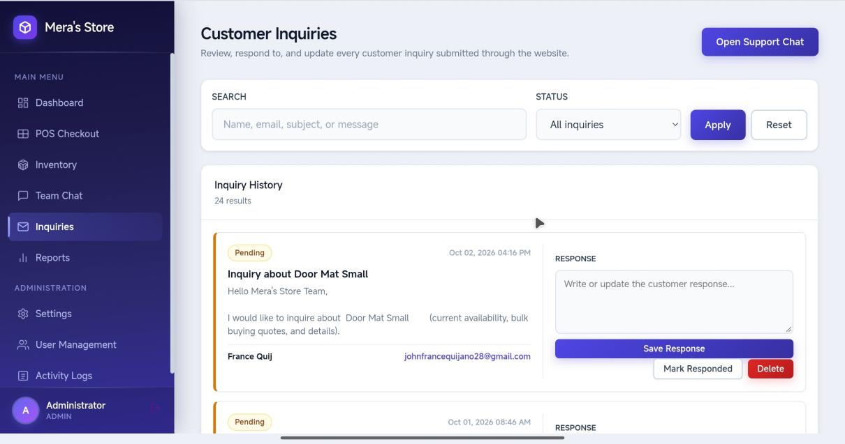
Figure 27. In terms of deducting sold quantities from the inventory automatically.
Figure 27 shows the part of the system where the administrator manages the inquiries sent by customers. The inquiries can be searched and filtered by status (All inquiries, Pending, or Responded), and the Inquiry History lists the subject and message of each inquiry. The administrator writes a response and selects Save Response, which sends the reply to the customer by email and by notification, and may also mark an inquiry as Responded or Pending or delete it. This section ensures that customer questions are answered and documented.
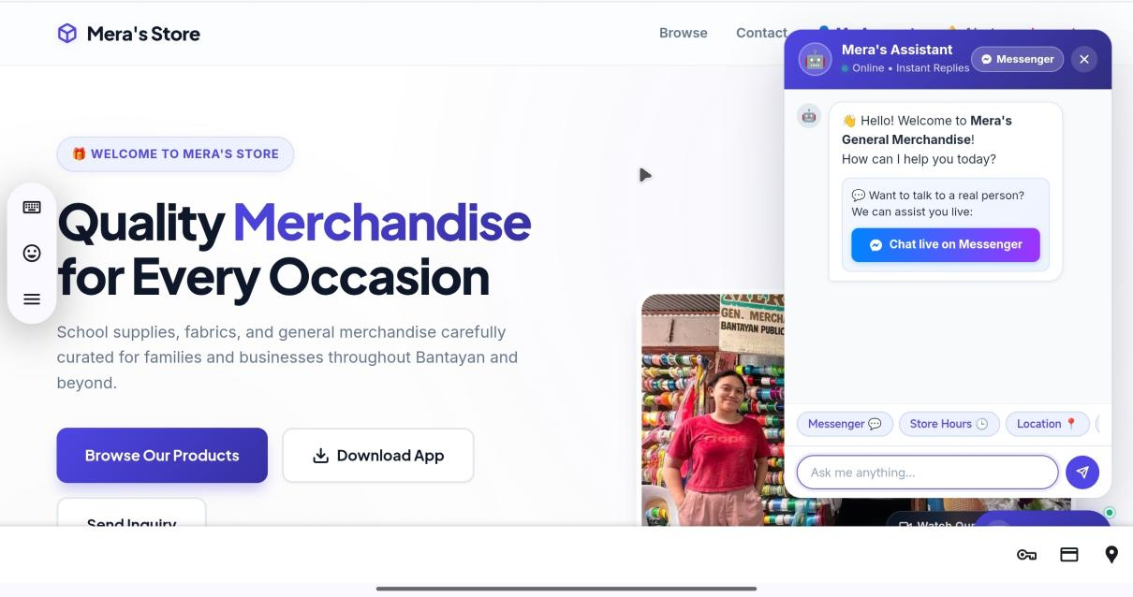
Figure 28.In terms of replying to customers through the chat support.
Figure 28 shows the chat support workspace. The Customer Questions panel lists the latest website inquiries with their pending or responded status and provides a reply template, while the Team Conversation allows the store personnel to exchange messages. Frequently asked topics such as Store Hours, Location, Products, and Payment, and quick replies such as Hello, Available, Out of Stock, Hours, and Address, help the personnel answer common questions faster. This section supports prompt and consistent communication with customers.
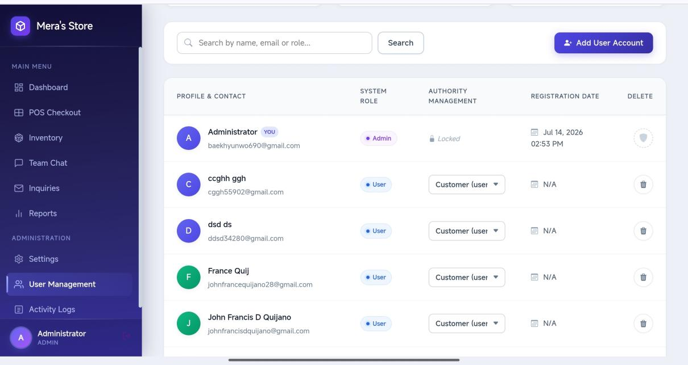
Figure 29. User Accounts
Figure 29 shows the part of the system where the administrator manages user accounts. The page summarizes the Total Accounts, Administrators, and Customers, and a table lists each user's profile and contact details, system role, registration date, and the actions to change the role or delete the account. A form allows a new account to be created by entering the full name, email address, password, and system access role. This section controls who can access the system and what each user is allowed to do.
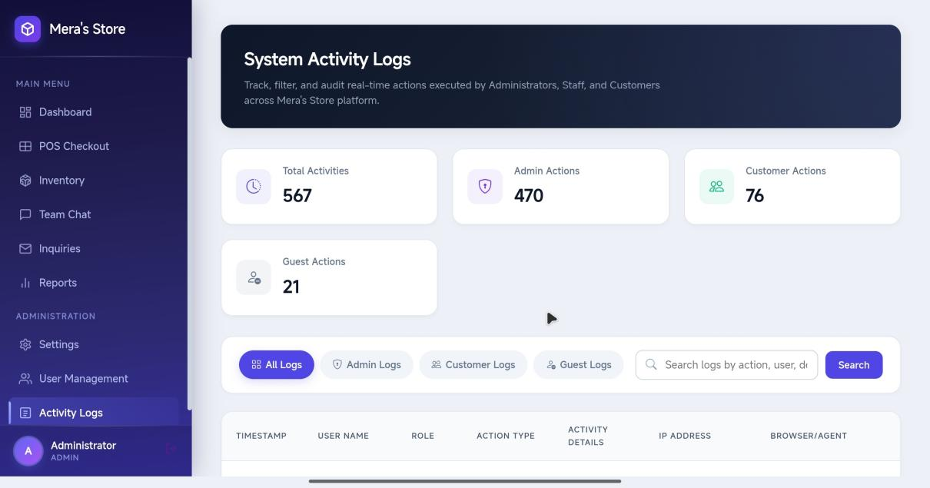
Figure 30. In terms of monitoring activity logs.
Figure 30 shows the part of the system where the administrator monitors the activity logs. The page shows the Total Activities and the number of Admin Actions, Customer Actions, and Guest Actions, and a table lists the timestamp, user name, role, action type, activity details, IP address, and browser of each activity, with a search option. This section supports accountability by keeping an audit trail of the actions performed in the system.
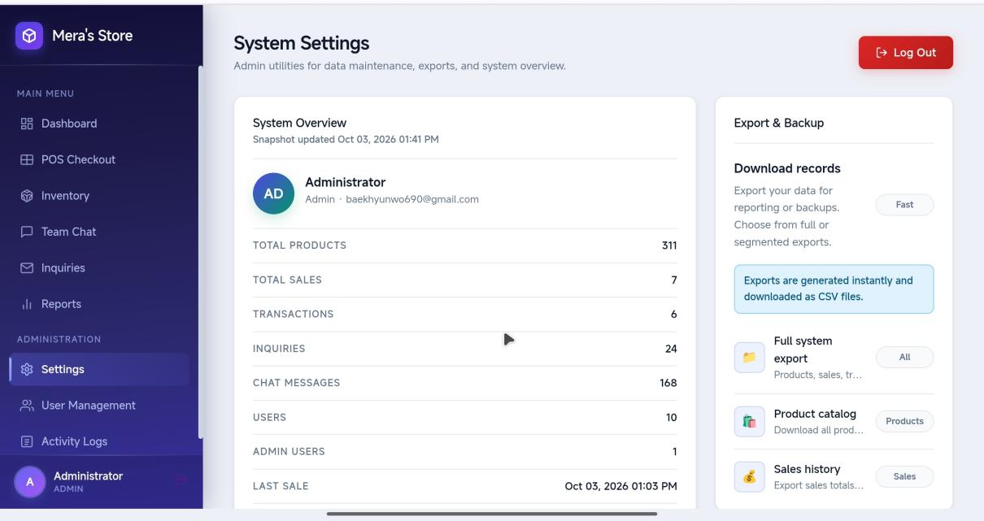
Figure 31. In terms of managing user accounts and roles.
Figure 31 shows the part of the system where the administrator manages the system settings. It presents a System Overview of the Total Revenue, Sales Count, and Active Users, the Export & Backup option for downloading the records, the Change Admin Password form, and the Maintenance Actions for seeding demo products, resetting the sales history, and clearing the chat history. This section helps the administrator protect the account, back up the data, and maintain the system.

Customer Website
Table 5 presents the functionality of the customer website as rated by the 35 respondents who used the customer website and the mobile application (the customers and the IT experts).

Table 5. Functionality of the Customer Website
 | MEAN | VERBAL INTERPRETATION
How functional is our system in terms of displaying the store landing page and product catalogue? | 4.60 | Strongly Functional
How functional is our system in terms of searching and filtering products by name, SKU, or category? | 4.54 | Strongly Functional
How functional is our system in terms of displaying product prices and stock status? | 4.57 | Strongly Functional
How functional is our system in terms of switching between the grid view and the table view of products? | 4.40 | Strongly Functional
How functional is our system in terms of submitting store inquiries? | 4.60 | Strongly Functional
How functional is our system in terms of registering and logging in, including Google sign-in? | 4.46 | Strongly Functional
How functional is our system in terms of recovering a forgotten password through an email reset link? | 4.49 | Strongly Functional
How functional is our system in terms of viewing the customer account and inquiry reply notifications? | 4.34 | Strongly Functional
How functional is our system in terms of providing chatbot assistance on store hours, location, products, and payment? | 4.54 | Strongly Functional
TOTAL WEIGHTED MEAN | 4.50 | Strongly Functional

Table 5 shows that the system was rated Strongly Functional across all criteria by the respondents, with mean scores ranging from 4.34 to 4.60. Specifically, the system obtained 4.60 for displaying the store landing page and product catalogue, 4.54 for searching and filtering products by name, SKU, or category, 4.57 for displaying product prices and stock status, 4.40 for switching between the grid view and the table view of products, 4.60 for submitting store inquiries, 4.46 for registering and logging in, including Google sign-in, 4.49 for recovering a forgotten password through an email reset link, 4.34 for viewing the customer account and inquiry reply notifications, and 4.54 for providing chatbot assistance on store hours, location, products, and payment. With a total weighted mean of 4.50, the overall interpretation is Strongly Functional, which indicates that customers can view the products and their availability, send inquiries, manage their accounts, and receive assistance from the chatbot without having to visit the store.
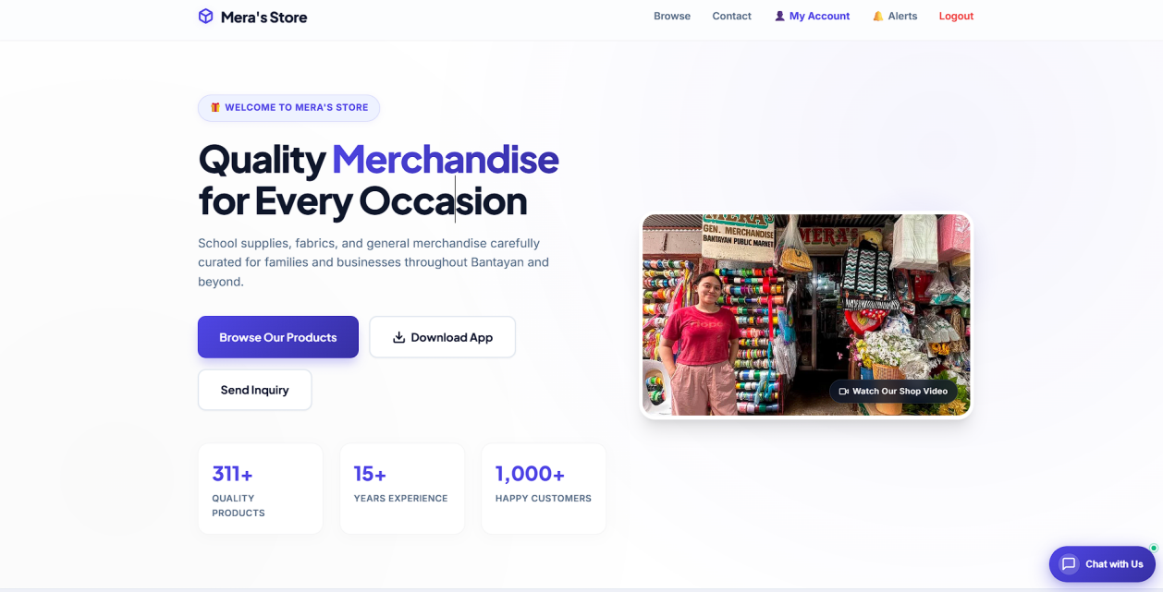
Figure 32. In terms of displaying the store landing page and product catalogue.

Figure 32 illustrates the Our Products section of the system, where customers can browse through the store’s catalogue. This interface allows users to search items by product name or SKU, filter them by category, and choose between a Grid View or DataTable display. Each product entry presents essential details such as category, SKU, price, and stock status (In Stock, Only a few left, or Out of Stock). This feature provides customers with a clear overview of product availability, helping them make informed decisions before proceeding to purchase.
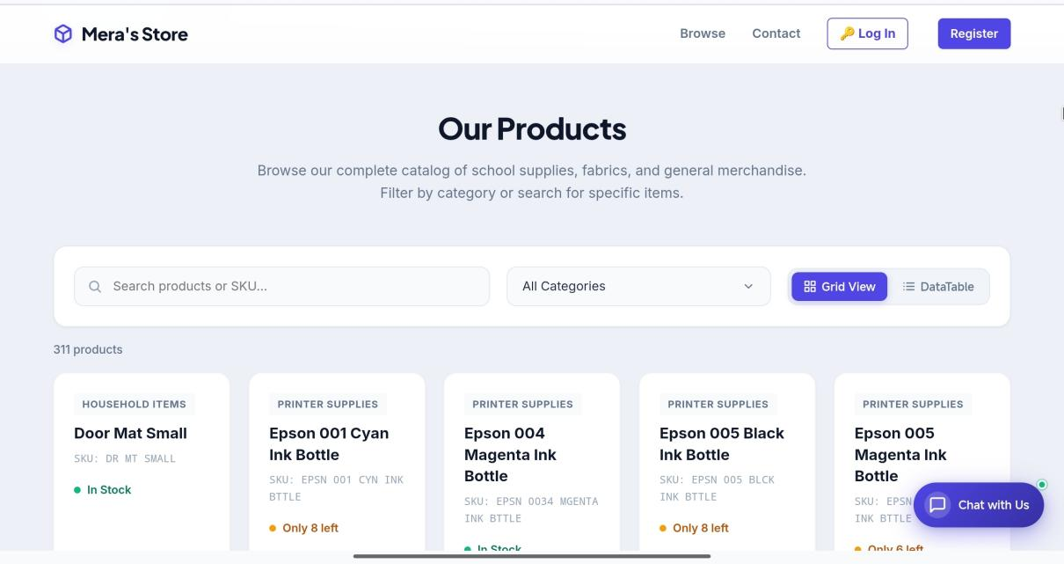
Figure 33. In terms of searching and filtering products by name, SKU, or category.
Figure 33 shows the part of the system where customers browse the Our Products catalogue. The products can be searched by name or SKU, filtered by category, and displayed in a Grid View or a DataTable view. Each product shows its category, SKU, price, and stock status (In Stock, Only a few left, or Out of Stock). This section lets customers check the products and their availability before going to the store.
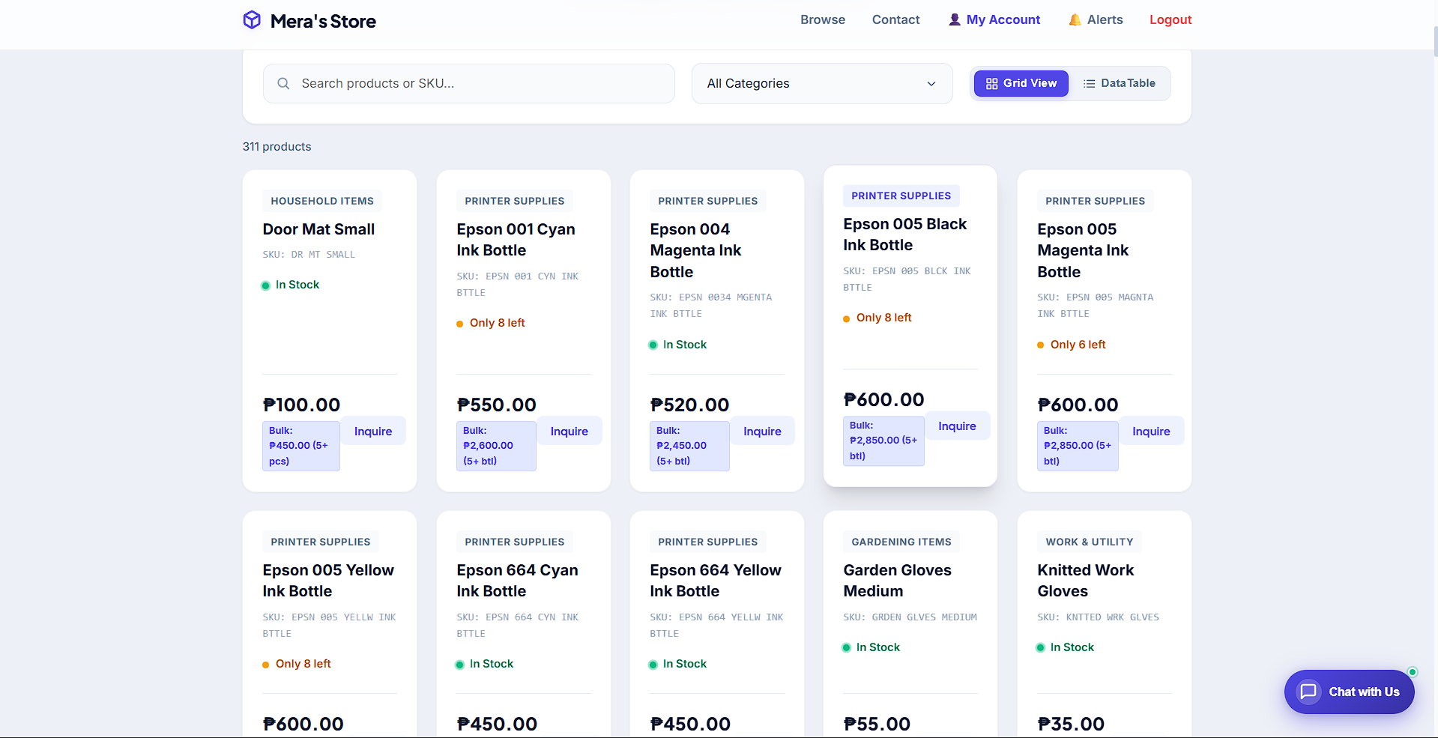
Figure 34.In terms of displaying product prices and stock status.
Figure 34 presents the product catalogue interface of the system, where customers can view items in a grid layout along with their names, categories, prices, and availability status. The page includes navigation options, a search bar, and a category filter to help users quickly locate specific products. Each product card displays essential details such as price and stock status (In Stock, Only a few left, or Out of Stock), and provides buttons for adding items to the cart or viewing more information. This section enables customers to conveniently browse, compare, and select products before proceeding with their purchase.

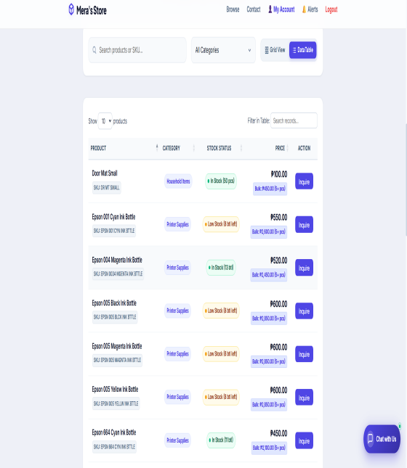
Figure 35.In terms of switching between the grid view and the table view of products?
Figure 35 highlights the PriceData dashboard, which provides users with tools to analyze product pricing information. The interface includes a search bar, category filter, and an “Analyze” button to process data. Products can be displayed in two formats: a table view, which organizes details such as product name, category, location, price, and date into rows and columns, and a card view, which presents the same information in a more visual, block-style layout. This dual representation allows users to choose between a structured tabular format for detailed comparison or a card-based format for quick browsing, making the system flexible and user-friendly for price monitoring and analysis.
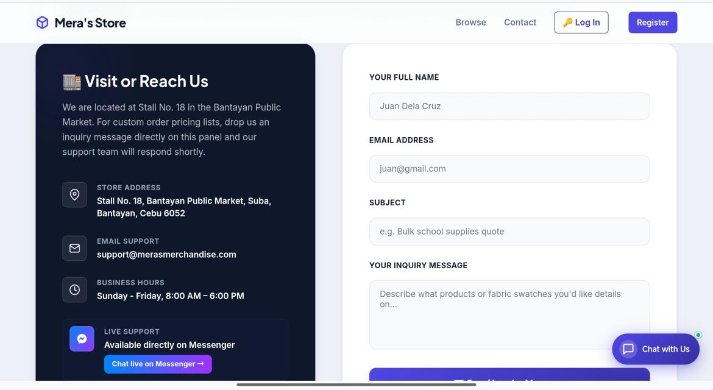
Figure 36. In terms of submitting store inquiries?
Figure 36 shows the Send Store Inquiry form, where a customer enters the full name, email address, subject, and inquiry message to ask about bulk sales, availability, or pickup schedules. A confirmation message appears once the inquiry is received, and the store location at Stall No. 18 in the Bantayan Public Market is displayed beside the form. This section gives customers a direct way to communicate with the store.

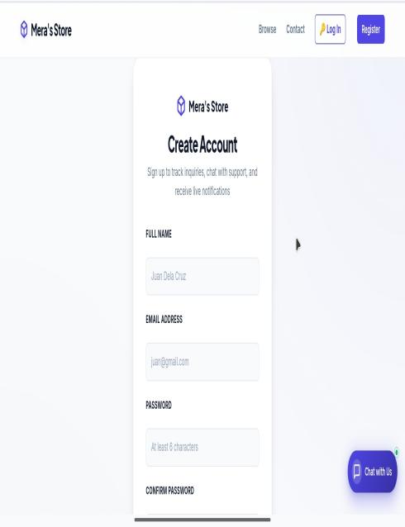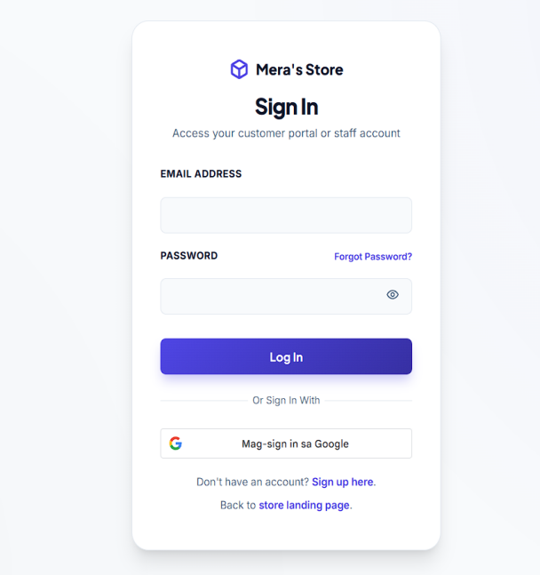
Figure 37. In terms of registering and logging in, including Google sign-in.
Figure 34 shows the pages where customers create an account and log in. The Create Account form asks for the full name, email address, password, and password confirmation, while the Sign In page asks for the email address and password and also offers sign-in with a Google account. This section allows customers to track their inquiries and receive notifications through a secure account.
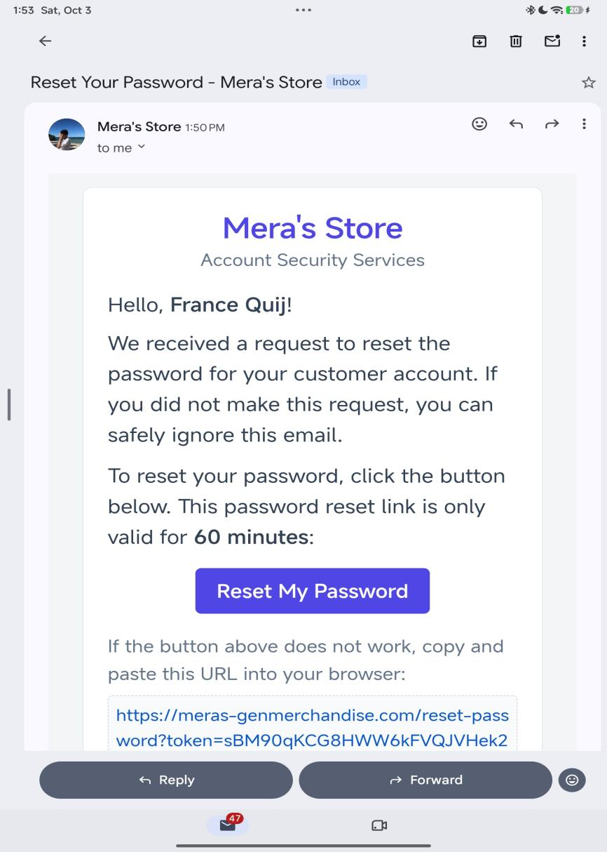
Figure 38. In terms of recovering a forgotten password through an email reset link.
Figure 38 shows the password recovery pages. The customer enters the registered email address and selects Send Reset Link, and a secure link that expires after a limited time is sent to the email. The link opens the Create New Password page, where the new password is entered and confirmed. This section allows customers to recover their accounts without the help of the administrator.
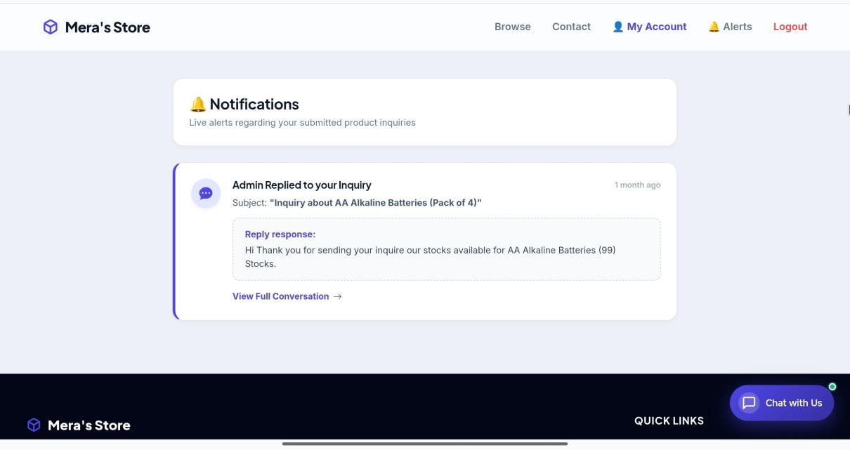
Figure 39.In terms of viewing the customer account and inquiry reply notifications.
Figure 39 shows the Customer Account page and the Notifications page. When the administrator replies to an inquiry, the alert Admin Replied to your Inquiry appears in the notifications of the customer. This section keeps customers informed of the store's responses to their concerns.
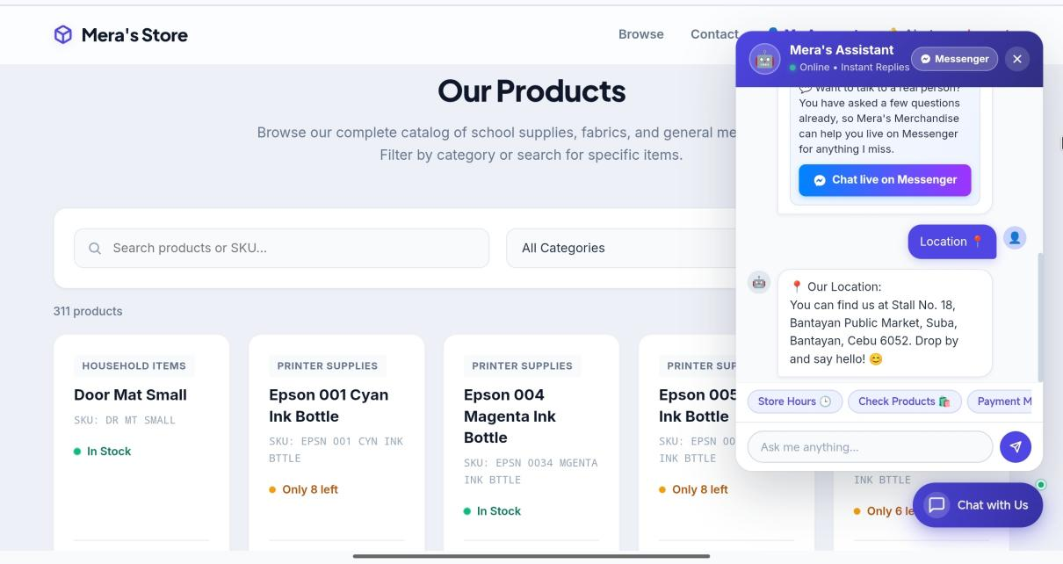
Figure 40.In terms of providing chatbot assistance on store hours, location, products, and payment.
Figure 37 shows the Chat with Us window, where customers can use the quick buttons for Store Hours, Location, Products, and Payment, or type a question about a product to see its price and availability. This section gives customers immediate answers to common questions even when the store personnel are not available.

Android Mobile Application
Table 6 presents the functionality of the Android mobile application as rated by the 35 respondents who used the customer website and the mobile application (the customers and the IT experts).

Table 6. Functionality of the Android Mobile Application
CRITERIA | MEAN | VERBAL INTERPRETATION
How functional is our system in terms of downloading and installing the Android application from the store website? | 4.51 | Strongly Functional
How functional is our system in terms of browsing and searching products on a mobile device? | 4.60 | Strongly Functional
How functional is our system in terms of submitting inquiries through the mobile application? | 4.54 | Strongly Functional
How functional is our system in terms of receiving emails when the store replies to an inquiry? | 4.43 | Strongly Functional
How functional is our system in terms of using the chatbot on the mobile application? | 4.49 | Strongly Functional
TOTAL WEIGHTED MEAN | 4.51 | Strongly Functional

Table 6 shows that the system was rated Strongly Functional across all criteria by the respondents, with mean scores ranging from 4.43 to 4.60. Specifically, the system obtained 4.51 for downloading and installing the Android application from the store website, 4.60 for browsing and searching products on a mobile device, 4.54 for submitting inquiries through the mobile application, 4.43 for receiving push notifications when the store replies to an inquiry, and 4.49 for using the chatbot on the mobile application. With a total weighted mean of 4.51, the overall interpretation is Strongly Functional, which indicates that the Android application gives customers convenient access to the catalogue of the store, to inquiries, and to notifications of the store's replies on their mobile devices.
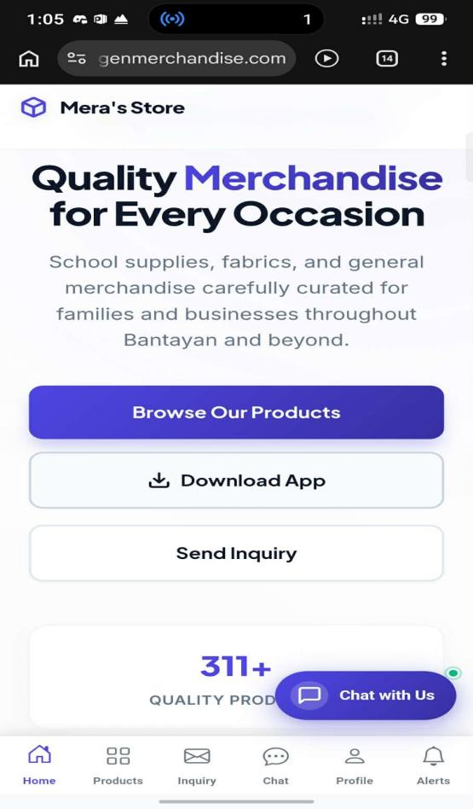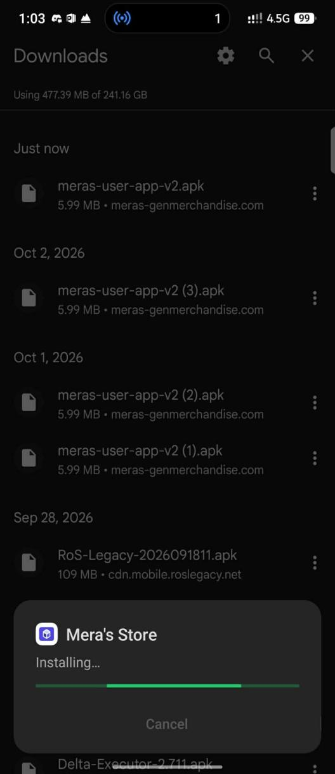
Figure 41. Android Mobile Application
Figure 38 shows the Mera's Store customer application running on an Android device. The application can be downloaded from the Download App button of the store website and opens the customer portal, where customers can browse and search the products, log in or register, send inquiries, use the chatbot, and receive a push notification when the store replies. This section highlights the portability of the system, allowing customers to use it anytime and anywhere.

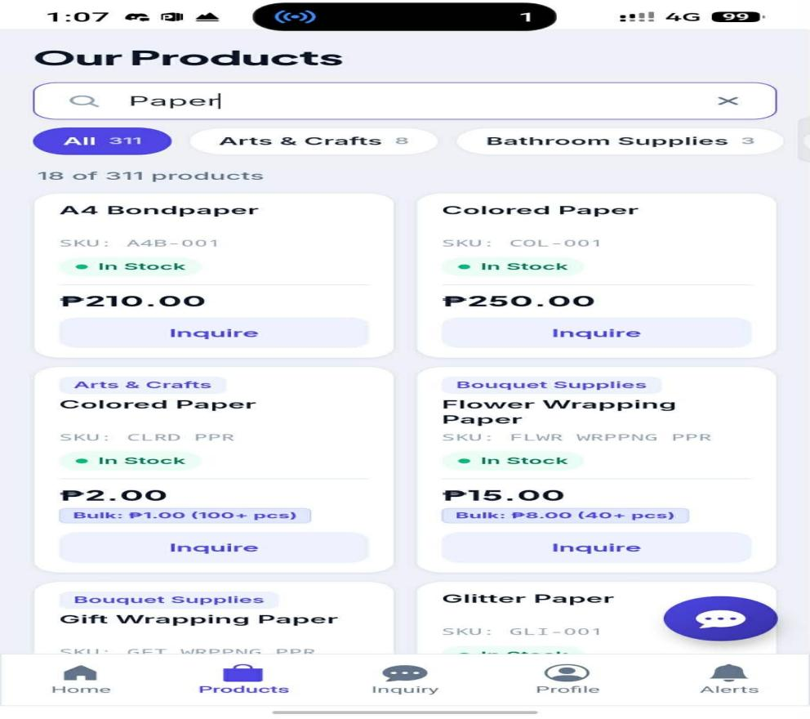
Figure 42 .In terms of browsing and searching products on a mobile device?
Figure 42 shows the mobile product catalogue interface under the “Our Products” section, where customers can browse paper-related items. The page includes a search bar at the top, allowing users to filter products by keyword, and each listing displays details such as product name, SKU, stock status, price, and an “Inquire” button for direct communication. Some products also show bulk pricing options, giving customers flexibility in purchasing larger quantities. A bottom navigation bar provides quick access to Home, Products, Inquiry, Profile, and Alerts, making the interface convenient for mobile users to explore and request product information on the go.
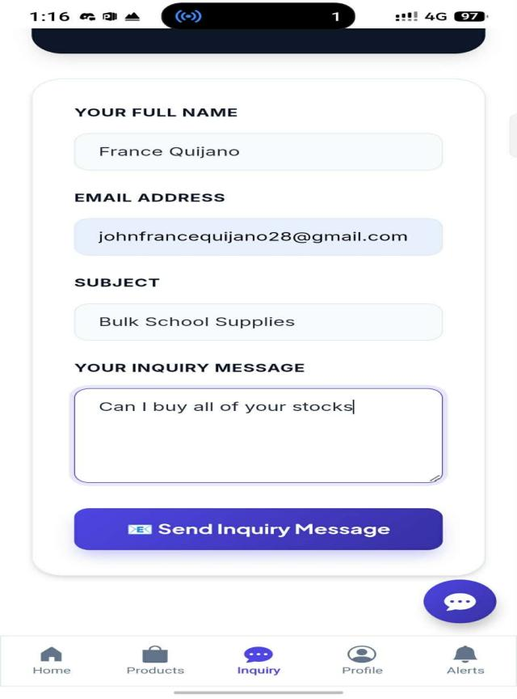
Figure 43.In terms of submitting inquiries through the mobile application.
Figure 43 illustrates the mobile inquiry form interface, which enables customers to directly communicate with the store regarding their purchase needs. The form captures essential details such as the customer’s full name, email address, subject of the inquiry, and a personalized message. Once completed, users can submit their request through the “Send Inquiry Message” button. This section streamlines customer interaction by providing a structured way to ask about product availability, bulk orders, or other concerns, while the bottom navigation bar ensures quick access to Home, Products, Inquiry, Profile, and Alerts for a seamless mobile shopping experience.
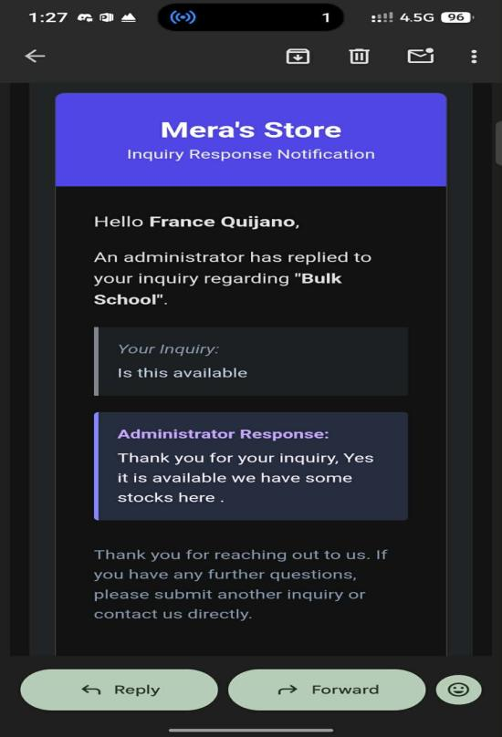
Figure 44. In terms of receiving emails when the store replies to an inquiry.
Figure 44 displays the inquiry response notification interface, where customers receive replies from the store regarding their submitted questions. The message includes the customer’s name, the subject of the inquiry, the original inquiry text, and the administrator’s response confirming product availability. A courteous note is also provided, encouraging further inquiries or direct contact if needed. At the bottom of the screen, options such as “Reply” and “Forward” allow the customer to continue the conversation or share the response. This feature ensures clear communication between the store and its customers, supporting efficient handling of product inquiries and purchase decisions.
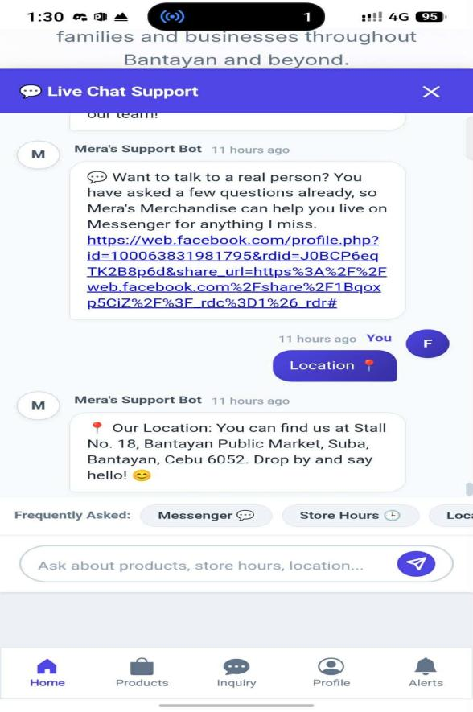

Figure 45. In terms of using the chatbot on the mobile application.
Figure 45 illustrates the live chat support interface, where customers can interact with Mera’s Support Bot for quick assistance. The chat provides automated responses, including links to the store’s social media and location details. When a user requests the location, the bot replies with the exact stall address at Bantayan Public Market along with a friendly message. The bottom navigation bar offers shortcuts to Home, Products, Inquiry, Profile, and Alerts, ensuring smooth navigation while chatting. This feature enhances customer service by giving instant access to essential information such as business location and contact options.

Software Quality Based on ISO/IEC 25010
Table 7 presents the quality of the system as rated by the 5 IT experts according to the characteristics of the ISO/IEC 25010 Systems and Software Quality Model.
Table 7. Software Quality Based on ISO/IEC 25010
 | MEAN | VERBAL INTERPRETATION
Functionality | 4.50 | Strongly Functional
Usability | 4.37 | Strongly Functional
Reliability | 4.28 | Strongly Functional
Efficiency | 4.08 | Agree (Very Good)
Security | 4.36 | Strongly Functional
Maintainability | 4.15 | Agree (Very Good)
TOTAL WEIGHTED MEAN | 4.29 | Strongly Functional

Table 7 shows that the system was rated Strongly Functional overall by the IT experts, with a total weighted mean of 4.29. Specifically, the system obtained 4.50 for functionality, 4.37 for usability, 4.36 for security, 4.28 for reliability, 4.15 for maintainability, and 4.08 for efficiency. Efficiency and maintainability were rated Agree (Very Good), while the other characteristics were rated Strongly Functional. These findings confirm that the system is highly suitable and secure for the operation of the store, though there is room for improvement in efficiency and maintainability to further enhance the overall quality of the system.
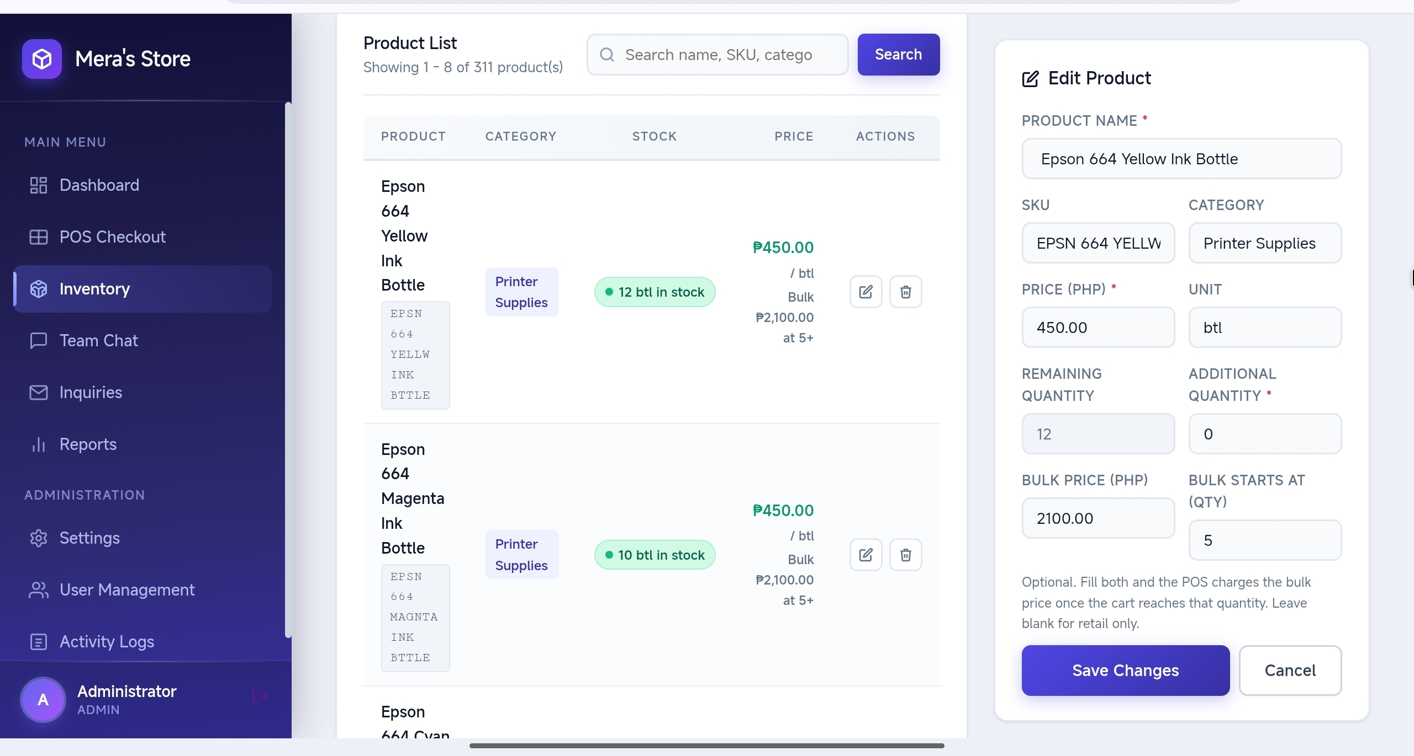
Figure 39. Software Best Quality Function
The figure above shows the best quality function of the system, which is functionality. In the POS checkout, the administrator adds products to the cart, receives a cash or GCash payment, and prints the receipt, while the sold quantities are deducted from the inventory automatically and the sale is recorded for the reports.

Usability of the System
Table 8 presents the usability of the system as rated by the 37 respondents composed of the store owner and merchants, the store employees, and the customers, based on the usefulness, satisfaction, and ease of use and learning of the system.

Table 8. Usability of the System
 | MEAN | VERBAL INTERPRETATION
Usefulness | 4.35 | Strongly Functional
Satisfaction | 4.28 | Strongly Functional
Ease of Use and Learning | 4.22 | Strongly Functional
TOTAL WEIGHTED MEAN | 4.28 | Strongly Functional

Table 8 shows that the system was rated Strongly Functional overall, with mean scores ranging from 4.22 to 4.35. Specifically, the system obtained 4.35 for usefulness, 4.28 for satisfaction, and 4.22 for ease of use and learning. With a total weighted mean of 4.28, the findings confirm that the system provides a positive user experience, balancing usability, practicality, and satisfaction, thereby supporting effective use and adoption by the store owner, the store employees, and the customers.
Figure 40. Software Usability
The figure above shows the landing page of the system, where customers can view the products of the store, send an inquiry, log in or register, and download the Android application. The simple layout and the clear labels make the system easy to use and to learn for customers who have limited technical knowledge.

Summary of the Evaluation Results
Table 9 summarizes the weighted mean of each component evaluated in this study.
Table 9. Summary of the Evaluation Results
COMPONENT | RESPONDENTS | MEAN | VERBAL INTERPRETATION
Administrator dashboard (functionality) | 12 | 4.53 | Strongly Functional
Administrator management functions (functionality) | 12 | 4.54 | Strongly Functional
Customer website (functionality) | 35 | 4.50 | Strongly Functional
Android mobile application (functionality) | 35 | 4.51 | Strongly Functional
Software quality based on ISO/IEC 25010 | 5 | 4.29 | Strongly Functional
Usability (usefulness, satisfaction, ease of use and learning) | 37 | 4.28 | Strongly Functional
OVERALL WEIGHTED MEAN |  | 4.44 | Strongly Functional

Table 9 shows that all of the components of the system were rated Strongly Functional, with component means ranging from 4.28 to 4.54 and an overall weighted mean of 4.44. These results show that the system was judged by its administrators, customers, and IT experts to be functional, of good quality, and easy to use.
CHAPTER V
SUMMARY OF FINDINGS, CONCLUSIONS, AND RECOMMENDATIONS

SUMMARY OF FINDINGS
This chapter presents the summary of findings, conclusions, and recommendations of the study entitled “Mera’s General Merchandise Store Management System with POS and Chat Support.” The system was developed to replace the manual handling of sales, inventory, reports, and customer communication at Mera’s General Merchandise Store by providing a web portal for the administrator, a customer website with inquiry and chatbot support, and an Android mobile application. It was developed using the Agile (Scrum-based) model and was evaluated by 42 respondents composed of the store owner and merchants, the store employees, the customers, and the IT experts, using the ISO/IEC 25010-based questionnaire and the usability questionnaire described in Chapter III.
The Chapter IV evaluation showed that the system obtained an overall weighted mean of 4.44, interpreted as Strongly Functional. The component-level weighted means ranged from 4.28 to 4.54, indicating that the system was able to support the intended sales, inventory, reporting, and customer-communication processes of the store. The major findings are summarized below.
1. Profile of the respondents. The evaluation involved 33 respondents: 2 store owner and merchants (4.76%), 2 store employees (11.90%), 26 customers (71.43%), and 3 IT experts (11.90%). The customers were the largest group, so the system was evaluated mainly by its intended end users, while the IT experts assessed its software quality.
2. Administrator dashboard. The dashboard that displays the daily, weekly, and monthly sales, the total revenue, the number of products, the low-stock count and alerts, the recent sales, and the sales and product charts obtained a total weighted mean of 4.53. This indicates that the dashboard gives the store owner accessible and accurate information about the operation of the store. Displaying the Low Stock Alerts received the highest indicator mean of 4.75, while displaying the Seven-Day Sales Trend chart received the lowest indicator mean of 4.33, showing an opportunity for further refinement of the dashboard.
3. Administrator management functions. The functions for managing products and inventory, importing products, bulk pricing, POS checkout, cash and GCash payment, receipts, sales reports, customer inquiries, support chat, user accounts, activity logs, and system settings achieved a total weighted mean of 4.54. These results confirm that the administrator portal can support the daily transactions and record keeping of the store. Processing POS sales through the cart and checkout and deducting sold quantities from the inventory automatically received the highest indicator mean of 4.75, while importing products from a CSV file received the lowest indicator mean of 4.33, showing an opportunity for further refinement of the administrator portal.
4. Customer website. The functions for viewing and searching the product catalogue, checking prices and stock status, sending inquiries, registering and logging in, recovering a password, receiving notifications, and using the chatbot obtained a total weighted mean of 4.50. This shows that customers can obtain information from the store and communicate with it through the website. Displaying the store landing page and product catalogue and submitting store inquiries received the highest indicator mean of 4.60, while viewing the customer account and inquiry reply notifications received the lowest indicator mean of 4.34, showing an opportunity for further refinement of the customer website.
5. Android mobile application. The Android application obtained a total weighted mean of 4.51, which indicates that providing access through a mobile device supports the convenience and portability of the system, including the push notification of the store's replies to inquiries. Browsing and searching products on a mobile device received the highest indicator mean of 4.60, while receiving push notifications when the store replies to an inquiry received the lowest indicator mean of 4.43, showing an opportunity for further refinement of the mobile application.
6. Software quality based on ISO/IEC 25010. The IT experts rated the quality of the system with a total weighted mean of 4.29. Functionality received the highest mean of 4.50, while efficiency received the lowest mean of 4.08, interpreted as Agree (Very Good). The system is therefore functional, secure, and reliable for the needs of the store, with the lowest-rated characteristics offering the greatest opportunity for improvement.
7. Usability. The store owner, the store employees, and the customers rated the usability of the system with a total weighted mean of 4.28. Usefulness received the highest mean of 4.35, while ease of use and learning received 4.22. This confirms that the system is useful, satisfying, and easy to learn for the people who use it.

CONCLUSIONS
Based on the findings, the researchers conclude that Mera’s General Merchandise Store Management System with POS and Chat Support achieved its intended purpose of providing the store with a centralized and reliable platform for managing products, inventory, point-of-sale transactions, sales reports, and customer communication. The Strongly Functional rating of the evaluated components shows that the system can record sales accurately, deduct sold items from the inventory automatically, monitor low-stock products, produce sales reports, and respond to customer inquiries in an organized and efficient manner.
The system also supports the needs of its different users. The administrator, who handles the POS, can manage products, process cash and GCash sales, print receipts, generate reports, answer customer inquiries, and monitor user accounts and activity logs, while customers can browse the catalogue, send inquiries, receive replies, and use the chatbot through the website or the Android application. These capabilities improve the record keeping, the speed of service, and the communication of the store with its customers.
The ISO/IEC 25010 results show that the system is functional, secure, and usable, while efficiency and maintainability received lower ratings than the other characteristics. The positive usability results also confirm that the store owner, the store employees, and the customers find the system useful, satisfying, and easy to use and learn. Continued maintenance, user guidance, and regular review of records will be important to sustain the usefulness and reliability of the system after deployment.

RECOMMENDATIONS
To sustain and further improve Mera’s General Merchandise Store Management System with POS and Chat Support, the researchers recommend the following actions:
1. Improve system efficiency. Efficiency received one of the lowest quality ratings (4.08). The researchers recommend optimizing database queries, adding indexes and caching for the dashboard, reports, and product catalogue, compressing product images, and paginating long lists so that pages load and respond faster as the number of products and sales records grows.
2. Strengthen maintainability. Maintainability received a mean of 4.15. Technical documentation, consistent coding standards, and automated tests for the POS, inventory, report, and account modules should be prepared so that errors can be corrected and features can be updated with less risk. The modular structure and the version control of the code should be maintained.
3. Integrate an online payment gateway. The POS currently displays a GCash QR code and relies on the cashier to confirm the payment. Integrating an official GCash or other payment gateway will allow payments to be confirmed automatically, reference numbers to be recorded, and digital receipts to be generated, which reduces errors and speeds up the checkout.
4. Expand user roles and online ordering. Separate Cashier and Merchant accounts with limited access should be added, and customers should be allowed to place orders or reservations through the website and the mobile application. This will improve the accountability for sales and extend the system from information and inquiries to complete online transactions.
5. Enhance the mobile application and chat support. Native features of the Android application such as in-app notifications, offline viewing of the product catalogue, and an iOS version should be developed. The answers of the chatbot should be expanded and a chat history should be kept in the account of the customer.
6. Provide user orientation and support. Orientation sessions and concise user guides should be prepared for the administrator, the store employees, and the customers, particularly on POS checkout, product and stock updates, report generation, inquiry handling, account recovery, and installing the Android application.
7. Maintain security and data privacy. Hashed passwords, role-based access, and activity logs should be kept, stronger password rules should be required, the database should be backed up regularly using the Export & Backup function, and the framework and libraries should be updated regularly. Customer information should continue to be handled in accordance with the Data Privacy Act of 2012 (Republic Act No. 10173).
8. Conduct continuing evaluation. Feedback should be collected regularly from the store owner, the employees, and the customers after deployment and used to guide improvements. A future evaluation may involve a larger number of respondents and a broader ISO/IEC 25010 assessment that also covers compatibility and portability.

REFERENCES

APPENDIX A

EXPERT EVALUATION USING ISO/IEC 25010

SOFTWARE QUALITY MODEL

Name: _____________________ Company: _______________
Position: _________________ Specialization: ________
Direction: Listed below are the characteristics of a Software or Product as based on ISO/IEC 25010 Software Quality Model.
Each of the items is provided with five options. Please read each item carefully and check (/) the box that closely represents your choice.

Rating Scale:
[5] Very Good [4] Good [3] Average [2] Fair [1] Poor

How would you rate the developed system, “CAPSTONE MONITORING AND TABULATION MANAGEMENT SYSTEM” in terms of the following software criteria:
Functional Suitability
the degree to which a product or system provides functions that meet stated and implied needs when used under specified conditions
Functional completeness. Degree to which the set of functions covers all the specified tasks and user objectives. | [1] [2] [3] [4] [5]
Functional correctness. Degree to which a product or system provides the correct results with the needed degree of precision. | [1] [2] [3] [4] [5]
Functional appropriateness. Degree to which the functions facilitate the accomplishment of specified tasks and objectives. | [1] [2] [3] [4] [5]
Performance efficiency
the performance relative to the amount of resources used under stated conditions
Time behaviour. Degree to which the response and processing times and throughput rates of a product or system, when performing its functions, meet requirements. | [1] [2] [3] [4] [5]
Resource utilization. Degree to which the amounts and types of resources used by a product or system, when performing its functions, meet requirements. | [1] [2] [3] [4] [5]
Capacity. Degree to which the maximum limits of a product or system parameter meet requirements. | [1] [2] [3] [4] [5]
Compatibility
Degree to which a product, system or component can exchange information with other products, systems or components, and/or perform its required functions, while sharing the same hardware or software environment.
Co-existence. Degree to which a product can perform its required functions efficiently while sharing a common environment and resources with other products, without detrimental impact on any other product. | [1] [2] [3] [4] [5]
Interoperability. Degree to which two or more systems, products or components can exchange information and use the information that has been exchanged. | [1] [2] [3] [4] [5]
Appropriateness recognisability. Degree to which users can recognize whether a product or system is appropriate for their needs. | [1] [2] [3] [4] [5]
Learnability. degree to which a product or system can be used by specified users to achieve specified goals of learning to use the product or system with effectiveness, efficiency, freedom from risk and satisfaction in a specified context of use. | [1] [2] [3] [4] [5]
Operability. Degree to which a product or system has attributes that make it easy to operate and control. | [1] [2] [3] [4] [5]
User error protection. Degree to which a system protects users against making errors. | [1] [2] [3] [4] [5]
User interface aesthetics. Degree to which a user interface enables pleasing and satisfying interaction for the user. | [1] [2] [3] [4] [5]
Accessibility. Degree to which a product or system can be used by people with the widest range of characteristics and capabilities to achieve a specified goal in a specified context of use. | [1] [2] [3] [4] [5]
Reliability
Degree to which a system, product or component performs specified functions under specified conditions for a specified period of time
Maturity. Degree to which a system, product or component meets needs for reliability under normal operation. | [1] [2] [3] [4] [5]
Availability. Degree to which a system, product or component is operational and accessible when required for use. | [1] [2] [3] [4] [5]
Fault tolerance. Degree to which a system, product or component operates as intended despite the presence of hardware or software faults. | [1] [2] [3] [4] [5]
Recoverability. Degree to which, in the event of an interruption or a failure, a product or system can recover the data directly affected and re-establish the desired state of the system. | [1] [2] [3] [4] [5]
Security
Degree to which a product or system protects information and data so that persons or other products or systems have the degree of data access appropriate to their types and levels of authorization.
Confidentiality. Degree to which a product or system ensures that data are accessible only to those authorized to have access. | [1] [2] [3] [4] [5]
Integrity. Degree to which a system, product or component prevents unauthorized access to, or modification of, computer programs or data. | [1] [2] [3] [4] [5]
Non-repudiation. Degree to which actions or events can be proven to have taken place, so that the events or actions cannot be repudiated later. | [1] [2] [3] [4] [5]

__________________________
Signature over printed name

APPENDIX B
RESULT OF EVALUATION USING ISO/IEC 25010 SOFTWARE QUALITY
MODEL
CRITERIA | MEAN | VERBAL INTERPRETATION
Functional Suitability | 4.50 | Strongly Functional
Performance efficiency | 4.37 | Strongly Functional
Compatibility | 4.28 | Strongly Functional
Reliability | 4.08 | Agree
Security | 4.36 | Strongly Functional
TOTAL WEIGHTED MEAN | 4.15 | Agree

APPENDIX C
Name: _____________________ Company: _______________
Position: _________________ Specialization: ________

EVALUATION INSTRUMENT
USE Questionnaire: Usefulness, Satisfaction, and Ease of use
Based on: Lund, A.M. (2001) Measuring Usability with the USE Questionnaire. STC Usability SIG Newsletter, 8:2.
Name of System: CAPSTONE MONITORING AND TABULATION MANAGEMENT SYSTEM
Instruction: Please rate the system on how strongly you agree or disagree with each of the following statements by placing a check mark in the appropriate box.
Legend:
1 – Strongly Disagree 2 – Disagree
3 - Neither agree nor disagree 4 – Agree
5 – Strongly Agree

Usefulness | 1 | 2 | 3 | 4 | 5
It helps me be more effective.
It helps me be more productive.
It is useful.
It gives me more control over the activities in my life.
It makes the things I want to accomplish easier to get done.
It saves me time when I use it.
It meets my needs.
It does everything I would expect it to do.

Ease of Use | 1 | 2 | 3 | 4 | 5
It is easy to use.
It is simple to use.
It is user friendly.
It requires the fewest steps possible to accomplish what I want to do with it.
It is flexible.
Using it is effortless.
I can use it without written instructions.
I don't notice any inconsistencies as I use it.
Both occasional and regular users would like it.
I can recover from mistakes quickly and easily.
I can use it successfully every time.

Ease of Learning | 1 | 2 | 3 | 4 | 5
I learned to use it quickly.
I easily remember how to use it.
It is easy to learn to use it.
I quickly became skillful with it.

Satisfaction | 1 | 2 | 3 | 4 | 5
I am satisfied with it.
I would recommend it to a friend.
It is fun to use.
It works the way I want it to work.
It is wonderful.
I feel I need to have it.
It is pleasant to use.

List the most negative aspect(s):
_______________________________________________________________________________________________________________________________________________________________________________________________________________________________________________________________

List the most positive aspect(s):
_______________________________________________________________________________________________________________________________________________________________________________________________________________________________________________________________

_______________________
Signature over printed name

APPENDIX D
RESULT OF EVALUATION USING USE QUESTIONNAIRE
Result of USE Questionnaire: Usefulness, Ease of use, Ease of
Learning and Satisfaction of MERA’S GENERAL MERCHANDISE STORE MANAGEMENT WITH POS AND CHAT SUPPORT.
CRITERIA | MEAN | VERBAL INTERPRETATION
Ease of Use | 4.26 | Functional
Usefulness | 4.32 | Functional
Ease of Learning | 4.17 | Functional
Satisfaction | 4.28 | Functional
Total weighted mean | 4.26 | Functional

APPENDIX E
SURVEY QUESTIONNAIRE
MERA'S GENERAL MERCHANDISE STORE MANAGEMENT SYSTEM WITH POS AND CHAT SUPPORT
Name: ______________________________________________
Address: ____________________________________________
Direction: Please check (✓) the box corresponding to the rating that best describes the functionality of the system.
Rating Scale:
5 – Strongly Functional
4 – Functional
3 – Moderately Functional
2 – Slightly Functional
1 – Not Functional
No. | Questionnaire | 5 | 4 | 3 | 2 | 1
A. ADMIN MANAGEMENT
1 | How functional is the system in terms of managing sales to create records and processing customer transactions?
2 | How functional is the system in terms of monitoring and viewing customer inquiries and messages?
3 | How functional is the system in terms of updating product information, stock quantities, prices, categories, and units?
4 | How functional is the system in terms of deleting incorrect sales entries, discontinued products, inactive user accounts, spam messages, unnecessary reports, and outdated configurations?
B. DASHBOARD
5 | How functional is the system in terms of displaying total daily, weekly, and monthly sales?
6 | How functional is the system in terms of displaying total revenue and the total number of products?
7 | How functional is the system in terms of displaying the number of low-stock products and providing low-stock alerts?
8 | How functional is the system in terms of displaying the 7-day sales trend and top-selling products?
9 | How functional is the system in terms of displaying stock distribution by category and recent sales transactions?
10 | How functional is the system in terms of providing quick access to POS Checkout, Inventory, Support Chat, and Sales Reports?
C. REPORTS MODULE
11 | How functional is the system in terms of generating accurate daily, weekly, monthly, and yearly sales reports?
12 | How functional is the system in terms of displaying total sales, transactions, and revenue in generated reports?
13 | How functional is the system in terms of generating reports for top-selling products based on units sold and revenue?
14 | How functional is the system in terms of displaying recent transactions with the cashier, date, time, and transaction total?
15 | How functional is the system in terms of exporting sales reports in CSV format?
16 | How functional is the system in terms of printing generated sales reports for documentation and record-keeping?
D. ACCOUNT SECURITY AND RECOVERY
17 | How functional is the system in terms of providing email verification for newly registered accounts and enable secure password recovery through email notifications using password reset links to ensure authorized access and improve system security?
E. MOBILE APPLICATION
18 | How functional is the system in terms of allowing merchants to access relevant system functions through the Android mobile application provides  a convenient platform for both merchants and customers to access the system anytime using their Android smartphones?
F. GCASH ONLINE PAYMENT
19 | How functional is the system in terms of allowing customers to pay for their purchases through GCash payment gateway that enables customers to pay for their purchases electronically?

Open-Ended Questions
1. Which system feature was most useful to you, and why?
________________________________________________________________________________
________________________________________________________________________________
2. What problem or difficulty did you encounter while using the system?
________________________________________________________________________________
________________________________________________________________________________
3. What improvement would make the system more useful or easier to use?
________________________________________________________________________________

APPENDIX F
 | MEAN | VERBAL INTERPRETATION
How functional is our system in terms of managing product records and inventory? | 4.67 | Strongly Functional
How functional is our system in terms of importing products from a CSV file? | 4.33 | Strongly Functional
How functional is our system in terms of setting bulk prices and units of measure for products? | 4.42 | Strongly Functional
How functional is our system in terms of processing POS sales through the cart and checkout? | 4.75 | Strongly Functional
How functional is our system in terms of accepting cash and GCash payments and computing the change? | 4.58 | Strongly Functional
How functional is our system in terms of generating and printing receipts? | 4.67 | Strongly Functional
How functional is our system in terms of deducting sold quantities from the inventory automatically? | 4.75 | Strongly Functional
How functional is our system in terms of generating weekly, monthly, and yearly sales reports and exporting them to CSV? | 4.58 | Strongly Functional
How functional is our system in terms of viewing top-selling products and recent transactions? | 4.50 | Strongly Functional
How functional is our system in terms of managing customer inquiries and sending email responses? | 4.50 | Strongly Functional
How functional is our system in terms of replying to customers through the support chat? | 4.42 | Strongly Functional
How functional is our system in terms of managing user accounts and roles? | 4.50 | Strongly Functional
How functional is our system in terms of monitoring activity logs? | 4.42 | Strongly Functional
How functional is our system in terms of managing system settings and security? | 4.50 | Strongly Functional
TOTAL WEIGHTED MEAN | 4.54 | Strongly Functional

 | MEAN | VERBAL INTERPRETATION
How functional is our system in terms of displaying the Daily Sales? | 4.58 | Strongly Functional
How functional is our system in terms of displaying the Weekly Sales? | 4.50 | Strongly Functional
How functional is our system in terms of displaying the Monthly Sales? | 4.50 | Strongly Functional
How functional is our system in terms of displaying the Total Revenue? | 4.67 | Strongly Functional
How functional is our system in terms of displaying the Total Number of Products? | 4.58 | Strongly Functional
How functional is our system in terms of displaying the Low Stock Count? | 4.42 | Strongly Functional
How functional is our system in terms of displaying the Recent Sales? | 4.50 | Strongly Functional
How functional is our system in terms of displaying the Low Stock Alerts? | 4.75 | Strongly Functional
How functional is our system in terms of displaying the Seven-Day Sales Trend chart? | 4.33 | Strongly Functional
How functional is our system in terms of displaying the Top-Selling Products and Stock by Category charts? | 4.42 | Strongly Functional
TOTAL WEIGHTED MEAN | 4.53 | Strongly Functional

 | MEAN | VERBAL INTERPRETATION
How functional is our system in terms of displaying the store landing page and product catalogue? | 4.60 | Strongly Functional
How functional is our system in terms of searching and filtering products by name, SKU, or category? | 4.54 | Strongly Functional
How functional is our system in terms of displaying product prices and stock status? | 4.57 | Strongly Functional
How functional is our system in terms of switching between the grid view and the table view of products? | 4.40 | Strongly Functional
How functional is our system in terms of submitting store inquiries? | 4.60 | Strongly Functional
How functional is our system in terms of registering and logging in, including Google sign-in? | 4.46 | Strongly Functional
How functional is our system in terms of recovering a forgotten password through an email reset link? | 4.49 | Strongly Functional
How functional is our system in terms of viewing the customer account and inquiry reply notifications? | 4.34 | Strongly Functional
How functional is our system in terms of providing chatbot assistance on store hours, location, products, and payment? | 4.54 | Strongly Functional
TOTAL WEIGHTED MEAN | 4.50 | Strongly Functional

CRITERIA | MEAN | VERBAL INTERPRETATION
How functional is our system in terms of downloading and installing the Android application from the store website? | 4.51 | Strongly Functional
How functional is our system in terms of browsing and searching products on a mobile device? | 4.60 | Strongly Functional
How functional is our system in terms of submitting inquiries through the mobile application? | 4.54 | Strongly Functional
How functional is our system in terms of receiving emails when the store replies to an inquiry? | 4.43 | Strongly Functional
How functional is our system in terms of using the chatbot on the mobile application? | 4.49 | Strongly Functional
TOTAL WEIGHTED MEAN | 4.51 | Strongly Functional

